

**PRODUCT SPECIFICATION**

**DESICCANT AIR DRYER – MODULAR HEATLESS REGENERATION (3-177 SCFM)**

This Product Specification is for heatless modular desiccant type dryers used for removal of water and contaminants from compressed air to a specified degree. The dryers use the pressure swing principle to regenerate the desiccant media and require no supplementary heat source. The Specification includes information for a range of dryers that can be applied to air systems of varying size.

**SCOPE**

Unit shall be factory assembled, self contained and completed in all respects including component equipment, wiring, controls, instrumentation and pre and post filtration. Unit shall be free standing, requiring only inlet/outlet air connections and electrical connection. All standard controls and instruments shall be factory set/calibrated so as to provide for "turn-key" operation.

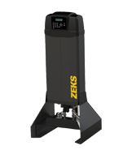

For reference only

**OPERATION**

Dryer shall be designed and assembled to operate as follows:

* Continuously and automatically
* Drying and Regeneration cycle shall be ten (10) minutes for -40 °F pressure dew point dryers.
* The portion of air used in regeneration shall be expanded to atmospheric pressure at the dry air outlet of the dryer, and routed to and through the off-line (regenerating) tower.
* Regeneration shall be accomplished by passing a portion of dry expanded air through the regenerating tower in a reverse direction of the drying flow path and then purging it to atmosphere.
* The off-line tower shall be gradually brought back up to line pressure prior to tower switch over. This shall prevent desiccant attrition and dusting and premature failure of downstream particulate filter elements.
* Velocity through the desiccant towers shall provide adequate contact time to deliver an efficient, consistent dew point. Pressure drop across the dryer and filters shall be less than 3 PSID at design conditions.

**PERFORMANCE**

Dryer shall provide for water removal so that the air moisture level shall not exceed -40°F pressure dew point at all times. Dryers 24 SCFM and larger may be configured to deliver optional -100 °F pressure dew point.

Dryer shall perform at saturated inlet air temperatures of up to 122°F and ambient temperatures between 35°F and 120°F.

Note: Rated capacity is reduced when inlet temperatures exceed 100°F.

**COMPONENTS AND CONSTRUCTION**

Dryer Towers shall be constructed from extruded aluminum.

To maintain lowest possible pressure drop, dryers shall be equipped with full flow shuttle valves.

Towers shall be internally and externally anodized for exceptional corrosion resistance. External surface shall also be powder coated for additional protection.

On dryers 24 SCFM and larger, each tower shall be provided with a pressure gauge.

HEATLESS DESICCANT AIR DRYER (Cont.)

**DESICCANT BED**

Dryers designed for -40 °F pressure dew point shall be filled with Activated Alumina desiccant. Grade A minimum.

Desiccant volume shall be sufficient to provide stated outlet dew point at rated operating conditions of moisture load and temperature.

Desiccant shall be rated for saturated air service and shall not fracture in the presence of liquid water. Silica Gel shall not be acceptable.

NO CHLORIDE TYPE ABSORBENTS WILL BE ALLOWED.

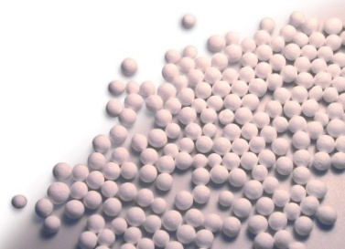

**DRYER FLOW PATH**

DRYING FLOW SHALL BE UPWARDS through the beds, REGENERATION flow shall be downward (Counter-current flow).

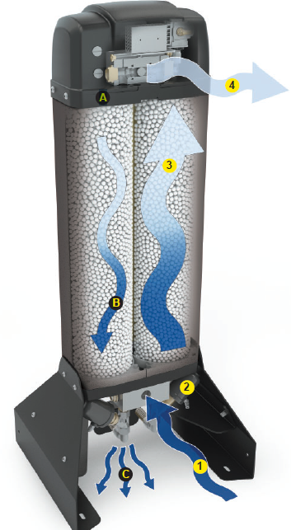

**DRYING PROCESS**

1. Wet, untreated compressed air flows from the coalescing prefilter into the dryer.
2. Purge valves open or close in a timed cycle to direct the flow of incoming compressed air into the tower that contains regenerated desiccant.
3. Desiccant media adsorbs moisture as the air flows through it, making the air clean and dry.
4. High quality air exits the dryer and particulate after filter and continues on to downstream processes for safe use.

**DESICCANT REGENERATION PROCESS**

1. A small portion of the dried air is directed into the offline tower
2. The air, now expanded to atmospheric pressure, strips away the moisture that was held on the surface of the desiccant media in the previous operating cycle.
3. Purge valves are configured to enable the purge airflow to exit the dryer, carrying moisture and contaminants out of the dryer.

**CONTROLS AND INSTRUMENTATION**

Main Control enclosure shall be constructed in accordance with NEMA standards; factory mounted directly on the unit and shall include all controls, and other instrumentation devices.

Drying System shall be shipped completely calibrated and tested so that only single entry electrical connection is necessary for the unit's entire electrical system.

END PRODUCT SPECIFICATION