**Ingersoll Rand**

**Davidson, U.S.A**

***ZEKSPro 3.0***

**Version 3.0**

|  |
| --- |
| **Notice** |
| © 2013 Tata Consultancy Services Limited  This is a controlled document. Unauthorized access, copying, replication or usage for a purpose other than for which it is intended, are prohibited.  All trademarks that appear in the document have been used for identification purposes only and belong to their respective companies. |

ZEKSPro/IR/Mfg.

Tata Consultancy Services, Mumbai

**About this Document**

**Purpose**

This document describes the High Level Design (HLD) specifications for the ZEKSPro 3.0 application. The specifications are based on a detailed study of the requirement specifications provided in the approved System Requirement Specifications (SRS) document by IR.

**Intended Audience**

This document will help:

* Ingersoll Rand to understand and approve the design specifications of the proposed application, as adequate for meeting its stated business needs.
* The project team to develop the ZEKSPro 3.0 application using the specifications, as well as to plan and manage all project resources thereof.
* The acceptance testing team to develop test data and to test the application.
* The maintenance team to understand all aspects of the application, and maintain it.

This document is intended for the developers in IR, who are going to construct ZEKSPro 3.0.

**Scope of the Document**

This document primarily discusses the overall designs of the following:

* Database
* Screen

It also contains the traceability matrix and provides audit trailing information for the database objects.

However, the following are outside the scope of this design document:

* Definition of the actual logic for each and every component of the system
* Class diagrams with all the methods and relation between classes
* Programs specifications

**Typographical Conventions**

The following table gives the details of the typographical conventions used in the document:

| Formatting Convention | Type of Information |
| --- | --- |
| Controls Name | Names of Controls are in bold. |
| Menu Name | Name of Menu are in italics. |

**Contents**

1. Introduction 12

1.1. Background 12

1.2. Functional Description 12

1.3. System Environment 12

1.4. Assumptions and Dependencies 13

1.5. Dependencies 13

2. System Architecture 14

2.1. Logical View of the Architecture 14

2.2. Physical View of the Architecture 15

2.3. Data Dictionary 15

3. Screen Design 26

3.1. Menu Structure and Navigation 26

• Menu Structure of ZEKS Admin Web Application 26

• Menu Structure of ZEKS Client Application 26

3.2. Screens of ZEKS Admin Web Application 27

3.2.1. Login Page 27

3.2.1.1. Purpose 27

3.2.1.2. Layout 27

3.2.1.3. Called from/by 28

3.2.1.4. Specifications 28

3.2.2. Model Management 28

3.2.2.1. Purpose 28

3.2.2.2. Called from/by 28

3.2.2.3. Layout 29

3.2.2.4. Specifications 29

3.2.3. Add New Sub Category 30

3.2.3.1. Purpose 30

3.2.3.2. Called from/by 30

3.2.3.3. Layout 31

3.2.3.4. Specifications 31

3.2.4. Add New Specification 32

3.2.4.1. Purpose 32

3.2.4.2. Called from/by 32

3.2.4.3. Layout 32

3.2.4.4. Specifications 32

3.2.5. Add New Model 33

3.2.5.1. Purpose 33

3.2.5.2. Called from/by 34

3.2.5.3. Layout 34

3.2.5.4. Specifications 36

3.2.6. Add New Optional Equipment 39

3.2.6.1. Purpose 39

3.2.6.2. Called from/by 39

3.2.6.3. Layout 39

3.2.6.4. Specifications 40

3.2.7. Add Optional Equipment Price 41

3.2.7.1. Purpose 41

3.2.7.2. Called from/by 41

3.2.7.3. Layout 42

3.2.7.4. Specifications 42

3.2.8. Export – Bulk Price 43

3.2.8.1. Purpose 43

3.2.8.2. Called from/by 43

3.2.8.3. Layout 44

3.2.8.4. Specifications 44

3.2.9. Import – Bulk Price 45

3.2.9.1. Purpose 45

3.2.9.2. Called from/by 45

3.2.9.3. Layout 45

3.2.9.4. Specifications 45

3.2.10. Search Specification 46

3.2.10.1. Purpose 46

3.2.10.2. Called from/by 46

3.2.10.3. Layout 47

3.2.10.4. Specifications 47

3.2.11. Search Models 48

3.2.11.1. Purpose 48

3.2.11.2. Called from/by 48

3.2.11.3. Layout 48

3.2.11.4. Specifications 48

3.2.12. Search Optional Equipments 49

3.2.12.1. Purpose 49

3.2.12.2. Called from/by 49

3.2.12.3. Layout 50

3.2.12.4. Specifications 50

3.2.13. Define Optional Equipment Relationship 51

3.2.13.1. Purpose 51

3.2.13.2. Called from/by 51

3.2.13.3. Layout 51

3.2.13.4. Specifications 52

3.2.14. Search Optional Equipment Price 53

3.2.14.1. Purpose 53

3.2.14.2. Called from/by 53

3.2.14.3. Layout 53

3.2.14.4. Specifications 53

3.2.15. Edit Specification 54

3.2.15.1. Purpose 54

3.2.15.2. Called from/by 54

3.2.15.3. Layout 54

3.2.15.4. Specifications 55

3.2.16. Edit Model Details 55

3.2.16.1. Purpose 55

3.2.16.2. Called from/by 56

3.2.16.3. Layout 56

3.2.16.4. Specifications 58

3.2.17. Edit Optional Equipment Details 60

3.2.17.1. Purpose 60

3.2.17.2. Called from/by 60

3.2.17.3. Layout 60

3.2.17.4. Specifications 62

3.2.18. Edit Optional Equipment Price 63

3.2.18.1. Purpose 63

3.2.18.2. Called from/by 63

3.2.18.3. Layout 63

3.2.18.4. Specifications 64

3.2.19. Delete Model Details/Optional Equipment/Optional Equipment Price Details/Model Specification 64

3.2.19.1. Purpose 64

3.2.19.2. Called from/by 65

3.2.19.3. Layout 65

3.2.19.4. Specifications 65

3.2.20. User Management 65

3.2.20.1. Purpose 65

3.2.20.2. Called from/by 65

3.2.20.3. Layout 66

3.2.20.4. Specifications 66

3.2.21. Add New User 66

3.2.21.1. Purpose 66

3.2.21.1. Called from/by 67

3.2.21.2. Layout 67

3.2.21.3. Specifications 67

3.2.22. Search Users 68

3.2.22.1. Purpose 68

3.2.22.1. Called from/by 68

3.2.22.2. Layout 68

3.2.22.3. Specifications 68

3.3. Screens of ZEKS Client Application 69

3.3.1. Splash Screen 69

3.3.1.1. Purpose 69

3.3.1.2. Called from/by 69

3.3.1.3. Layout 70

3.3.1.4. Specifications 70

3.3.2. Home Page 70

3.3.2.1. Purpose 70

3.3.2.2. Called from/by 70

3.3.2.3. Layout 71

3.3.2.4. Specifications 71

3.3.3. ZEKS Synchronization Process 73

3.3.3.1 Purpose 73

3.3.3.2 Layout 73

3.3.3.3 Called from/by 73

3.3.3.4 Implementation 73

3.3.4. Quotation 74

3.3.4.1. Purpose 74

3.3.4.2. Called from/by 74

3.3.4.3. Layout 75

3.3.4.4. Specifications 76

3.3.5. Quotation Preview 83

3.3.5.1. Purpose 83

3.3.5.2. Called from/by 83

3.3.5.3. Layout 84

3.3.5.4. Specifications 85

3.3.6. Quotation Cover Page 87

3.3.6.1. Purpose 87

3.3.6.2. Called from/by 88

3.3.6.3. Layout 89

3.3.6.4. Specifications 89

3.3.7. Model Quotation 90

3.3.7.1. Purpose 90

3.3.7.2. Called from/by 90

3.3.7.3. Layout 91

3.3.8. Quotation Specification 91

3.3.8.1. Purpose 91

3.3.8.2. Called from/by 92

3.3.8.3. Layout 92

3.3.9. Energy Calculations 93

3.3.9.1. Purpose 93

3.3.9.2. Called from/by 93

3.3.9.3. Layout 93

3.3.9.4. Specifications 94

3.3.10. Toolbox – Moisture Removal Calculation 97

3.3.10.1. Purpose 97

3.3.10.2. Called from/by 97

3.3.10.3. Layout 98

3.3.10.4. Specifications 98

3.3.11. Toolbox – Unit Converter 99

3.3.11.1. Purpose 99

3.3.11.2. Called from/by 99

3.3.11.3. Layout 99

3.3.11.4. Specifications 100

3.3.12. Toolbox – ACFM To SCFM Conversion 102

3.3.12.1. Purpose 102

3.3.12.2. Called from/by 102

3.3.12.3. Layout 103

3.3.12.4. Specifications 103

3.3.13. Toolbox – Pressure Drop 104

3.3.13.1. Purpose 104

3.3.13.2. Called from/by 104

3.3.13.3. Layout 105

3.3.13.4. Specifications 105

3.3.14. Toolbox – Cost Of Pressure Drop 106

3.3.14.1. Purpose 106

3.3.14.2. Called from/by 106

3.3.14.3. Layout 107

3.3.14.4. Specifications 107

3.3.15. Toolbox – ISO 8573.1 (Compressed Air Quality Standards) 108

3.3.15.1. Purpose 108

3.3.15.2. Called from/by 108

3.3.15.3. Layout 109

3.3.15.4. Specifications 109

3.3.16. Settings - Logo 109

3.3.16.1. Purpose 109

3.3.16.2. Called from/by 109

3.3.16.3. Layout 110

3.3.16.4. Specifications 110

3.3.17. Settings - Signature 111

3.3.17.1. Purpose 111

3.3.17.2. Called from/by 111

3.3.17.3. Layout 111

3.3.17.4. Specifications 112

3.3.18. Settings – Return Address 112

3.3.18.1. Purpose 112

3.3.18.2. Called from/by 112

3.3.18.3. Layout 112

3.3.18.4. Specifications 113

3.3.19. Help 113

3.3.19.1. Purpose 113

3.3.19.2. Called from/by 113

3.3.19.3. Layout 113

3.3.19.4. Specifications 113

4. Attachments 114

5. Exception Handling 115

5.1. Application Level 115

5.2. Data Base Level 115

**List of Figures**

Figure 1: Logical View of Architecture 14

Figure 2: Database Design Diagram 20

Figure 3: High Level Class Diagram of ZEKS Web Application 21

Figure 4: High Level Class Diagram of ZEKS Client Application 23

Figure 5: Login Page 27

Figure 6: Model Management Page 29

Figure 7: Add New Sub Category 31

Figure 8: Add New Specification 32

Figure 9: Add New Model 36

Figure 10: Add New Optional Equipment 40

Figure 11: Add Optional Equipment Price 42

Figure 12: Export Bulk Price 44

Figure 13: Import Bulk Price 45

Figure 14: Search Specification 47

Figure 15: Search Models 48

Figure 16: Search Optional Equipments 50

Figure 17: Optional Equipment Relationship 51

Figure 18: Search Optional Equipment Price 53

Figure 19: Edit Specification 54

Figure 20: Edit Model Details 58

Figure 21: Edit Optional Equipment Details 62

Figure 22: Edit Optional Equipment Price 63

Figure 23: Delete functionality 65

Figure 24: User Management Page 66

Figure 25: Manage Users 67

Figure 26: Search Users 68

Figure 27: Splash Screen 70

Figure 28: Home Page 71

Figure 29: Quotation (This is a dynamic screen and design of it may differ from model to model) 75

Figure 30: Preview Quotation 84

Figure 31: Print Quotation 86

Figure 32: Cover Page 89

Figure 33: Model Quotation 91

Figure 34: Specification Tab 92

Figure 35: Energy Calculations 93

Figure 36: Moisture Removal Calculation 98

Figure 37: Unit converter 100

Figure 38: ACFM To SCFM Converter 103

Figure 39: Pressure Drop 105

Figure 40: Cost of Pressure Drop 107

Figure 41: ISO 8573.1 – Compressed Air Quality Standards 109

Figure 42: Logo 110

Figure 43: Signature 111

Figure 44: Return Address 112

**List of Tables**

Table 1: Software Environment 12

Table 2: Physical View Architecture 15

Table 3: tblCategory 15

Table 4: tblSubCategory 15

Table 5: tblProductSpecificationMaster 16

Table 6: tblProduct 16

Table 7: tblProductDtlSpecificationData 17

Table 8: tblOptionalEquipmentMaster 17

Table 9: tblOptionalEquipment_Relationship 17

Table 10: tblOptionalEquiPriceDetails 18

Table 11: tblUnitType 18

Table 12: tblUnitName 18

Table 13: tblTranLog 18

Table 14: tblUserMaster 19

Table 15: tblWaterCooled 19

Table 16: Functions of ZEKS Web Application 21

Table 17: Functions in ZEKS Client Application 23

Table 18: Menus of ZEKS Admin Web Application 26

Table 19: Menu Structure of ZEKS Client Application 26

**List of Abbreviations**

|  |  |
| --- | --- |
| **Abbreviation** | **Expanded Form** |
| IR | Ingersoll Rand |
| IRP | Ingersoll Rand Products |
| TCS | Tata Consultancy Services |
| MS Office | Microsoft Office |

# Introduction

## Background

ZEKSPro is ZEKS’ proprietary specifying and quotation software used by ZEKS inside and outside salespersons, as well as ZEKS distributors since 1998. ZEKSPro generates quotations based on user-inputted information while also providing the user with tools and energy calculations to assist in the sale of ZEKS air treatment products.

The purpose of this project is to create a new version of ZEKSPro (ZEKSPro 3.0) that will not only run on current operating systems, but offer enhanced features and functionality of the program to better serve the ZEKS sales force and distributors.

## Functional Description

The new system will be divided in two parts, ZEKS Admin Web Application and ZEKS client application.

In ZEKS Admin Web Application, user will be authenticated by using corporate active directory; he/she can add new users of IR AD to web application.

User will be able to create, modify and delete models and optional equipment, their price and specifications, also user can attach the model or equipment specification in the form of the MS word template. There will be a provision to import price of a bulk of models through the excel sheets. User will be provided a grid view of models Sizing Conditions to update them in bulk on the basis of certain search criteria.

In ZEKS client application, whenever any user provides some inputs the program generates the quotation and also provides the user with the toolbox and energy calculations. The quotations are generated in MS Word format and can be exported in PDF format. Only cover page of the quotation can be modified by the user while generating the quotation. Quotations are stored at the client side for future reference. On quotation screen, user cannot edit or delete model specification or optional equipment specification. This data is non editable in client application. But the user can select or deselect provided optional equipments.

The Standalone Client Application will work in the offline mode and will be synchronized with the server mode. There will be a daemon process running on the client machine to download all the model details to the client machine.

## System Environment

Table 1: Software Environment

|  |  |
| --- | --- |
| **Operating System** | Windows XP (32-bit) - Desktop Users  Windows 7 (32-bit) - Desktop Users  Windows XP (64-bit) - Desktop Users  Windows 7 (64-bit) - Desktop Users  Windows 8 - Desktop Users  Chris (11/04/2013): TATA to provide feedback on Windows * / 8.1  TCS (11/05/2013): We cannot use applications developed on lower version directly on Windows 8. We need to migrate it to Windows Store. We need to analyze this part. |
| **Database** | SQL Server 2008 |
| **Server Software** | Microsoft Visual Studio 2010, VSS 5.0 |
| **Browsers** | Firefox - Desktop Browsers  Mozilla Desktop Browsers  IE8+ Desktop Browsers  Chrome Desktop Browsers |
| **Other Software** |  |

## Assumptions and Dependencies

**Assumptions**

1. All the calculations will be rounded to whole number that is nearest to integer. All pricing will be in the decimal format.

Chris (11/04/2013): Fine for general calcs. Will pricing be in $X,XXX.XX format?

TCS (11/07/2013): Yes, pricing will be in decimal format.

1. Numeric value will always be right aligned.
2. The testing will be done on above mentioned Operation System Configurations and Browsers (Please refer System Environment section).
3. The functionality of Print will be available in quotation preview screen only. Once the user clicks Print, default print dialog box opens so that the user prints the quotation.
4. For data synchronization, we will use FTP (File Transfer Protocol) approach.

Chris (11/04/2013): Ronak – Will look to you for guidance as to how this is executed with ZEKS or IR network.

TCS (11/07/2013): OK

## Dependencies

1. IR needs to provide static instructions to be shown on each page.
2. IR needs to provide logos and images to be shown on the page wherever applicable like login page.
3. IR needs to provide samples of quotation.

# System Architecture

## Logical View of the Architecture

**ASPX PAGES**

**Authentication / Authorization (AD)**

**Provides simplified access to data stored in database.**

**Data Access layer**

**Business layer**

**Business Rules And Calculations**

**User Interface (UI)**

**Presentation Layer**

**File System**

**Provides simplified access to data stored in database.**

**Data Access layer**

**Business Rules And Calculations**

**Business layer**

**ZEKS**

**Component**

**ZEKS Client Application**

**ZEKS Web Admin Application**

**Presentation Layer**

**SQL Database**

**Error Execution Handling & Communication**

**Error Execution Handling & Communication**

**Resource File**

Figure 1: Logical View of Architecture

Chris (11/04/2013): This section to be reviewed and commented upon by Ronak and / or Kevin.

TCS (11/05/2013): OK

## Physical View of the Architecture

Table 2: Physical View Architecture

|  |  |  |  |
| --- | --- | --- | --- |
| **Database Server** | **Database Name** | **Application Server** | **Application Site Name** |
| **ZEKSPro 3.0– DEV** | | | |
|  |  |  |  |
| **ZEKSPro 3.0–UAT** | | | |
|  |  |  |  |
| **ZEKSPro 3.0–PROD** | | | |
|  |  |  |  |

## Data Dictionary

Table 3: tblCategory

|  |  |  |  |  |  |  |  |
| --- | --- | --- | --- | --- | --- | --- | --- |
| **Table** | **Column** | **Data Type** | **Length** | **Scale** | **Nulls Allowed?** | **Primary Key** | **Description** |
| tblCategory | CatID | int | 4 |  | NO | Yes | PK |
|  | Category | varchar | 50 |  | NO |  |  |
|  | CreatedBy | varchar | 25 |  | NO |  |  |
|  | CreatedDate | datetime |  |  | NO |  |  |
|  | ModifiedBy | varchar | 25 |  | YES |  |  |
|  | ModifiedDate | datetime |  |  | YES |  |  |

Table 4: tblSubCategory

|  |  |  |  |  |  |  |  |
| --- | --- | --- | --- | --- | --- | --- | --- |
| **Table** | **Column** | **Data Type** | **Length** | **Scale** | **Nulls Allowed?** | **Primary Key** | **Description** |
| tblSubCategory | SubCatID | int | 4 |  | NO | Yes | PK |
|  | CatID | int | 4 |  | NO |  | FK |
|  | SubCategory | varchar | 30 |  | NO |  |  |
|  | CreatedBy | varchar | 25 |  | NO |  |  |
|  | CreatedDate | datetime |  |  | NO |  |  |
|  | ModifiedBy | varchar | 25 |  | YES |  |  |
|  | ModifiedDate | datetime |  |  | YES |  |  |

Table 5: tblProductSpecificationMaster

|  |  |  |  |  |  |  |  |
| --- | --- | --- | --- | --- | --- | --- | --- |
| **Table** | **Column** | **Data Type** | **Length** | **Scale** | **Nulls Allowed?** | **Primary Key** | **Description** |
| tblProductSpecificat  ionMaster | SpecID | int |  |  | NO | Yes | PK |
|  | SubCatID | int |  |  | NO |  | FK |
|  | SpecificationName | varchar | 25 |  | NO |  |  |
|  | Specificationvalue |  |  |  |  |  |  |
|  | UnitID | Int |  |  | NO |  |  |
|  | Active | bit |  |  | NO |  | By Default 1 |
|  | CreatedBy | varchar | 25 |  | NO |  |  |
|  | CreatedDate | datetime |  |  | NO |  |  |
|  | ModifiedBy | varchar | 25 |  | YES |  |  |
|  | ModifiedDate | datetime |  |  | YES |  |  |

Table 6: tblProduct

|  |  |  |  |  |  |  |  |
| --- | --- | --- | --- | --- | --- | --- | --- |
| **Table** | **Column** | **Data Type** | **Length** | **Scale** | **Nulls Allowed?** | **Primary Key** | **Description** |
| tblProduct | ProdID | int |  |  | NO | Yes | PK |
|  | ProductName | varchar | 25 |  | NO |  |  |
|  | SubcatID | Int |  |  | NO |  |  |
|  | Instructions | nvarchar | 500 |  | YES |  |  |
|  | DocumentPath | varchar | 250 |  | YES |  |  |
|  | ImagePath | varchar | 250 |  | YES |  |  |
|  | Active | bit |  |  | NO |  |  |
|  | CreatedBy | varchar | 25 |  | NO |  |  |
|  | CreatedDate | datetime |  |  | NO |  |  |
|  | ModifiedBy | varchar | 25 |  | YES |  |  |
|  | ModifiedDate | datetime |  |  | YES |  |  |

Table 7: tblProductDtlSpecificationData

|  |  |  |  |  |  |  |  |
| --- | --- | --- | --- | --- | --- | --- | --- |
| **Table** | **Column** | **Data Type** | **Length** | **Scale** | **Nulls Allowed?** | **Primary Key** | **Description** |
| tblProductDtlSpecification  Data | ProdID | int |  |  | NO |  | FK |
|  | SpecID | int |  |  | NO |  | FK |
|  | SpecValues | Varchar | 100 |  | YES |  |  |

Table 8: tblOptionalEquipmentMaster

|  |  |  |  |  |  |  |  |
| --- | --- | --- | --- | --- | --- | --- | --- |
| **Table** | **Column** | **Data Type** | **Length** | **Scale** | **Nulls Allowed?** | **Primary Key** | **Description** |
| tblOptionalEquipmen  tMaster | OEID | Int |  |  | NO | Yes | PK |
|  | OptionalEquipName | varchar | 25 |  | NO |  |  |
|  | SubCatID | Int |  |  | NO |  | FK |
|  | Instructions | nvarchar | 500 |  | YES |  |  |
|  | Type | Varchar | 3 |  | NO |  |  |
|  | DocumentPath | varchar | 250 |  | YES |  |  |
|  | ImagePath | varchar | 250 |  | YES |  |  |
|  | Active | bit |  |  | NO |  |  |
|  | CreatedBy | varchar | 25 |  | NO |  |  |
|  | CreatedDate | datetime |  |  | NO |  |  |
|  | ModifiedBy | varchar | 25 |  | YES |  |  |
|  | ModifiedDate | datetime |  |  | YES |  |  |

Table 9: tblOptionalEquipment_Relationship

|  |  |  |  |  |  |  |  |
| --- | --- | --- | --- | --- | --- | --- | --- |
| **Table** | **Column** | **Data Type** | **Length** | **Scale** | **Nulls Allowed?** | **Primary Key** | **Description** |
| tblOptionalEquipment_  Relationship | SRNO | int |  |  | NO |  | PK |
|  | OEID | int |  |  | NO |  | FK |
|  | ProdID | Int |  |  | NO |  | FK |
|  | InclusiveExclusive | Int |  |  | NO |  |  |
|  | Flag | Varchar | 1 |  | YES |  |  |

Table 10: tblOptionalEquiPriceDetails

|  |  |  |  |  |  |  |  |
| --- | --- | --- | --- | --- | --- | --- | --- |
| **Table** | **Column** | **Data Type** | **Length** | **Scale** | **Nulls Allowed?** | **Primary Key** | **Description** |
| tblOptionalEquiPriceDetails | OEID | Int |  |  | NO |  | FK |
|  | ProdID | Int |  |  | NO |  | FK |
|  | Price | Float |  |  | YES |  |  |
|  | CreatedBy | varchar | 25 |  | NO |  |  |
|  | CreatedDate | datetime |  |  | NO |  |  |
|  | ModifiedBy | varchar | 25 |  | YES |  |  |
|  | ModifiedDate | datetime |  |  | YES |  |  |

Table 11: tblUnitType

|  |  |  |  |  |  |  |  |
| --- | --- | --- | --- | --- | --- | --- | --- |
| **Table** | **Column** | **Data Type** | **Length** | **Scale** | **Nulls Allowed?** | **Primary Key** | **Description** |
| tblUnitType | UnitTypeID | int |  |  | NO |  | PK |
|  | UnitType | Varchar | 50 |  | NO |  |  |

Table 12: tblUnitName

|  |  |  |  |  |  |  |  |
| --- | --- | --- | --- | --- | --- | --- | --- |
| **Table** | **Column** | **Data Type** | **Length** | **Scale** | **Nulls Allowed?** | **Primary Key** | **Description** |
| tblUnitType | UnitID | int |  |  | NO |  | PK |
|  | UnitTypeID | int |  |  | NO |  | FK |
|  | UnitName | Varchar | 50 |  | NO |  |  |

Table 13: tblTranLog

|  |  |  |  |  |  |  |  |
| --- | --- | --- | --- | --- | --- | --- | --- |
| **Table** | **Column** | **Data Type** | **Length** | **Scale** | **Nulls Allowed?** | **Primary Key** | **Description** |
| tblTranLog | TID | int |  |  | NO | Yes | PK |
|  | UserID | int |  |  | NO |  | FK |
|  | TranName | varchar | 25 |  | NO |  |  |
|  | FieldName | varchar | 25 |  | YES |  |  |
|  | OldValue | varchar | 500 |  |  |  |  |
|  | NewValue | varchar | 500 |  |  |  |  |
|  | ModifiedDate | DateTime |  |  | NO |  |  |

Table 14: tblUserMaster

|  |  |  |  |  |  |  |  |
| --- | --- | --- | --- | --- | --- | --- | --- |
| **Table** | **Column** | **Data Type** | **Length** | **Scale** | **Nulls Allowed?** | **Primary Key** | **Description** |
| tblUserMaster | UserID | int |  |  | NO | Yes | PK |
|  | FirstName | Varchar | 50 |  | NO |  |  |
|  | LastName | Varchar | 50 |  | NO |  |  |
|  | CorpID | Varchar | 10 |  | NO |  |  |
|  | Active | bit |  |  | NO |  |  |
|  | CreatedBy | varchar | 25 |  | NO |  |  |
|  | CreatedDate | datetime |  |  | NO |  |  |
|  | ModifiedBy | varchar | 25 |  | YES |  |  |
|  | ModifiedDate | datetime |  |  | YES |  |  |

Table 15: tblWaterCooled

|  |  |  |  |  |  |  |  |
| --- | --- | --- | --- | --- | --- | --- | --- |
| **Table** | **Column** | **Data Type** | **Length** | **Scale** | **Nulls Allowed?** | **Primary Key** | **Description** |
| tblWaterCooled | WaterCooledID | int |  |  | NO |  | PK |
|  | ProdID | int |  |  | NO |  | FK |
|  | SpecID | int |  |  | NO |  |  |
|  | FlowGPM | Varchar | 50 |  | NO |  |  |
|  | ConnNPT | Varchar | 50 |  | NO |  |  |

**Database Design Diagram**

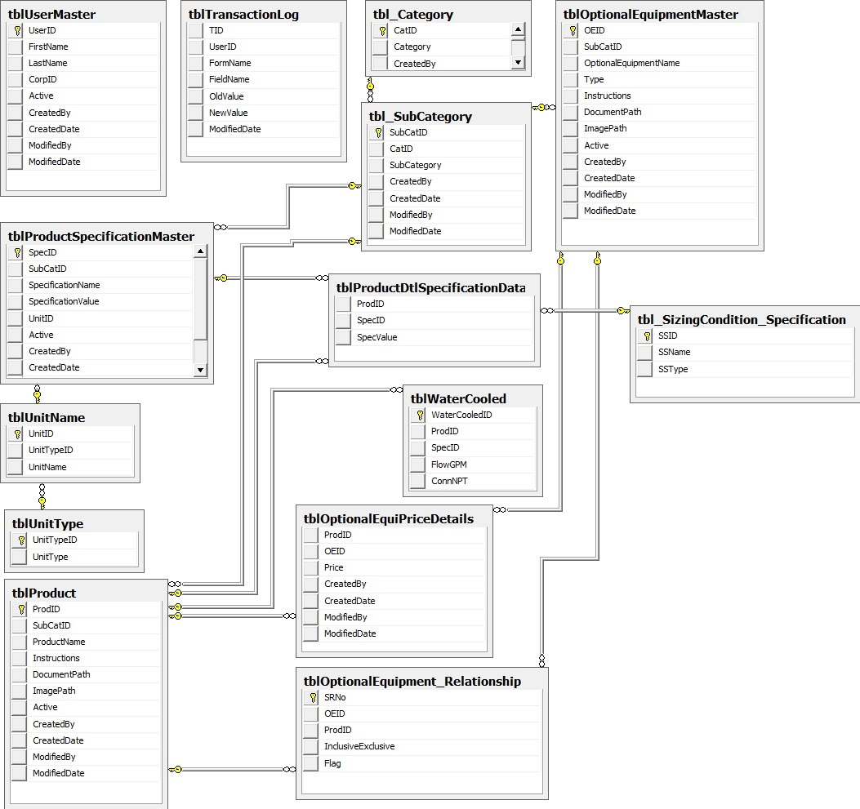

Figure 2: Database Design Diagram

**High Level Class Diagram**

* **ZEKS Web Application Class Diagram**

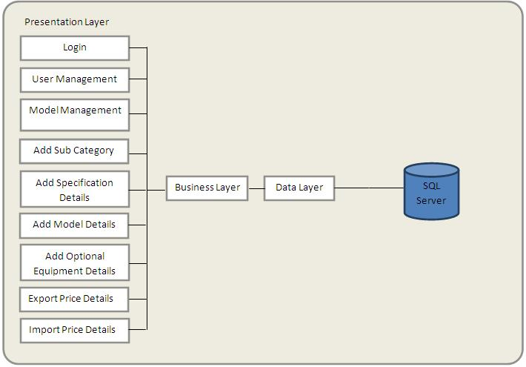

Figure 3: High Level Class Diagram of ZEKS Web Application

The list of functions called at each layers is as follows:

Table 16: Functions of ZEKS Web Application

| **Screen Name** | **Function Name (BLL)** | **Function Name (DAL)** |
| --- | --- | --- |
| ***Login*** | ValidateUser() | ValidateUser() |
| ***User Management*** | GetUserDetails()  AddUser() | GetUserDetails()  AddUser() |
| ***Model Management*** | GetCategory()  GetSubCategory()  SearchSpecification()  SearchModel()  SearchOptionalEqu() | GetCategory()  GetSubCategory()  SearchSpecification()  SearchModel()  SearchOptionalEqui() |
| ***Add SubCategory*** | AddSubCategory() | AddSubCategory() |
| ***Add Specification Details*** | GetSpecDetail()  AddSpecDetB() | GetSpecDetail()  AddSpecDet() |
| ***Add Model Details*** | GetSpecDetail()  AddModel() | GetSpecDetail()  AddModel() |
| ***Add Optional Equipment Details*** | GetOptEquiDetail()  AddOptEquiDet() | GetOptEquiDetail()  AddOptEquiDet() |
| ***Import Price Details*** | UpdatePriceDetail() | UpdatePriceDetail() |

1. ValidateUse(): This function will check combination of userid and password in database.
2. GetUserDetails(): This function will be used to get user details having valid IR account.
3. AddUser(): This function will be used to add users in database
4. GetCategory():This function will be used to get categories from database.
5. GetSubCategory():This function will be used to get sub categories from database based on selected category.
6. SearchSpecification():This function will be used to get specification details from database.
7. SearchModel():This function will be used to get model details from database.
8. SearchOptionalEqui():This function will be used to get optional equipment details from database.
9. AddSubCategory():This function will be used to add sub category in database.
10. GetSpecDetails():This function will be used to get specification details from database.
11. AddSpecDetails():This function will be used to add specification in database.
12. AddModelDetails():This function will be used to add model in database.
13. GetOptEquiDetails():This function will be used to get optional equipment details from database.
14. AddOptEquiDetails():This function will be used to add optional equipment details in database.
15. UpdatePriceDetails():This function will be used to update price details to database.

* **ZEKS Client Application Class Diagram**

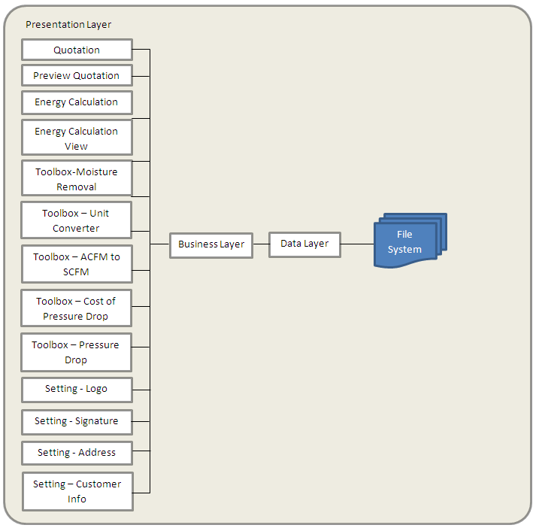

Figure 4: High Level Class Diagram of ZEKS Client Application

The list of functions called at each layers is as follows:

Table 17: Functions in ZEKS Client Application

| **Screen Name** | **Function Name (BLL)** | **Function Name (DAL)** |
| --- | --- | --- |
| ***Quotation*** | GetCategory()  GetSubCategory()  GetModels()  GetSizingConditions()  GetSpecifications()  CreateQuotation()  GetCustInfo()  SaveCustInfo() | GetCategory()  GetSubCategory()  GetModels()  GetSizingConditions()  GetSpecifications()  GetCustInfo()  SaveCustInfo() |
| ***Energy Calculation*** | CalculateEnergyCalc() |  |
| ***Toolbox –*** | CalcMoistureRem()  CalcUnitConverter()  CalcACFMToSCFM()  CalcCostPressureDrop()  CalctPressureDrop() |  |
| ***Settings*** | GetLogo()  SaveLogo()  GetSignature()  SaveSignature()  GetRetAdd()  SaveRetAdd() | GetLogo()  SaveLogo()  GetSignature()  SaveSignature()  GetRetAdd()  SaveRetAdd() |

1. GetCategory():This function will be used to get categories.
2. GetSubCategory():This function will be used to get subcategories.
3. GetSubModel():This function will be used to get models.
4. GetSpecifications (): This function will be used to get Specifications from database.
5. CreateQuotation(): This function will be used to Create Quotation.
6. CalculateEnergyCalc(): This function will be used to calculate energy.
7. CalcMoistureRem(): This function will be used to calculate moisture removal content.
8. CalcUnitConverter(): This function will be used to calculate unit conversion.
9. CalcACFMToSCFM(): This function will be used calculate the conversion of ACFM to SCFM.
10. CalcCostPressureDrop(): This function will be used to calculate cost of Pressure drop.
11. CalctPressureDrop(): This function will be used to calculate Pressure drop.
12. GetLogo(): This function will be used to get logo details.
13. SaveLogo(): This function will be used to save logo to the database.
14. GetSignature(): This function will be used to get signature given by the user.
15. SaveSignature(): This function will be used to save signature to the database.
16. GetRetAdd(): This function will be used to get return address.
17. SaveRetAdd(): This function will be used to save return address.
18. GetCustInfo(): This function will be used to get the customer information.
19. SaveCustInfo(): This function will be used to save the customer information.

# Screen Design

## Menu Structure and Navigation

### Menu Structure of ZEKS Admin Web Application

Table 18: Menus of ZEKS Admin Web Application

|  |  |
| --- | --- |
| Menu Option | Function |
| *Login Page* | The users will be able to login to the application by providing the valid User Name and Password. |
| *Model Configuration* | The user will be able to create sub category. Users also able to create, edit, delete and configure models, optional equipment and specifications. |
| *User Management* | User can add another users having valid account in IR domain. |
| *Import Price* | User will be able to import price of models in bulk. |
| *Logout* | User will be able to log off. |

### Menu Structure of ZEKS Client Application

Table 19: Menu Structure of ZEKS Client Application

|  |  |
| --- | --- |
| Menu Option | Function |
| *Quotation* | The user will be able to configure and generate quotation of models. User can also view, print or export the quotation. |
| *Energy Calculation* | The user will be able to calculate energy calculations. |
| *Toolbox* | The user will be able to do calculations like moisture removal, unit converter, ACFM to SCFM converter etc. |
| *Settings* | User can save his logo, signature, customer Information, return address and configuration. |
| *Help* | Help will be provided to user through this menu. |

## Screens of ZEKS Admin Web Application

## Login Page

## Purpose

In the below provided screen, user has to provide valid Username and Password (corp user id and password) to get logged- in into the application. User name and password should be available in IR Active Directory.

## Layout

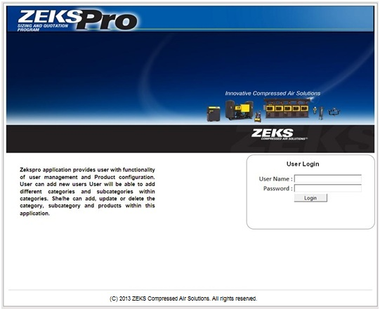

Figure 5: Login Page

Chris (11/04/2013): It is important to NOT have Ingersoll Rand name show up in this program. As odd as that might seem, the West Chester factory has NO traces of the Ingersoll Rand name on the building or in the lobby. This is because the ZEKS distributors are actually in competition with Ingersoll Rand distributors. As such, we minimize (or eliminate where possible) any and all references to Ingersoll Rand. Would like the caption for the copyright notice to say “ZEKS Compressed Air Solutions” rather than “Ingersoll Rand”.

TCS(11/05/2013): Done

## Called from/by

Once the user enters the URL of the application the above screen will appear to authenticate the user by providing valid Username and Password.

## Specifications

**User Inputs:**

1. **Username** (Textbox): The user enters Username
2. **Password**(Textbox):The user enters Password

**Buttons:**

1. **Login** (Button): After providing user name and password, user needs to click on login button, based on which user will be authenticated.
2. **Reset** (Button):If the user clicks on Reset button, the information entered in Username and Password textbox will be cleared.

**Validations**:

1. Entered **Username** and **Password** will be checked against IR corporate Active Directory.
2. If **Username** and **Password** is not matched, the user gets an error message “Either Username OR Password is incorrect. Kindly correct it and Login again”.
3. If the user has not entered anything and directly clicks **Login**, the user will be shown with below validation messages:

* If user name textbox is blank then error message will be “Please provide valid user name”
* If password textbox is blank then error message will be “Please provide valid password”.

## Model Management

## Purpose

After User gets logged-in then he will be redirected to home page where he will be provided with Model Management and User Management functionality as provided below.

## Called from/by

This screen appears after successful login and will be used for managing Model information.

## Layout

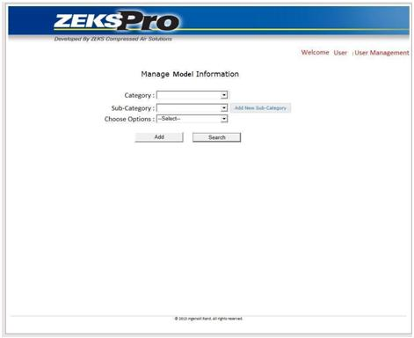

Figure 6: Model Management Page

## Specifications

**User Inputs:**

* + - 1. **Category** (Drop Down): This dropdown will be populated with all the categories.
      2. **Add New Category** (Button): If User wants to add new category then he has to click on Add New Category button besides the category dropdown.
      3. **Sub Category** (Drop Down): This dropdown will get populated on the basis of category selected by the user.
      4. **Add New Sub Category** (Button):If User wants to add new sub category then he has to click on Add New Sub Category button besides the sub category dropdown.
      5. **Choose Options** (Dropdown) :This dropdown consists of these options-
* Define Specification
* Model Details
* Define Optional Equipment
* Model Optional Equipment Price
* Export Price Template
* Import Price

**Buttons:**

1. **Add** (Button): If User wants to add new Model, Model specification, Optional Equipment Price or Optional Equipment, then user needs to click on Add button.
2. **Search** (Button): If User wants to search existing Model, Model specification, Optional Equipment Price or Optional Equipment then he has to click on Search button.

## Add New Sub Category

## Purpose

User can add new Sub category by clicking on Add New Sub Category button besides the Sub Category dropdown.

## Called from/by

This popup screen appears after click on Add New Sub Category button besides Sub Category dropdown.

User can add subcategory within a category by selecting a category first and then adding new subcategory. As the new Subcategory is created then by default some sizing conditions get added to it. User can add/edit/delete these sizing conditions. User will be having a freedom to attach condenser type with respect to model as per there requirement.

For Refrigerated Dryers these sizing conditions will get added by default.

* Air Cooled Condensor
* Air Cooled Flow Capacity 38 F dew point
* Air Cooled 38 F dew point Pressure Drop
* Water Cooled Condensor
* Water Cooled Flow Capacity 38 F dew point
* Water Cooled 38 F dew point Pressure Drop

For Desiccant Dryers these sizing conditions will get added by default.

* Fake AreaFlow
* Delta P
* Model ZPA/MPS

For ZTF Filters these sizing conditions will get added by default.

* Flow

For Mist Eliminator these sizing conditions will get added by default.

* Flow

For F-Cast Filters these sizing conditions will get added by default.

* Flow

Chris (11/04/2013): I do not understand why these are a default for every product. These only apply to a specific series of dryers. Not every product.

TCS (11/05/2013): Above sizing conditions will be added by default while creating new sub category.

Chris (11/11/2013): Per Ronak on 11/7/13, there will be specific sizing rules per subcategory. Somehow, the user must be able to define which sizing rule is applicable for the new products that are being created. If this is not the proper understanding of how this will be executed, please let me know.

TCS (11/12/2013): User needs to contact IT support to create new Sizing Conditions. There may be chances of code change if user adds new Sizing Conditions.

## Layout

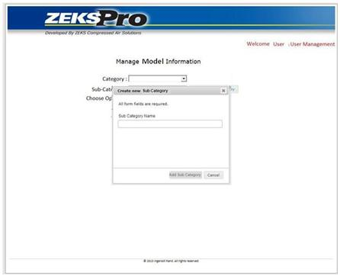

Figure 7: Add New Sub Category

## Specifications

**User Inputs:**

1. **Sub Category Name** (Textbox): User will enter sub category name here.

**Buttons:**

1. **Add Sub Category** (Button): User will click on Add Sub Category button to save the sub category. The added sub-category will be shown in sub-category dropdown of parent window.
2. **Cancel** (Button): On clicking **Cancel** button Pop up will be closed and previous page will be shown to the user.

## Sizing Condition Group

Here a group of sizing conditions will be provided according to the categories. There will be customer inputs as well as basic variables behind math equations for the particular category for the model selection.

Here we are representing sizing conditions of refrigerated dryers category as one group and similarly for all other categories as another group.

Here sizing condition are termed as the basic variables which are used in math calculations while customer inputs are termed simply as specification which will be visible in the quotation screen for the customer input according to which model will be selected.

* For e.g.- In **Refrigerated dryers** basic **customer inputs** for the model selection are
* Flow ,
* Inlet Pressure
* Inlet Temperature
* Ambient Temperature

For the math equations there are five basic variable inputs for the Refrigerated dryer category which should be entered by the user in web application for validating the calculation based on formulas. These all five sizing conditions for refrigerated dryers will come under the Refrigerated Dryers Sizing Condition Group.So, the **Sizing conditions variables** for the Refrigerated dryers are-

* Air Cooled Flow Capacity 38 °F dew point
* Air Cooled Pressure Drop 38 °F dew point
* Water Cooled Flow Capacity 38 °F dew point
* Water Cooled Pressure Drop 38 °F dew point
* Water Cooled Flow Capacity 50 °F dew point
* Similarly in **desiccant dryers** basic **customer inputs** for the model selection are
* Flow ,
* Inlet Pressure
* Inlet Temperature
* Ambient Temperature

For math calculations the **Sizing conditions variables** for the Desiccant dryers are-

* Fake Area Flow
* Delta P
* Model ZPA/MPS

` These three sizing conditions will come under Desiccant Dryers Sizing Condition Group

* In **filters** category basic **customer inputs** for the model selection are
* Flow
* Pressure
* Temperature

For math calculations the **sizing conditions variable** for the filters is

* Flow

For filters there are three groups ZTF Filters Sizing Condition Group, FCAST Filters Sizing Condition Group and Mist Filters Sizing Condition Group which will consist of only one sizing condition variable as Flow.

Here all the groups according to category are shown in the tabular form.

| Category | Sizing Condition Group |
| --- | --- |
| Refrigerated Dryer | Refrigerated Dryers Sizing Condition Group |
| Desiccant Dryers | Desiccant Dryers Sizing Condition Group |
| Filtration | ZTF Filters Sizing Condition Group |
| Filtration | FCAST Filters Sizing Condition Group |
| Filtration | Mist Filters Sizing Condition Group |

Here all the sizing conditions and customer inputs are listed according to the category in the tabular form.

|  |  |  |  |  |  |
| --- | --- | --- | --- | --- | --- |
| **Category** | **Specification Name** | **Unit** | **Default value** | **Is Customer input** | **Condensor Type** |
| Refrigerated Dryer | Flow | SCFM | 10 | Y |  |
| Refrigerated Dryer | Inlet Pressure | PSIG | 100 | Y |  |
| Refrigerated Dryer | Inlet Temperature | F | 100 | Y |  |
| Refrigerated Dryer | Ambient Temperature | F | 100 | Y |  |
| Refrigerated Dryer | Flow Capacity 38 °F dew point | SCFM | 0 | N | AirCooled |
| Refrigerated Dryer | Pressure Drop 38 °F dew point | PSID | 0 | N | AirCooled |
| Refrigerated Dryer | Flow Capacity 38 °F dew point | SCFM | 0 | N | WaterCooled |
| Refrigerated Dryer | Pressure Drop 38 °F dew point | PSID | 0 | N | WaterCooled |
| Refrigerated Dryer | Flow Capacity 50 °F dew point | SCFM | 0 | N | WaterCooled |
| Desiccant | Flow | SCFM | 10 | Y | N/A |
| Desiccant | Inlet Pressure | PSIG | 100 | Y | N/A |
| Desiccant | Inlet Temperature | F | 100 | Y | N/A |
| Desiccant | Ambient Temperature | F | 100 | Y | N/A |
| Desiccant | Fake AreaFlow | ft^2 |  | N | N/A |
| Desiccant | Delta P | PSID |  | N | N/A |
| Desiccant | Model ZPA/MPS |  |  | N | N/A |
| Filtration | Flow | SCFM | 10 | Y | N/A |
| Filtration | Pressure | PSID | 100 | Y | N/A |
| Filtration | Temperature | F | 100 | Y | N/A |
| Filtration | Flow | SCFM | 0 | N | N/A |

## Add New Specification

## Purpose

For adding new Specification, User has to select category, sub-category and Define Specification from Choose Option dropdown and click on **Add** button.

Specification will be shown in specification section of client application.

## Called from/by

This popup screen appears when User clicks on Add button after selecting category, subcategory and Define Specification from Choose Option dropdown.

## Layout

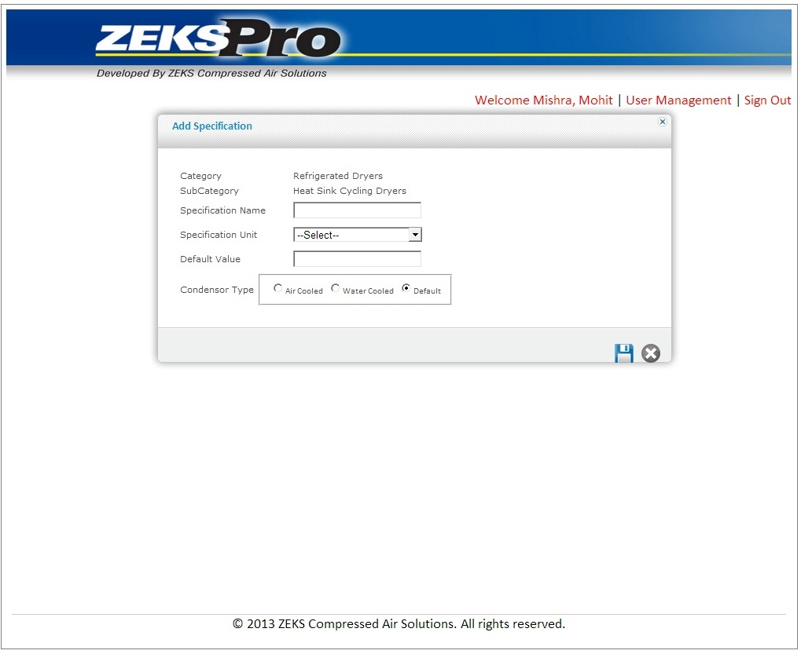

Figure 8: Add New Specification

## Specifications

**User Inputs:**

1. **Specification Name** (Textbox): User will enter specification name here.
2. **Specification Unit** (Dropdown): User will select specification unit here. This dropdown will contain these values.

* $
* ˚F
* KG.
* SCFM
* KW
* HOURS
* TEXT(There would be no Unit)

Chris (11/04/2013): I think the choices from the pull down should be documented here.

TCS (11/07/2013): Done

Chris (11/11/2013): If these “types” of specifications are critical to the functionality of the program, then other specification types like “kW”, “HP”, etc would likely be needed. How are these “Specification Types” used in the program?

TCS (11/12/2013): OK, We have changed specification type to Specification Unit.

1. **Default Value** (Textbox): User will enter the default value of specification.
2. **Air Cooled/Water Cooled/Default (**Radio Button**):** User needs to select particular radio button.

**Buttons:**

1. **Save** (Button): If the user clicks save button, Popup window will get disappeared and Specification Details corresponding to that category and sub-category will get saved in database.
2. **Cancel** (Button): On clicking Cancel button pop up window will close and previous page will be shown to user.

**Validations:**

1. If user clicks save button without putting any value in specification and Default Value textbox a message will be displayed “Please enter Specification Name/ Default value.”
2. If user clicks save button without selecting any value from specification type dropdown a message will be displayed “Please select Specification type.”

## Add New Model

## Purpose

For adding new Model, User has to select category, sub-category and Model Details from Choose Option dropdown and click on **Add** button.

When User clicks Add New Model button, then pop up screen will open which contains Sizing Conditions, Specification with default values as defined for the sub category. User can override the default values for sizing conditions and specifications and save.

Here user can add a new model along with Specification data for a particular category and subcategory. There will be some by default specifications added to a subcategory whose values will be entered by the user here. Based on those specifications, models will be selected in client application. User will also have a provision to upload either the documents or instructions and images along with the model which will be reflected in the quotation generated by the client application.

## Called from/by

This popup screen appears when User clicks on Add button after selecting category, subcategory and Model Specifications from Choose Option dropdown.

## Layout

This will be a dynamic screen and below figure is showing some sample controls. User can upload either documents or can enter the manual instructions. When User selects manual instructions below screen is shown. In the below screen, we have shown Sizing Condition controls only for **Refrigerated Dryer Category**, these controls will change category to category.

Chris (11/04/2013) : Need to discuss why this is a default field for each product

TCS (11/07/2013): These Sizing conditions fields are only for Refrigerated Dryers

When user selects Upload document below screen will be shown

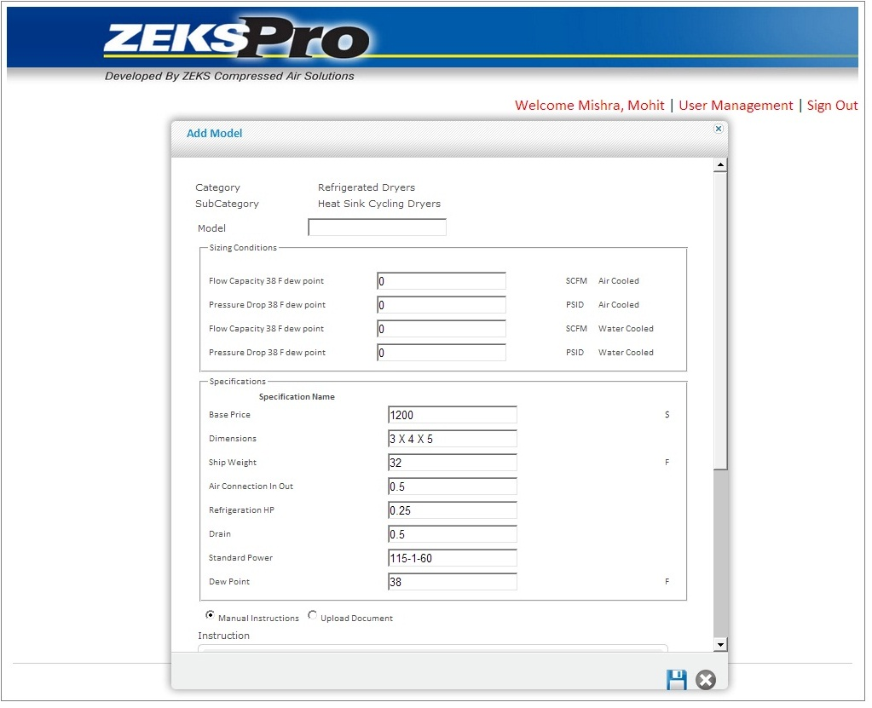

Figure 9: Add New Model

## Specifications

.**Radio buttons:**

User can specify whether the condenser is Air Cooled or Water Cooled for that particular model.

Chris (11/04/2013): I appreciate that some distinction for air vs. Water cooled is necessary. However, other products have other sizing criteria. For example, filters have no dew point associated with them at all. Desiccant dryers are sized on a -40 F dew point. Perhaps some expanded radio buttons are required to trap the characteristics of these other products??? This aspect of the design is going to be the hardest. I don’t know if what I am seeing represents a misunderstanding or a novel approach to the algorithm.

TCS (11/07/2013): Sizing conditions depend on sub category .For filters sub category; a different set of sizing conditions will be defined. Models of different sub category have different sizing conditions. Models of same sub category have same sizing conditions

Chris (11/11/2013): OK. Per Ronak, what I am seeing just below this comment is merely an example of what the sizing conditions look like for a refrigerated air dryer. Other sizing conditions will default for other types of equipment. WE NEED TO REVIEW THE SPECIFIC PRODUCTS AND THEIR SIZING CONDITIONS. AS ZEKS PRODUCTS HAVE EVOLVED SINCE ZEKSPRO 2.12 WAS RELEASED.

TCS (11/12/2013): We are collecting data of Products with their sizing conditions and specifications from existing system.

For Refrigerated Dryer, the user needs to enter values of following sizing conditions-

1. **Flow capacity 38 F dew point** (Textbox): User will enter the flow capacity here. Mandatory field.
2. **Flow capacity 38 F dew point Unit** (Dropdown): User will select the unit of flow capacity here. Mandatory field
3. **38 F dew point pressure drop** (Textbox): User will enter Pressure Drop here. Mandatory field.
4. **38 F dew point pressure drop Unit** (Dropdown): User will select the unit of pressure drophere. Mandatory field.
5. **Flow capacity 38 F dew point** (Textbox): User will enter the flow capacity here. Mandatory field.
6. **Flow capacity 38 F dew point Unit** (Dropdown): User will select the unit of flow capacity here. Mandatory field
7. **38 F dew point pressure drop** (Textbox): User will enter Pressure Drop here. Mandatory field.
8. **38 F dew point pressure drop Unit** (Dropdown): User will select the unit of pressure drophere. Mandatory field.
9. **Flow GPM 38**(Textbox): User needs to enter the value of this specification.
10. **Conn. NPT 1.5** (Textbox): User needs to enter the value of this specification.

For Desiccant Dryer, the user needs to enter values of following sizing conditions-

1. **Fake Area Flow** (Textbox): User will enter the Fake Area Flow value. Mandatory field.
2. **Delta P @rated flow** (Textbox): User will enter Delta P @rated flow value. Mandatory field.
3. **Model ZPA/MPS** (Textbox): User will enter Model ZPA/MPS value. Mandatory field.

For Filtration, the user needs to enter values of following sizing conditions-

1. **Flow** (Textbox): User will enter the Flow value. Mandatory field.

**Other User Inputs:**

User needs to put values in these Specifications

1. **Model number** (Textbox): User will enter model number here. Mandatory field
2. **Base Price** (Textbox):User will enter base price here
3. **Dimensions** (Textbox):User will enter dimensions here
4. **Refrigeration HP**(Textbox):User will enter refrigeration HP here

**Chris (11/04/2013):** I am a little confused. I thought in previous screens, we were defining what the specifications were to be for the subcategory. Yet it seems that these specifications are default specifications for every subcategory. This comment also applies to 3.2.12.4

TCS (11/07/2013): These are example where all these specifications are defined for a sub category. You are right, for each sub category specifications may differ

1. **Ship Weight** (Textbox):User will enter ship weight here
2. **Drain** (Textbox):User will enter drain here
3. **Air Connection In Out** (Textbox):User will enter ait connection in out here
4. **Dew Point** (Textbox):User will enter dew point here

**Radio buttons:**

User can either write the manual specification or can upload the specification document.

1. **Manual Specification (**Rich Textbox**):** User will enter specification manually here. It will be specific to model only**.** These specifications are optional and it will be appear in Quotation as description.

Chris (11/04/2013): Where will these instructions ultimately appear?

TCS (11/07/2013): Specifications can be attached as a MS Word document or manually created on the rich text box.

1. **File Upload** (File dialog box): User can upload specification doc file here (only .doc extension).

**Buttons:**

1. **Image Upload** (File dialog box): User can upload JPEG image file here (only .jpg extension).
2. **Save** (Button): If the user clicks save button, popup window will get disappears and model corresponding to that category and sub-category will get saved in database.
3. **Cancel** (Button): On clicking Cancel button pop up window will close and previous page will be shown to user.

**Validations:**

1. If user clicks **save** button without putting any value in model number textbox a message will be displayed “Please enter Model Number”.
2. User can enter any value in specification section. All values will be considered as a text.

## Add New Optional Equipment

## Purpose

For adding new Optional Equipment, User has to select category, sub-category and Optional Equipment from Choose Option dropdown and click on **Add** button.

User can add new optional equipment within a category and subcategory. User will have a provision of uploading images, documents and instructions relevant to the optional equipment which will be reflected in the quotation generated by the client application.

## Called from/by

This popup screen appears when User clicks on Add button after selecting category, subcategory and Add Optional Equipment from Choose Option dropdown.

## Layout

User can either upload the documents or can enter the manual instructions.

When user selects manual instructions below screen is provided.

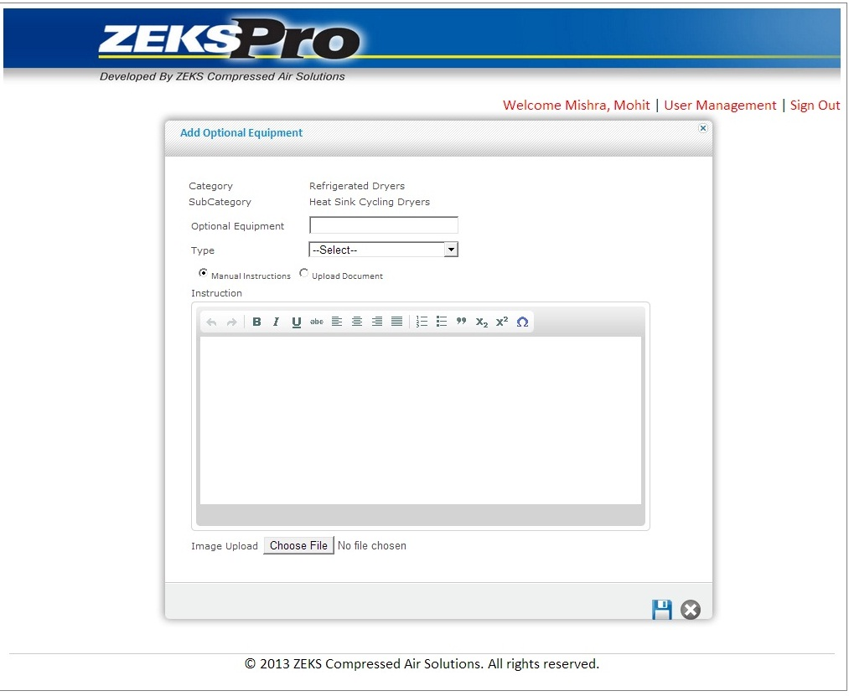

When User selects Upload document below screen is provided.

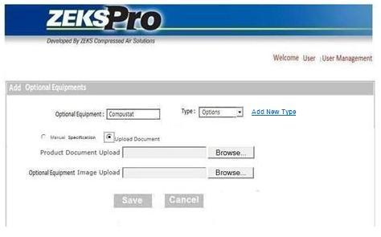

Figure 10: Add New Optional Equipment

## Specifications

**User Inputs:**

1. **Optional Equipment Name** (Textbox): User will enter optional equipment name here. Mandatory field
2. **Type** (Dropdown): User will select type of optional equipment. This will be a mandatory field. Type dropdown will contain these items
   1. Power
   2. Enclosure
   3. Control
   4. Options
   5. Condenser
   6. Filters And Bypasses
   7. Alarm And Accessories
3. **Add New Type** (Link Button): On clicking this button, one control will get appear and user create new optional equipment type there.

**Radio buttons:**

User can either write the specification manually or can upload the Optional Equipment document.

1. **Manual Specifications (**Rich Textbox**):** User will enter specification manually here. It will be specific to model only**.**

Chris (11/04/2013): Where will these instructions ultimately appear?

TCS (11/07/2013): Specifications can be attached as a MS Word document or manually created on the rich text box.

Chris (11/11/2013): Assuming these descriptions will appear at the end of the Specification page under Optional Equipment.

TCS (11/12/2013): OK

1. **File Upload** (File dialog box): User can upload specification doc file here (only .doc extension).

**Buttons:**

1. **Add New Type** (Button): User can add new type of optional equipment here.
2. **Image Upload** (File dialog box): User can upload image (JPEG) file here (only .jpg extension).
3. **Save** (Button): If the user clicks save button, Popup window will get disappears and model corresponding to that category and sub-category will get saved in database.
4. **Cancel** (Button): On clicking Cancel button pop up window will close and previous page will be shown to user.

**Validations:**

1. If user clicks **Submit** button without putting any value in optional Equipment name textbox a message will be displayed “Please enter value in Optional Equipment.”
2. If user clicks **Submit** button without selecting any value in type dropdown a message will be displayed “Please select type.”

## Add Optional Equipment Price

## Purpose

For adding Optional Equipment Price, User has to select category, sub-category and Add Optional Equipment Price from Choose Option dropdown and click on **Add** button.

The main purpose of this screen is to link optional equipment with models and to add price details of optional equipment.

User can link different optional equipments to model and can add the price for particular optional equipment here. User can also define the particular optional equipment will be available with the model or not by checking / unchecking the Add column provided in the grid and only the checked optional equipments will be shown for the particular model in the client application.

## Called from/by

This popup screen appears when User clicks on Add button after selecting category, subcategory and Add Optional Equipment Price from Choose Option dropdown.

## Layout

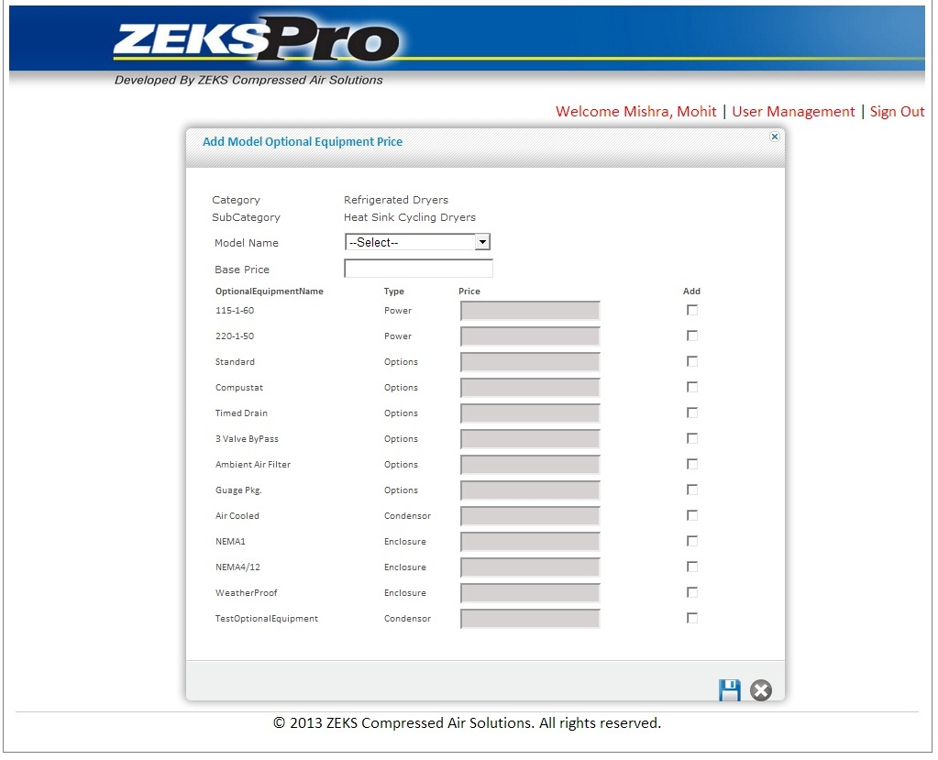

Figure 11: Add Optional Equipment Price

## Specifications

**User Inputs:**

1. **Category**: Will show category (Non Editable)
2. **Sub Category**: Will show sub category (Non Editable)
3. **Model Number** (Dropdown): User will select Model Number here. Mandatory field
4. **Base Price** (Textbox): Will fetch base price of selected model. Auto populated and non-editable field
5. **Optional Equipment Grid**: Application will provide a grid to select related optional Equipments. Price and Add Columns in the grid will be editable. User can enter related price in the price column. If user wants to link optional equipments with model then they needs to click add column. This grid will populate all the optional equipment related with that sub category. It will contain these columns
   1. Optional Equipment
   2. Type
   3. Price
   4. Add (Checkbox column)

**Buttons:**

1. **Save** (Button): If the user clicks save button, popup window will get disappears and price details corresponding to that model and optional equipment will get saved in database.
2. **Cancel** (Button): On clicking Cancel button pop up window will close and previous page will be shown to user.

**Validations:**

1. If user clicks **Submit** button without selecting any item in model number dropdown, a message will be displayed “Please select model.”
2. If user clicks **Submit** button without selecting any value in optional equipment grid, a message will be displayed “Please select at least one optional equipment from grid.”
3. If user clicks **Submit** button without putting any value in price column of optional equipment grid, a message will be displayed “Please enter price for selected optional equipment.
4. User can select as much optional equipment to link it with model and to add price details.

## Export – Bulk Price

## Purpose

For exporting Bulk Price, User has to select category, sub-category and Export Bulk Price from Choose Option dropdown and click on **Export** button.

## Called from/by

This functionality will be available after selecting category and subcategory and if user selects Export Price from Choose Option dropdown and clicks on Export button.

User will have a provision to import price of models in bulk through excel sheets. To import that data, user first needs to download excel template. User can export that template on the basis of search criteria of category and sub category through this menu.

## Layout

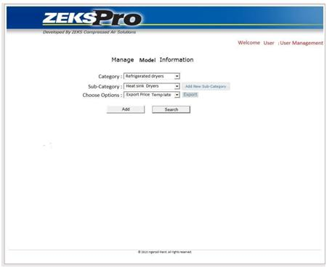

Figure 12: Export Bulk Price

## Specifications

**User Inputs:**

1. **Category** (Dropdown)

User will select category from dropdown.

1. **Sub Category** (Dropdown)

According to selected category, user will be shown subcategories from where user will select a subcategory from subcategory dropdown.

1. **Choose Option** (Dropdown)

User needs to select Export price from choose option dropdown.

**Buttons:**

1. **Export** (Button): If the user clicks **Export** button, file dialog box will open and user can select desired location to save the file and file will exported to that location.

**Validations:**

1. When user select Price Export option in choose option dropdown, Search and Add button will get disabled and Export button will be visible.
2. To import bulk price, user needs to download existing excel template first.

## Import – Bulk Price

## Purpose

For importing Bulk Price, User has to select category, sub-category and Import Bulk Price from Choose Option dropdown and click on **Import** button

## Called from/by

This functionality will be available after selecting category and subcategory and if user selects Import Price from Choose Option dropdown and clicks on Import button.

User will have a provision to import price of models in bulk through excel sheets on the basis of search criteria of category and sub category. User can also save excel template by right clicking on the Import button and save it at a particular location.

## Layout

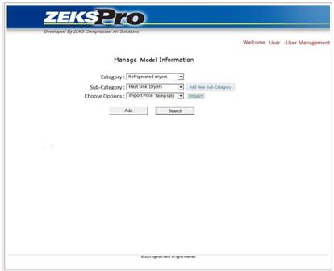

Figure 13: Import Bulk Price

## Specifications

**User Inputs:**

1. **Category** (Dropdown)

User will select category from dropdown.

1. **Sub Category** (Dropdown)

According to selected category, user will be shown subcategories from where user will select a subcategory from subcategory dropdown.

1. **Choose Option** (Dropdown)

User needs to select Import Price from choose option dropdown.

**Buttons:**

1. **Import** (Button): If the user clicks **Import** button, file dialog box will open and user can select desired file to import. Also, User can also save excel template by right clicking on the Import button and save it at a particular location.

Chris (11/04/2013): How will the program know which is the proper file to import? Is there some naming convention of the file name that is generated by the program? I am under the impression it is important for the upload file needs to have specific fields that align with the subcategory.

TCS (11/07/2013): We are providing Export Bulk Price functionality. Before import any Bulk Price, user needs to export the template first on client. After that user needs to fill the template with proper values, after that user can import same spreadsheet file to system.

**Validations:**

1. When user select Price Import option in choose option dropdown, Search and Add button will get disabled and Import button will be visible.
2. To import bulk price, user needs to download existing excel template first.
3. Existing data will get update through this transaction.

## Search Specification

## Purpose

For searching Specification, User has to select category, sub-category and Specification from Choose Option dropdown and click on **Search** button.

## Called from/by

This popup screen appears when User clicks on Search button after selecting category, subcategory and Specification from Choose Option dropdown. Here specification will be shown in grid.

## Layout

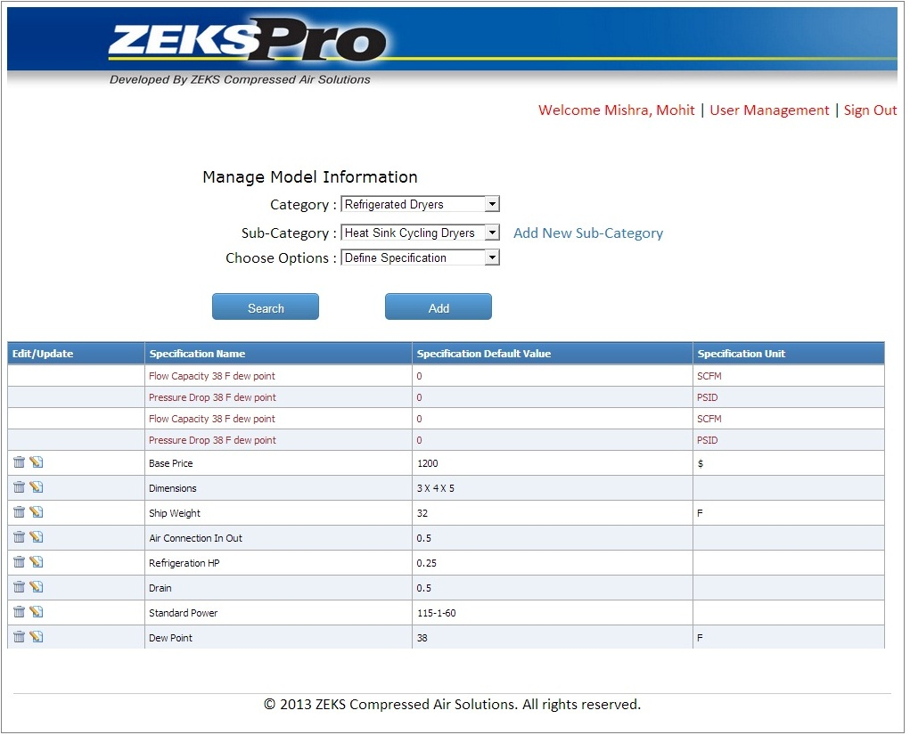

Figure 14: Search Specification

## Specifications

**Grid Details:**

On clicking search button a grid of Specification will open as shown consisting of following columns-

1. Specification Name

It will consist of all the specifications existing in the database.

1. Edit

This Column will consist of Edit link button. To edit any data, user needs to click on it.

1. Delete

This Column will consist of Delete link button. To delete any data, user needs to click on it.

## Search Models

## Purpose

In this screen user can search all models based on combination of category and sub category. Here Model Details will be shown in editable grid and user can edit and save engineering and specification data in bulk in this screen.

## Called from/by

For searching Model Details, User has to select category, sub-category and Model Details from Choose Option dropdown and click on **Search** button.

## Layout

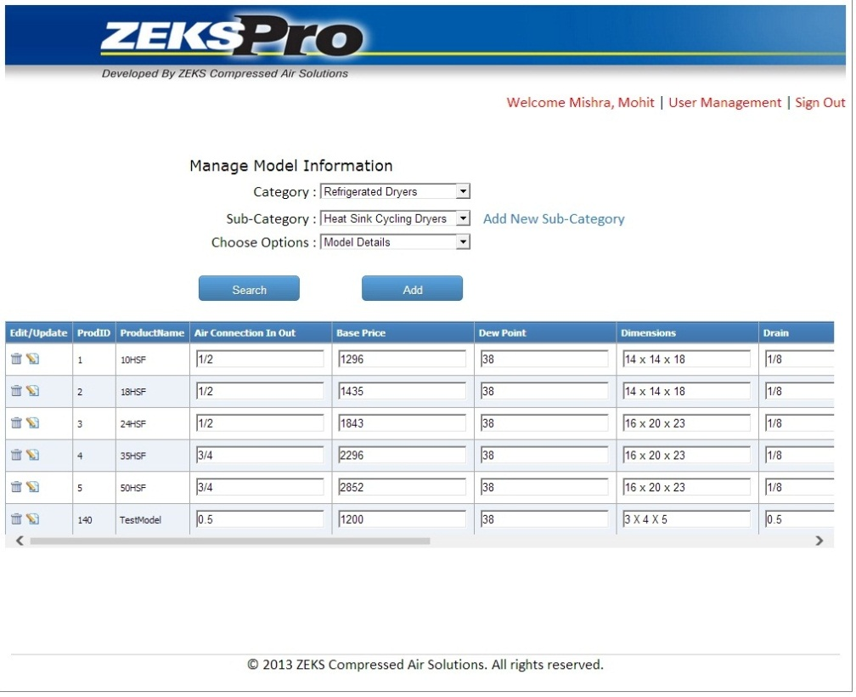

Figure 15: Search Models

## Specifications

**Grid Details:**

On clicking search button a grid of Model details will open. It will show all the Model data corresponding to selected subcategory. Grid will contain following columns.

1. **Model Number**: User can change model number here.
2. **Flow capacity 38 F dew point:** User can change the flow capacity here.
3. **Flow capacity 38 F dew point Unit Type:** User can change the unit type of flow capacity here.
4. **38 F dew point pressure drop:** User can change the Pressure Drop here.
5. **38 F dew point pressure drop Unit Type**: User can change the unit type of pressure drophere. Mandatory field
6. **Dew Point**: User can change the value of dew point here.
7. **Base Price**: User can change base price here
8. **Dimensions**: User can change dimensions here
9. **Refrigeration HP**: User can change refrigeration HP here
10. **Ship Weight**: User can change ship weight here
11. **Drain**: User can change drain here
12. **Air Connection In Out**: User can change air connection in out here
13. **Dew Point**: User can change dew point here.
14. **Edit**: This Column will consist of Edit link button.
15. **Delete**: This Column will consist of Delete link button.

**Buttons:**

1. **Save** (Button):

If the user clicks save button, Model Details corresponding to that category and sub category will get saved in database. After save, the grid will get disappear.

1. **Cancel** (Button):

On clicking Cancel button the grid will get disappear.

**Validations:**

1. If user clicks **save** button without putting any value in Model Number, a message will be displayed “Please enter Model Number.”

## Search Optional Equipments

## Purpose

Here user can select existing optional equipment. User has to select category, sub-category and Optional Equipments from Choose Option dropdown and click on **Search** button. Here Optional Equipments will be shown in grid.

## Called from/by

For searching Optional Equipments, User has to select category, sub-category and Optional Equipments from Choose Option dropdown and click on **Search** button.

## Layout

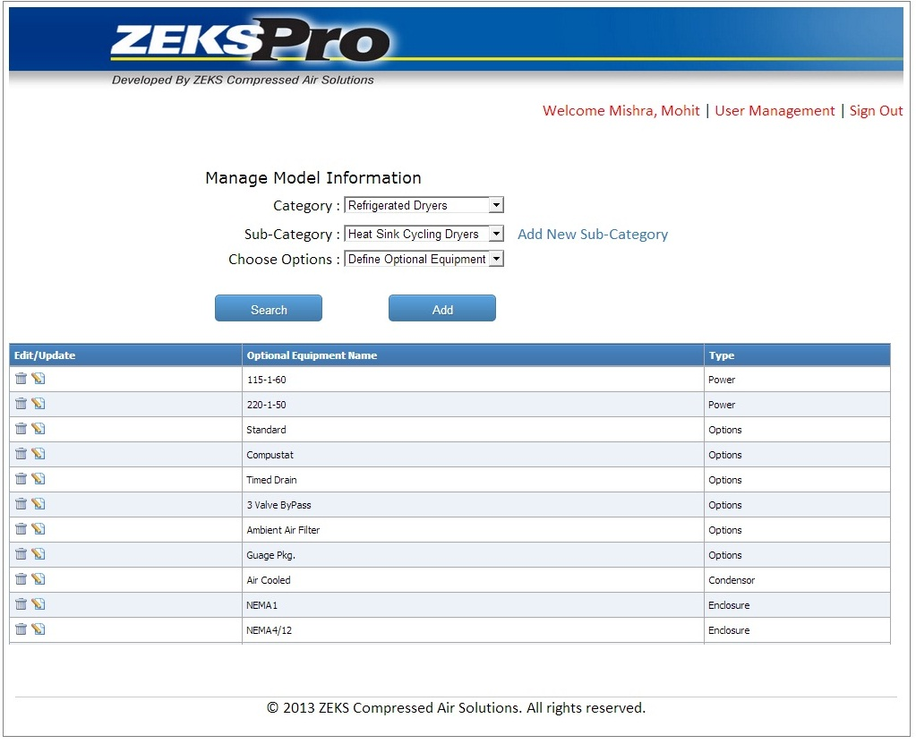

Figure 16: Search Optional Equipments

## Specifications

**Grid Details:**

On clicking search button a grid of Optional equipment will open as shown consisting of following columns-

1. Optional Equipment

It will consist of all the Optional equipment existing in the database.

1. Type

Type of the optional equipments like Power, Enclosure, optional equipments etc.

1. Edit

This column will consist of Edit link button.

1. Delete

This Column will consist of Delete link button.

**Buttons:**

1. **Define Relationship** (Button):

Define Relationship button will become visible as soon as user selects optional equipment in choose option dropdown. If the user clicks Define Relationship button, one pop up screen will get open to define optional equipment relation.

## Define Optional Equipment Relationship

## Purpose

There is an inclusion and exclusion functionality for some type of Optional Equipment like options and control options. We have provided one pop up screen to define this relation.

## Called from/by

To open this popup screen User needs to click on Define Relationship button besides choose option dropdown

## Layout

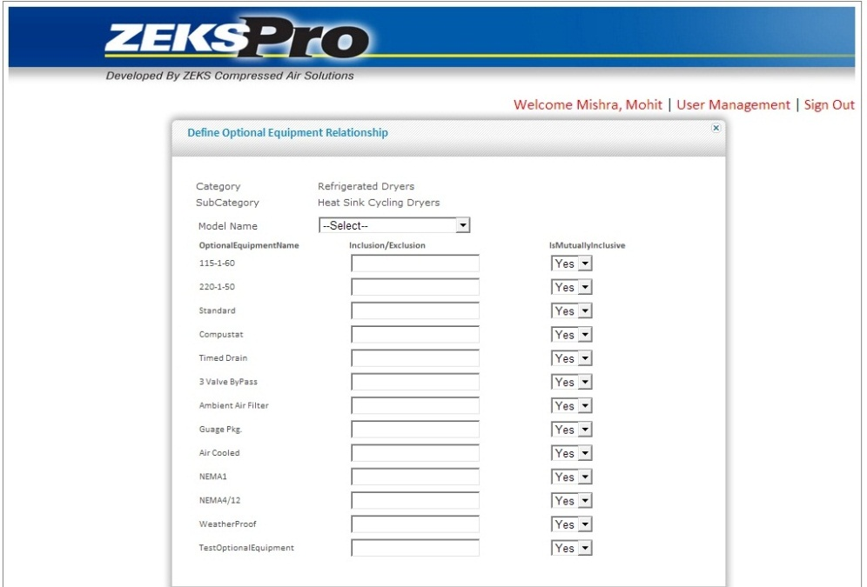

Figure 17: Optional Equipment Relationship

## Specifications

**User Inputs:**

1. **Model (Dropdown):** User will select the model corresponding to which optional equipments are to be mapped.
2. **Type (Dropdown):** User will select type of the optional equipment here.

**Grid Details:**

On clicking Define Relationship button, a grid will details of all optional equipments will open. It will contain these columns.

1. Optional Equipment Name

It will show the entire optional equipment for the selected subcategory.

1. Inclusion/Exclusion

User needs to define relation between optional equipments by putting same value in the text box corresponding to the optional equipments which are inclusive and different value for the optional equipment which is exclusive

For e.g.

* + - If Compustat and Timed drain are inclusive then user should put **1** in both text boxes.
    - If Compustat and Timed drain are exclusive then user should put **-1** in both text boxes as shown in image for Standard.
    - If user put **0** in textboxes that means that optional equipment does not have any relation and they will be considered as normal optional equipment.

1. Flag (Y/N)

If User wants optional equipment inclusive with another optional equipment but does not want vice versa then he needs to put N in the flag column of grid.

For e.g.

* + - If Compustat and Timed drain are inclusive such that when user selects Compustat then Timed drain also gets selected then user has to give Flag Y in corresponding dropdown. But if user wants, when he selects Timed drain then Compustat should not be selected so he needs to put N in front of Timed drain in the column of flag.

**Buttons:**

1. **Save** (Button): If the user clicks save button, Popup window will get disappeared and Relationship corresponding to that Optional Equipments will get saved in database.
2. **Cancel** (Button): On clicking Cancel button pop up window will close and previous page will be shown to user.

**Validations:**

1. If user clicks save button without putting any value in inclusion/exclusion textbox a message will be displayed “Please enter value in inclusion/exclusion textbox.”

## Search Optional Equipment Price

## Purpose

For searching Optional Equipments Price, User has to select category, sub-category and Optional Equipment price from Choose Option dropdown and click on **Search** button. Here Optional Equipments will be shown in grid.

## Called from/by

This popup screen appears when User clicks on Add button after selecting category, subcategory and Optional Equipment Price from Choose Option dropdown.

## Layout

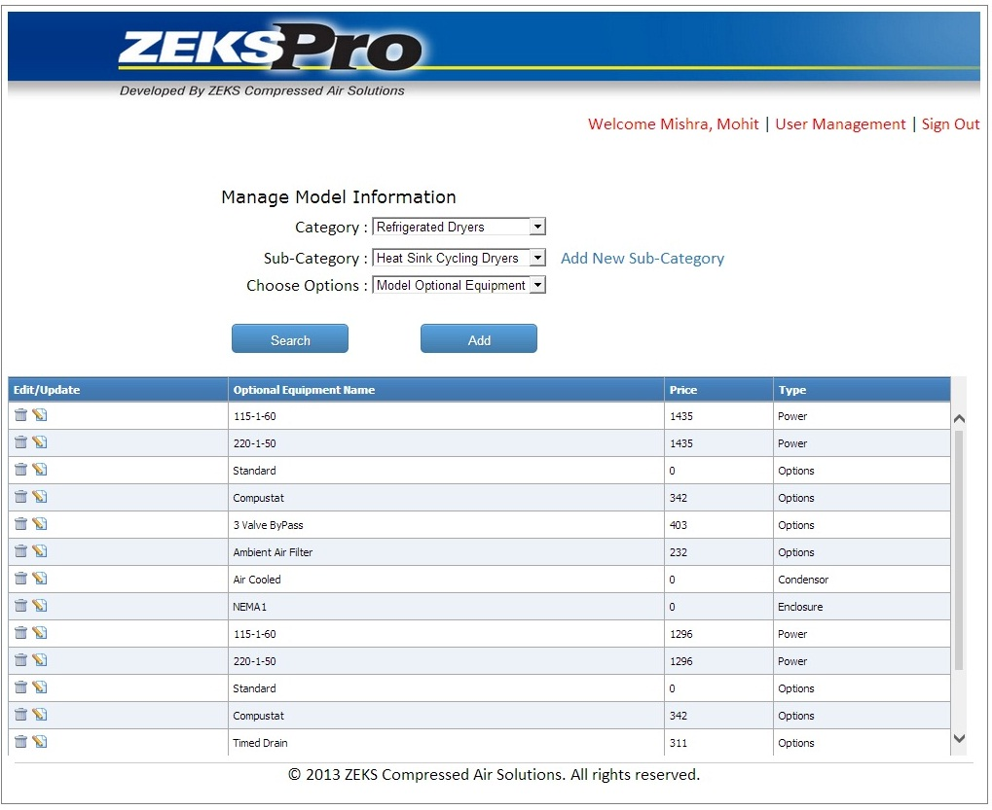

Figure 18: Search Optional Equipment Price

## Specifications

**Grid Details:**

On clicking search button a grid of Optional Equipment Details will open. It will contain these following columns.

1. Model

It will consist of all the Models existing in the database.

1. Optional Equipment Name

It will show the entire optional equipment price for the selected subcategory

1. Type

It will contain all the types of optional equipment price

1. Price

User can edit price details

1. Edit

This column will consist of Edit link button.

1. Delete

This Column will consist of Delete link button.

## Edit Specification

## Purpose

User can edit the existing Specification by clicking on Edit link button provided at the Grid. Here use can edit the data by row by row.

## Called from/by

This popup screen appears after User clicks on Edit link button provided in the Grid of Specification.

## Layout

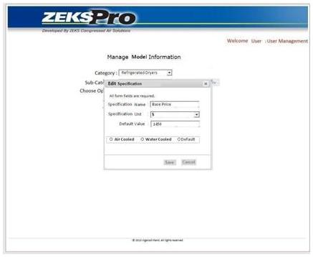

Figure 19: Edit Specification

## Specifications

**User Inputs**

1. **Specification Name** (Textbox): User will enter specification name here.
2. **Specification Unit** (Dropdown): User will select specification unit here. This dropdown will contain these values.

* $
* ˚F
* KG.
* SCFM
* KW
* HOURS
* TEXT(There would be no Unit)

1. **Default Value** (Textbox): User will enter the default value of specification.
2. **Sizing Conditions (**Radio Button**):** User needs to check Sizing Condition radio button if current specification is Sizing Condition.On selecting this Air Cooled/Water Cooled/ Default radio buttons will get enabled.
3. **Specification (**Radio Button**):** User needs to check Specification radio button if it is specification.
4. **Air Cooled/Water Cooled/Default (**Radio Button**):** User needs to select particular radio button.

**Buttons:**

1. **Save** (Button): If the user clicks save button, Popup window will get disappeared and Specification Details corresponding to that category and sub-category will get saved in database.
2. **Cancel** (Button): On clicking Cancel button pop up window will close and previous page will be shown to user.

**Validations:**

1. If user clicks **Submit** button without putting any value in optional Equipment name textbox a message will be displayed “Please enter value in Optional Equipment.”
2. If user clicks **Submit** button without selecting any value in type dropdown a message will be displayed “Please select type.”

## Edit Model Details

## Purpose

User can edit the existing model specification by clicking on Edit link button provided at the Grid of model search.

## Called from/by

This popup screen appears after User clicks on Edit link button provided at the Grid of Model specification.

User can edit Sizing Conditions and their unit type. User can edit the Specifications, Instruction and can change the documents, images for a particular model.

## Layout

This will be a dynamic screen and below figure is showing some sample controls. When User will select Manual instructions below screen will be shown to the user. In the below screen, we have shown Sizing Condition controls only for **Refrigerated Dryer category**, these controls will change category to category.

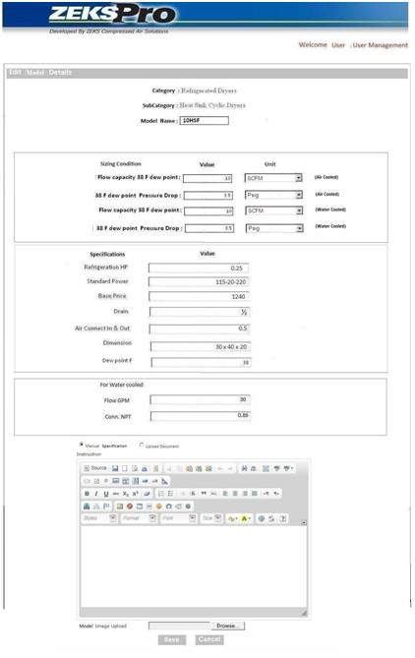

When user will select Upload document then this screen will be shown to the user.

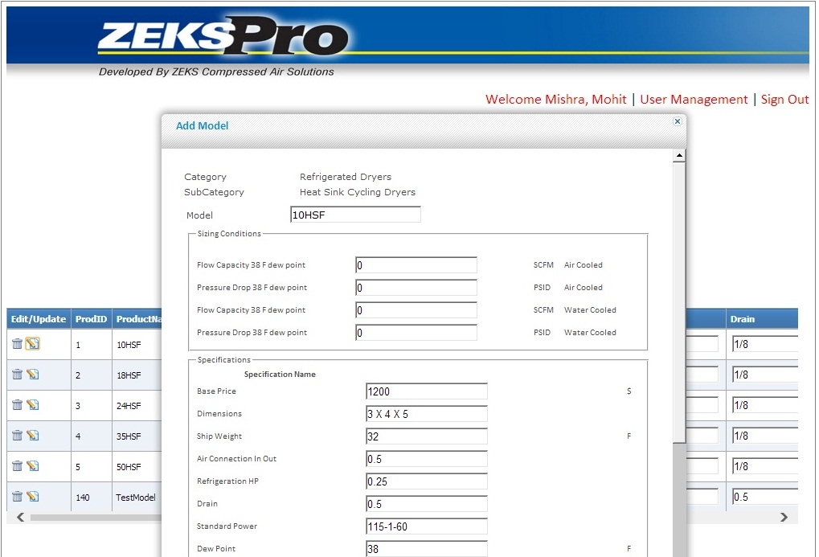

Figure 20: Edit Model Details

## Specifications

**Radio buttons:**

User can specify whether the condenser is Air Cooled or Water Cooled for that particular model.

For Refrigerated Dryer, the user needs to enter values of following sizing conditions-

1. **Flow capacity 38 F dew point** (Textbox): User will enter the flow capacity here. Mandatory field.
2. **Flow capacity 38 F dew point Unit** (Dropdown): User will select the unit of flow capacity here. Mandatory field
3. **38 F dew point pressure drop** (Textbox): User will enter Pressure Drop here. Mandatory field.
4. **38 F dew point pressure drop Unit** (Dropdown): User will select the unit of pressure drophere. Mandatory field.
5. **Flow capacity 38 F dew point** (Textbox): User will enter the flow capacity here. Mandatory field.
6. **Flow capacity 38 F dew point Unit** (Dropdown): User will select the unit of flow capacity here. Mandatory field
7. **38 F dew point pressure drop** (Textbox): User will enter Pressure Drop here. Mandatory field.
8. **38 F dew point pressure drop Unit** (Dropdown): User will select the unit of pressure drophere. Mandatory field.
9. **Flow GPM 38**(Textbox): User needs to enter the value of this specification.
10. **Conn. NPT 1.5** (Textbox): User needs to enter the value of this specification.

For Desiccant Dryer, the user needs to enter values of following sizing conditions-

1. **Fake Area Flow** (Textbox): User will enter the Fake Area Flow value. Mandatory field.
2. **Delta P @rated flow** (Textbox): User will enter Delta P @rated flow value. Mandatory field.
3. **Model ZPA/MPS** (Textbox): User will enter Model ZPA/MPS value. Mandatory field.

For Filtration, the user needs to enter values of following sizing conditions-

1. **Flow** (Textbox): User will enter the Flow value. Mandatory field.

**Other User Inputs:**

User needs to put values in these Specifications

1. **Model Number** (Textbox): User will enter model number here. Mandatory field
2. **Base Price** (Textbox):User will enter base price here
3. **Dimensions** (Textbox):User will enter dimensions here
4. **Refrigeration HP**(Textbox):User will enter refrigeration HP here
5. **Ship Weight** (Textbox):User will enter ship weight here
6. **Drain** (Textbox):User will enter drain here
7. **Air Connection In Out** (Textbox):User will enter ait connection in out here
8. **Dew Point** (Textbox):User will enter dew point here

**Radio buttons:**

User can either edit the manual specification or can change the uploaded Model document.

1. **Manual Specification (**Rich Textbox**):** User will enter specification manually here. It will be specific to model only**.** These specifications are optional and it will be appear in Quotation as description.
2. **File Upload** (File dialog box): User can upload specification doc file here (only .doc extension).

**Buttons:**

1. **Image Upload** (File dialog box): User can upload JPEG image file here (only.jpg extension).
2. **Save** (Button): If the user clicks save button, Popup window will get disappears and model corresponding to that category and sub-category will get saved in database.
3. **Cancel** (Button): On clicking Cancel button pop up window will close and previous page will be shown to user.

**Validations:**

1. If user clicks **save** button without putting any value in model number textbox a message will be displayed “Please enter value in Model Number”.

## Edit Optional Equipment Details

## Purpose

User can edit the existing Optional Equipment by clicking on Edit link button provided at the Grid of Optional equipment.

User can edit optional equipment within a category and subcategory. User will have a provision of uploading images, documents and instructions relevant to the optional equipment which will be reflected in the quotation generated by the client application.

## Called from/by

This popup screen appears after User clicks on Edit link button provided at the Grid of Optional equipment.

## Layout

When User will select Manual instructions then this screen will be shown to the user.

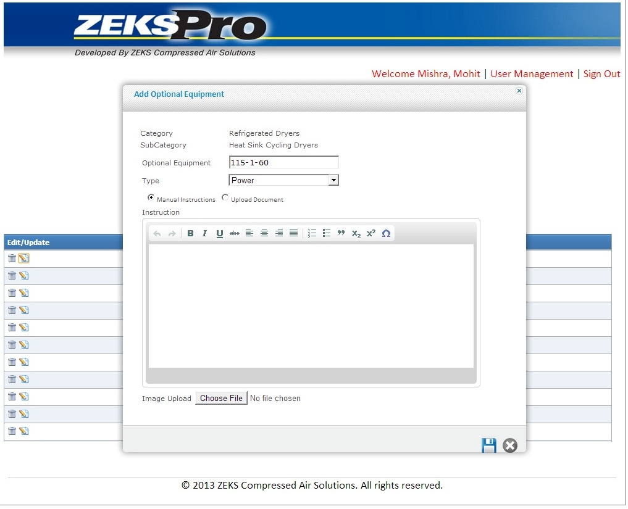

When User will select Upload Document then this screen will be shown to the user.

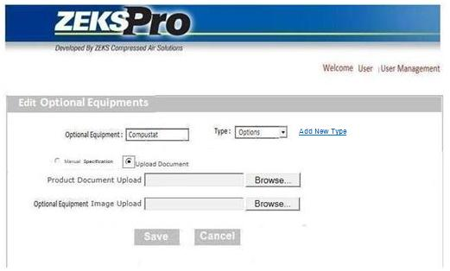

Figure 21: Edit Optional Equipment Details

## Specifications

**User Inputs:**

1. **Optional Equipment Name** (Textbox): User will enter optional equipment name here. Mandatory field
2. **Type** (Dropdown): User will select type of optional equipment. This will be a mandatory field. Type dropdown will contain these items
   1. Power
   2. Enclosure
   3. Control
   4. Options
   5. Condenser
   6. Filters And Bypasses
   7. Alarm And Accessories
3. **Add New Type** (Link Button): On clicking this button, one textbox will get appear and user create new optional equipment type there.

**Radio buttons:**

User can either edit the specification manually or can change the uploaded Optional Equipment document.

1. **Manual Specification (**Rich Textbox**):** User will enter specification manually here. It will be specific to model only**.**
2. **File Upload** (File dialog box): User can upload specification doc file here (only .doc extension).

**Buttons:**

1. **Image Upload** (File dialog box): User can upload JPEG image file here (only .jpg extension).
2. **Save** (Button): If the user clicks save button, Popup window will get disappears and model corresponding to that category and sub-category will get saved in database.
3. **Cancel** (Button): On clicking Cancel button pop up window will close and previous page will be shown to user.

**Validations:**

1. If user clicks **Submit** button without putting any value in optional Equipment name textbox a message will be displayed “Please enter value in Optional Equipment.”
2. If user clicks **Submit** button without selecting any value in type dropdown a message will be displayed “Please select type.”

## Edit Optional Equipment Price

## Purpose

The main purpose of this screen is to edit and link optional equipment with models and to add price details of optional equipment.

User can edit the price for particular optional equipment here. User can also change that the particular optional equipment will be available with the model or not by checking / unchecking the Add column provided in the grid and only the checked optional equipments will be shown for the particular model in the client application.

## Called from/by

This popup screen appears after User clicks on Edit link button provided at the Grid of Optional Equipment Price.

## Layout

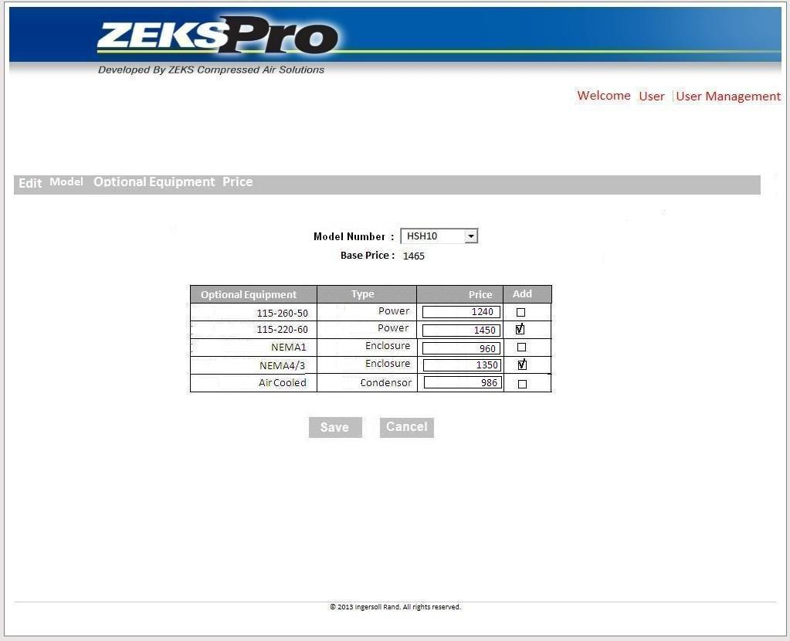

Figure 22: Edit Optional Equipment Price

## Specifications

**User Inputs:**

1. **Category**: Will show category (Non Editable)
2. **Sub Category**: Will show sub category (Non Editable)
3. **Model number** (Dropdown): User will select Model number here. Mandatory field
4. **Base Price** (Textbox): Will fetch base price of selected model. Auto populated and non-editable field
5. **Optional Equipment Grid**: Application will provide a grid to select related optional. This grid will populate all the optional equipment related with that sub category. It will contain these columns
   1. Optional Equipment
   2. Type
   3. Price
   4. Add (Checkbox column)

**Buttons:**

1. **Save** (Button): If the user clicks save button, Popup window will get disappears and price details corresponding to that model and optional equipment will get saved in database.
2. **Cancel** (Button): On clicking Cancel button pop up window will close and previous page will be shown to user.

**Validations:**

1. If user clicks **Submit** button without selecting any item in model number dropdown, a message will be displayed “Please select model.”
2. If user clicks **Submit** button without selecting any value in optional equipment grid, a message will be displayed “Please select at least one optional equipment from the grid.”
3. If user clicks **Submit** button without putting any value in price column of optional equipment grid, a message will be displayed “Please enter price for selected optional equipment.
4. User can select as much optional equipment to link it with model and to add price details.

## Delete Model Details/Optional Equipment/Optional Equipment Price Details/Model Specification

## Purpose

There is Delete link button provided in search grid of every transaction. The main purpose of this delete link is to delete existing data. The delete link will be available for these transactions.

* 1. Model Specification Details
  2. Model Details
  3. Optional Equipment Details
  4. Optional Equipment Price Details

## Called from/by

If user clicks Delete link in the grid then message box will open asking for confirmation of deletion of corresponding item.

## Layout

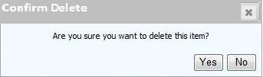

Figure 23: Delete functionality

## Specifications

**User Inputs:**

1. Confirmation Message Box: This message box will contain two buttons, Yes and No.

**Validations:**

1. If User clicks **yes** then corresponding item will be deleted from the database as well as from grid.
2. If user clicks No then message box will disappear and user will be again returned to the search grid of corresponding transactions.

## User Management

## Purpose

On this screen the user can add new users. Search functionality is also provided in this screen where user can search another user by entering First Name or Last Name or Corp Id.

## Called from/by

This screen appears if the user clicks User management link provided at the upper right corner of home page.

Here User can search existing users on the basis their Corp Id/First name/Last Name.

## Layout

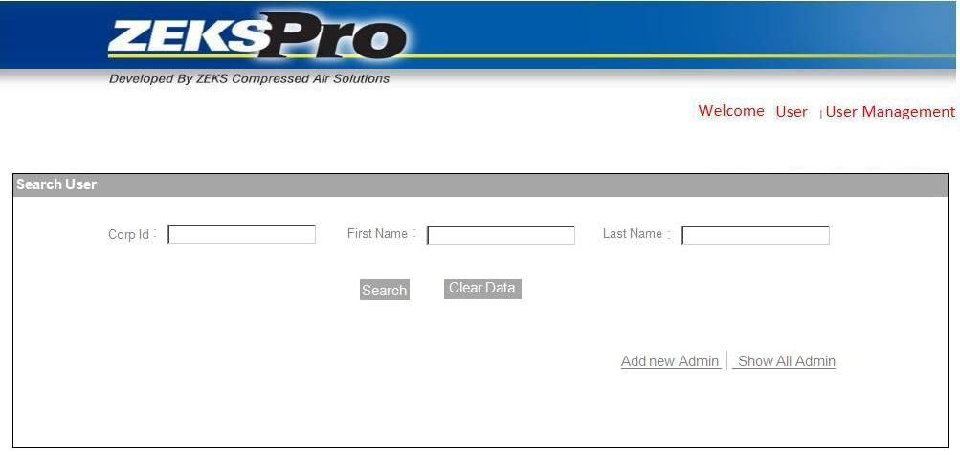

Figure 24: User Management Page

Chris (11/04/2013): What is needed for “Corp ID”? Ronak – Would the intent be the IR sign-on name or does this need to be even tied in to the IR employees ID???

TCS (11/07/2013): The used needs to have a IR Corp ID to login to ZEKS application..

## Specifications

**User Inputs:**

1. **Corp Id** (Textbox): User enters the Corp Id of the user to be searched.
2. **First Name** (Textbox): User enters the First name of the user to be searched.
3. **Last Name** (Textbox): User enters the Last name of the user to be searched.

**Buttons:**

1. **Search** (Button): On clicking Search button User will be shown a grid of existing Users with the details like first name, last name, corp. id etc.
2. **Clear Data** (Button): On clicking Clear Data button details entered by User will be cleared.
3. **Add New Admin** (Link Button): On Clicking Add New Admin link button provided at the bottom of page, a pop up window will open to add new admin user.

## Add New User

## Purpose

On this screen the user can add new admin users, who can use this web application.

## Called from/by

This screen appears if the user clicks on Add New Admin link in User Management page.

Here a pop up window will open asking for the details of the user which admin wants to add.

## Layout

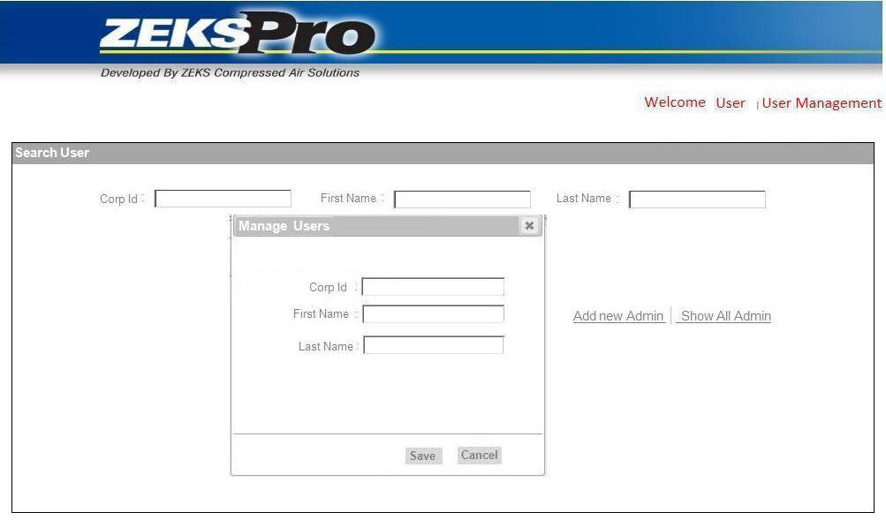

Figure 25: Manage Users

## Specifications

**User Inputs**

1. **Corp Id** (Textbox): User enters the Corp Id of the user.
2. **First Name** (Textbox): User enters the First name of the user.
3. **Last Name** (Textbox): User enters the Last name of the user.

**Buttons**

1. **Save** (Button): After entering the details If User clicks on save button then the details provided by the User will be saved to the database.
2. **Cancel** (Button): On clicking the Cancel button, pop will be closed and previous page will be shown to the user.

**Validations**

1. After clicking submit button; application will check existence of entered user in IR Corporate active directory. If user is not a member of IR domain then he will be added else appropriate message will be shown.
2. After clicking submit button, system will check User Ids for already existence in database. If user is not a member of web application then he will be added else appropriate message will be shown.

## Search Users

## Purpose

On this screen, User will be shown the grid of all the users matching search criteria in the database.

## Called from/by

This screen appears if the user clicks on Search Button in User Management page.

This screen will show the grid of all the users existing in the database.

## Layout

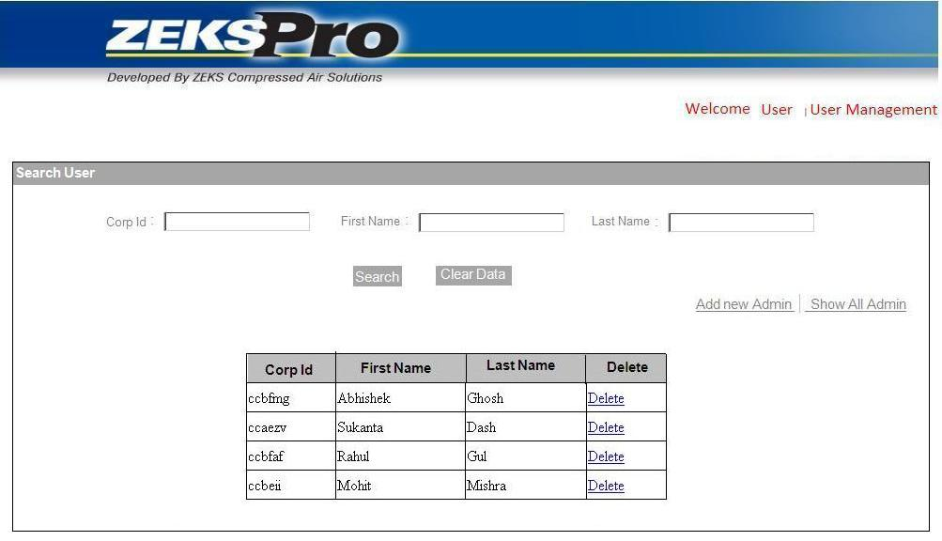

Figure 26: Search Users

## Specifications

**Auto Populate Fields:**

1. **User Details Grid** (Grid View): As the user clicks show button a grid will be shown to the user consisting of the user details. It will contain these columns.
   1. Corp ID
   2. First Name
   3. Last Name
   4. Delete
2. **Delete link in Grid**: If user clicks Delete link in the grid then pop will open asking for confirmation of deletion.

**Validations:**

1. If user clicks Yes in delete confirmation message, then particular item will be deleted from the database as well as grid.
2. If user clicks No in delete confirmation message, then this message box will be closed and again grid will be shown to the user.

## Screens of ZEKS Client Application

**Note: User needs to close first screen while moving one screen to another. Application will prompt a message “Do you want to close first screen”.**

## Splash Screen

## Purpose

The splash screen will invoke by exe automatically. It will disappear after some specific time for e.g. 5 seconds. It will show some useful information.

## Called from/by

It will be called automatically by ZEKSPro Application as soon as exe invoke.

## Layout



Figure 27: Splash Screen

## Specifications

Welcome screen will contain following Information:

* 1. The date of the last update(Label)

This will contain the date when the system was updated last time.

* 1. The date that the pricing within the program is effective.(Label)

It will show the date up to when the pricing will be effective.

* 1. Version Number(Label)

It will display the version number of ZEKS pro system.

* 1. Copyright notice(Label)

It will contain the copyright notice of IR.

* 1. Disclaimer(Label)

Here disclaimer name will be displayed.

## Home Page

## Purpose

Home page will be the first page. It will appear after splash screen and will host menu control.

## Called from/by

Appear automatically after splash screen.

## Layout

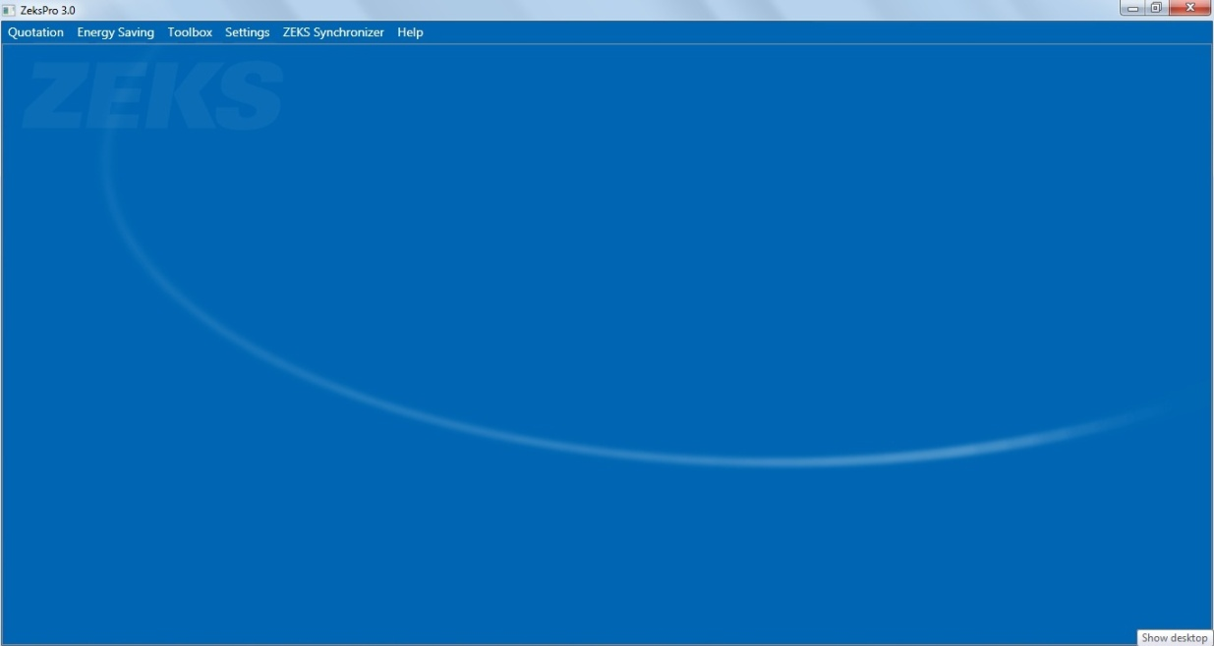

Figure 28: Home Page

## Specifications

We will have these menus on home page.

1. Quotation

Quotation menu will have these sub menus

* New

After click on new menu, it will open the quotation screen and it will also refreshes or clear all the controls and will reset dropdown to default values.

The user will be able to configure and generate quotation of models here. User can also view, print or export the quotation.

* Open

After click on Open menu, file dialog box will open. User can open existing XML quotation data file by selecting this menu. It will open quotation screen and fills data of XML file in controls.

* Save

After click on save menu, file dialog box will open. User can save the data Quotation screen controls as a XML file on selected path.

* Save As

After click on Save As menu, file dialog box will open. User can save existing XML data file with new name.

1. Energy Calculations

This menu provides user with the functionality of Energy Calculations. User has to enter some inputs and according to the formulas energy savings will get calculated.

Chris (11/04/2013): This should be “Energy Calculations”. While savings is a by product of the calcs, it is essentially calculating the cost of the energy needed.

TCS (11/07/2013): Done

1. Toolbox

Toolbox will provide following calculations and conversions.

* Moisture Removal Calculation
* Unit Converter
* ACFM To SCFM Conversion
* Moisture Content of Air
* Cost of Pressure Drop
* ISO 8573.1 – Compressed Air Quality Standards

1. Settings

User will be able to store or to change some constant information which is specific to particular client only. User can store following information

* Logo
* Return Address

Chris (11/04/2013): This section may need more descriptive fields for the user. i.e.: Name, Title. May also need a corporate address in addition to a local address.

TCS (11/07/2013): Done

* Signature

1. ZEKS Synchronizer

User can run synchronize the server data with client data by using this menu.

1. Help

Help menu will show user manual provided by IR. Application will provide basic help to user like purpose of screen.

Note: IR will provide user manual which will be shown in HELP button click.

Chris (11/04/2013): Help menu should include the ability to see the Last Updated Date and Price Effective Date (as the Splash Screen is the only place where this data is currently displayed.

TCS (11/07/2013): IR will provide user manual which will be shown in HELP button click.

Chris (11/11/2013): The point of my comment is that there needs to be some place for the user to be able to determine what version of the program they are running. Yes, we will provide HELP info, but we need to have some means of the users to identify the Last Update and Price Effective Dates other than the momentary splash screen. My request was for this information to be accessible somewhere within the program other than the Splash Screen.

TCS (11/12/2013): We will provide “About ZEKSPro” submenu in Help menu. Under this submenu we can show all details.

## ZEKS Synchronization Process

## Purpose

It will be responsible to download all model details to client machine. This process will get executed automatically as soon as client application started.

## Layout

This is background process; hence no user interface is required.

## Called from/by

This process will be called from these three places

* 1. As soon as client application gets started
  2. When user clicks Synchronize menu on menu bar

Chris (11/04/2013): I did not see where this button would be located. Will it be in the Settings Menu or is it to be somewhere else.

TCS (11/07/2013): Menu Provided

* 1. By Scheduler (Optional)

## Implementation

As soon as client application started, this process will check network connectivity, if network connectivity is there, the process will get executed.

We will add one Timestamp field in each model level data table, when any data gets updated or inserted we will insert the current date and time to the Timestamp field. When the process gets executed, it will check the timestamp of file with timestamp of corresponding table. If any mismatch is found then the daemon will fetch the data and will put it in file system at the particular client location. File Server should be in ZEKS Network to access common file structure.

**Server connectivity is required to fetch the data from server to client place.**

## Quotation

## Purpose

In this screen user can select different categories, subcategories and models. According to inputs, User will be able to generate or preview quotation of selected models. This is a dynamic screen and design of it may differ from model to model.

From Item Listbox, user can select any number of items. User needs to select particular category from category dropdown and based on that category, sub category dropdown will display corresponding sub categories. After selecting particular sub category, models of that sub category will display in model Listbox. User can also select models by putting particular values in sizing conditions controls.

Optional equipment section will display all the optional equipments corresponding to selected sub category. Specification section will display specifications of selected model.

Chris (11/04/2013): Just making sure we are on the same page.....the main purpose of the program is for the user to input the sizing variables and the program select the proper model. The current ZEKSPro permits the user to override the selected model. If too small, it displays an error. Just making sure this is understood.

TCS (11/07/2013): OK

Chris (11/04/2013): The architecture of this program is very dependent on this sentence. ZEKS has several categories of dryers. Refrigerated, Desiccant. Within each category of dryer, there are subcategories. I know this is recognized. But the available optional equipment varies depending on the type of dryer. Within a subcategory, there are HSH dryers which are unique. They are HeatSink Cycling dryers, but they are not like the larger HSF & HSG HeatSink dryers. Does the optional equipment that is displayed need to be confined to a specific subcategory or can it be unique by model. THIS IS SOMETHING WE NEED TO DISCUSS SOONER THAN LATER.

TCS (11/05/2013): Optional equipment are tied with Sub category. So a particular sub category would have all optional equipments defined under that sub category, but the optional equipments price is depended on a model, so for a model, a subset of optional equipments can be shown in quotation page for with price is defined. For a example there are 10 optional equipments defined for a sub category and out of 10 optional equipments 8 optional equipments would have price (0 or more) with respect to model. Then those 8 optional equipments will be visible in quotation for the model.

Chris (11/11/2013): OK. Per Ronak, there will be essentially two ways to determine what will be visible to the user. Either (a) create several specific subcategories that define the optional equipment relative to dryers within that subcategory or (b) create a few, broad subcategories with all options and only price options specific to a particular model. That was our understanding. Just making sure I follow it all.

TCS (11/12/2013): Need to discuss this

## Called from/by

When the user clicks on New submenu of Quotation menu provided in the home page, this form will open.

## Layout

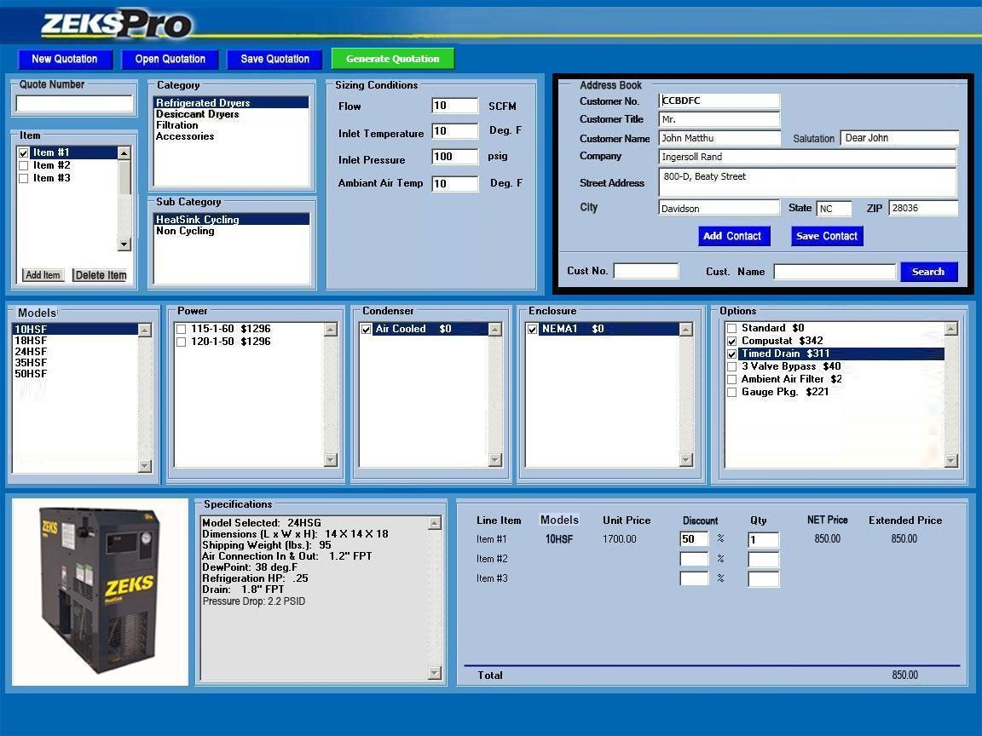

Figure 29: Quotation (This is a dynamic screen and design of it may differ from model to model)

Chris (11/04/2013): May be trivial, but with the revised layout, I am concerned that the user doesn’t confuse saving the quote vs. saving the contacts. As such, the green “Generate Quotation” button on my mock-up was placed to the right corner of the “Sizing Conditions” field. This keeps it over the quote data and NOT over the Address Book. Would like the green button to be placed accordingly. It will still be by itself, but biased towards the quotation portions of the screen

TCS (11/05/2013): Done.

Chris (11/04/2013): As I look at the screen, the screen is divided into three horizontal bands: Top (item, Category, Address Book...), Middle (Models, Options), Bottom (photo, Specs, $$). For the Middle, how will the fields show up when, for example, the dryers do not have a Condenser option type? I would expect to see the Models field fixed (with contents that varies based on the subcategory), but the remaining four fields are not the same for all products. Some may not have four fields worth of info.

TCS (11/05/2013): The Optional fields will not be fixed. We will put these controls in one scrollable panel and that panel will host necessary optional equipments which will be attached to particular product.

Chris (11/11/2013): Per discussion with Ronak, if there are 6 optional fields, the user will use the horizontal scroll bar. If there are only two fields, then there will be blank space to the right of the right-most option field. I’m fine with that. Let me know if I did NOT understand that correctly.

TCS (11/12/2013): Yes Chris, your understanding is correct.

## Specifications

**User Inputs:**

1. **Quote Number** (Textbox): In this textbox User can enter the Quotation Number which provides the user the ability to have the reference to the quotation automatically appear in the quote and keep the quotes organized.
2. **Item** (Listbox): In this section of control User can select number of items which he wants to add in quotation by checking on the checkbox provided before the item. Users can add any number of items. This is an auto growing control.
3. **Category** (Listbox): All the categories saved in the database will be displayed in this section and by default application will select first category, although, user can select the desired category.
4. **Subcategory** (Listbox): After selecting category user will be shown the subcategories corresponding to that category. If Refrigerated Dryers is selected in Category then by default Heat Sink Cycling Sub category will be selected.
5. **Model** (Listbox): As user selects sub category, all the models will be shown in model list box corresponding to category and subcategory. By default first model will be selected.
6. **Options** (Listbox): There will be some options provided to user which he can add to his quotation. User can add options by checking the checkbox provided before options.
7. **Power** (Listbox): There will be some Power options provided to user which he can add to his quotation. User can add Power options by checking the checkbox provided before powers
8. **Condenser** (Listbox): There will be some Condenser provided to user which he can add to his quotation. User can add Condenser by checking the checkbox provided before Condenser.
9. **Enclosure** (Listbox): There will be some Enclosure provided to user which he can add to his quotation. User can add Enclosures by checking the checkbox provided before Enclosures.
10. **Sizing Conditions** (Textboxes): As User selects the model, all the related sizing conditions will be shown. User will enter the sizing conditions and according to the sizing condition corresponding product or model will be selected. As the user changes the sizing conditions model will be changed. Only the applicable sizing conditions for corresponding model or product will be enabled and rest of the conditions which are not applicable will be disabled. All the sizing conditions are editable in textbox type.
11. **Specifications** (TextArea): After selecting model user will be shown the specifications as Model, Design, Dew Point, Air connections, dimensions etc. for the selected product or model. This will be non-editable.
12. **Address Book section**

This section will contain fields for entering the Customer details and there will be also search functionality through which user can search for the existing customer. Following are the section of controls under the Address book-

* **Customer Number** (Text Box): User will enter the customer number.
* **Customer Name** (Text Box): User will enter the customer name.
* **Customer Title** (Text Box): User will enter the Customer title.
* **Salutation** (Text Box): User will enter the salutation comment here.
* **Customer Company** (Text Box): User will enter the Customer Company name.
* **Customer Street Address** (Text Area): User will enter the Customer Address.
* **Customer State Zip** (Text Box): User will enter the customer state Zip.
* **Save Contact** (Button): On clicking the save button all the information provided by the user will be saved in the database
* **Add Contact** (Button): On clicking Add Contact button selected customer will be added to the quotation.
* **Search Functionality**
  + **Customer Number** (Text Box): User will enter the customer number which is to be searched.
  + **Customer Name** (Text Box): User will enter the customer name which is to be searched.
  + **Search** (Button): On clicking search button, one pop up screen will get open and details will be populated there with the searched user information.
* **Price and Discount section** (TextBox): This section will show following fields –
* **Line Item**(Label)

This Column shows the number of items added by the user in the quotation.

* **Model Number**(Label)

Model Number column will assist the user in keeping track which Item represents which product.

* **List price**(Label)

Pricing that is uploaded into ZEKSPro is LIST pricing.  If no item receives a discount, then the resulting quotation would reflect LIST pricing and the heading for the column for the price in the quote should read “LIST PRICING”

* **Discount**(Textbox)

User has ability to put specific discounts on individual line items. Different discounts would be afforded to different line items. Discount added by the user will be reflected in the price calculation.

* **Quantity(Qty)** (Textbox)

In this column user can enter the quantity for the specific model.

* **Net Price**(Label)

If any one of the line items in the Pricing section gets a discount, then the heading for the column for the price in the quote should read, “NET PRICING” and it will be shown in the section.

* **Extended Price**(Label)

This will provide the net price to user after discount.

**Buttons:**

1. **Generate Quotation** (Button): After selecting all the options, if user clicks on Generate Quotation button, it will open one pop up screen and user can view full quotation there. User can save quotation document in Preview Quotation screen.
2. **Save Quotation** (Button): After click on Save Quotation button, file dialog box will open. User can save the data Quotation screen controls as a .zks file on selected path.
3. **New Quotation** (Button): If user wants to start new quotation, he needs to click this button.
4. **Open Quotation** (Button): By clicking this button user can open the existing quotation.
5. **Add Item** (Button): By clicking this button, User can increase the item quantity if needed.
6. **Delete Item** (Button): By clicking this button, User can delete the item quantity.

**Validations:**

1. If user clicks Generate Quotation or Preview Quotation without selecting any category or sub category, a message will be displayed “Please select category.”
2. If the product specification is too small to select by specified sizing criteria, a warning comes up saying the selected product is not large enough.
3. Selection of Model will be depend on these four sizing conditions:
4. Flow
5. Inlet Pressure
6. Inlet Temperature
7. Ambient Temperature

**To select particular model of Refrigerated Dryer Sizer, application will calculate these Steps**

* **Calculate Factors**

Inlet Pressure Factor = (0.00000002*V6*V6*V6) – (0.00002*V6*V6) + (0.0065*V6) + 0.52999

Where V6 = Input value of Inlet Pressure

Inlet Temperature Factor = (20758*V8^-2.16) + 0.0065

Where V8 = Input value of Inlet Temperature

Ambient Temperature Factor = (-0.0165*V10 + 2.6535)-0.003

Where V10 = Input value of Ambient Temperature

*Factor = Inlet Pressure Factor * Inlet Temperature Factor * Ambient Temperature Factor*

* **Need array or table structure of Model Number, Flow Capacity and Pressure Drop (Column C, D, F in Critical Variables-Refrige sheet in ZEKS Dryer Sizer – TCS Copy)**

Array Structure will be

*Model Details = {Model Number, Air Cooled Flow capacity, Air Cooled Pressure Drop}*

* **Need to calculate Air Cooled Customer Conditions (Column G in Critical Variables-Refrige sheet in ZEKS Dryer Sizer – TCS Copy)**

*Flow Capacity of Model * Factor*

* **Need to calculate this calculation (Column K in Critical Variables-Refrige sheet in ZEKS Dryer Sizer – TCS Copy)**

*= ((Input value of Flow / Flow Capacity)^2)*Pressure Drop * ((Input value of Inlet Temperature + 460 ) / (Input value of Inlet Pressure + 14.7)) * ((114.7)/(560))*

* **Need to calculate this condition (Column H in Critical Variables-Refrige sheet in ZEKS Dryer Sizer – TCS Copy)**

*If value of Air Cooled Customer Conditions (Column G) is greater than Input Value of Flow then Consider 5 else 1.*

* **Need to calculate this condition (Column I in Critical Variables-Refrige sheet in ZEKS Dryer Sizer – TCS Copy)**

*If value previous row of Air Cooled Customer Conditions (Column G) is less than Input Value of Flow then Consider 5 else 9.*

* **This is the final condition to select model. (Column A in Critical Variables-Refrige sheet in ZEKS Dryer Sizer – TCS Copy)**

*If (Value of column H + Value of Column I) > 9 AND Value of column K is less than or equal to 5 Then 2 Else 0.*

*Select the first Model from Column A.*

**To select particular model of Desiccant Dryer Sizer, application will calculate these Steps**

* Will refer these constants

C1: -10214.16462 C8: -10440.39708

C2: -4.89350301 C9: -11.2946496

C3: -0.005376579 C10: -0.027022355

C4: 0.000000192023769 C11: 0.00001289036

C5: 0.000000000355758316 C12: -0.000000002478068

C6: -9.03446883E-14 C13: 6.5459673

C7: 4.1635019

Mwgas = 28.967

* **Calculate ACFM (F)**

First to need to calculate ACFM

*ACFM = Inlet Flow * (14.7 / (14.7 + Inlet Pressure)) * ((460+Inlet Temperature) / 530)*

* **Then Need to calculate VEL FLOW (Column K)**

*VEL FLOW = ACFM / Fake AreFlow*

* **Need to calculate Delta P (Column M)**

*Delta P = ((Input value Inlet Flow / Model ZPA MPS) ^2) * Delta P * ((Inlet Temp + 460)/(Inlet Pressure + 14.7)) * 114.7/560*

* **Need to calculate Baseline Moisture (Column N)**

*Baseline Moisture = Model ZPA/MPS * 0.000391875*

* **Need to calculate Pws2**

*=EXP((F97/I93)+F98+(F99*I93)+(F100*I93^2)+(F101*I93^3)+(F102*I93^4)+(F103*LN(I93)))*

* **Need to calculate PWS1**

*=EXP ((I97/I93)+I98+(I99*I93)+(I100*I93^2)+(I101*I93^3)+I102*LN(I93))*

* **Need to calculate Pwsuse**

*=IF (Inlet Temperature < 32, PWS2, PWS1)*

* **Need to calculate Pwsmod**

*=PwsUse*EXP (0.02708*((Inlet Pressure + 14.69) - PwsUse)/( Inlet Temperature + 459.67))*

* **Calculation of Work Load**

*=18.016 * PwsMod / (Mwgas * ((Inlet Pressure + 14.69) - PwsMod))*

* **Calculate Moisture**

*Moisture = Inlet Flow* WLoad * 0.075*

* **This is Final condition**

*If (Value of column K) <= 66 AND Value of column M is less than or equal to 5 AND if value of column N is greater than value of column O – 0.01 Then Good Else Bad.*

*Select model from column B.*

**To select particular model of Filtration, application will calculate these Steps**

* **Will refer these constants**

***Criteria Grade Delta P***

*Sufficient flow capacity P 0.5*

*Pressure Drop 3 psi or less G 1*

*Temp only included as a not-to-exceed 120 °F error. H 1.5*

**Calculation for ZTF Filters**

* **Calculation of @100 psig Delta P (Column Q)**

*IF Element Grade = "P" Then 0.5 Else IF Element Grade = "G" Then 1 Else IF Element Grade = "H" Then 1.5 Else 1*

* **Calculation of Delta P (Column T)**

*((User Input Flow / Flow) ^ 2) * @100 psig Delta P * ((100 + 460) / (Pressure + 14.7)) * ((100 + 14.7)/(100 + 460))*

* **Calculation of Delta P ? (Column V)**

*IF Delta P < (Max Delta P for sizing + 0.01) then 2 Else 1*

* **In case of ZTF Filters Max Delta P for Sizing is 3**
* **Calculation of Output (Column K2)**

*0.1027 * Pressure ^ 0.4943*

* **Calculation of Flow (Column S)**

*Output * Flow*

* **Calculation of Flow? (Column U)**

*If Calculation of Flow < User Input Flow Then 1 else 2*

* **Final Calculation**

*If (Flow ? + Delta P?) < 4 Then N Else Y*

* **Selection of Model**
* **Select the second column where Result = Y**

**Calculation for Mist Eliminators**

* **Calculation of @100 psig Delta P (Column Q)**

We are considering Delta P as constant value (0.5)

* **Calculation of Delta P (Column T)**

((User Input Flow / Flow) ^ 2) * @100 psig Delta P * ((100 + 460) / (Pressure + 14.7)) * ((100 + 14.7)/(100 + 460))

* **Calculation of Delta P ? (Column V)**

IF Delta P < (Max Delta P for sizing + 0.01) then 2 Else 1

In case of Mist Eliminator Max Delta P for Sizing is 1

* **Calculation of Output (Column K2)**

*0.0087 * Pressure ^ 0.1282*

* **Calculation of Flow (Column S)**

*Output * Flow*

* **Calculation of Flow ? (Column U)**

*If Calculation of Flow < User Input Flow Then 1 else 2*

* **Final Calculation**

*If (Flow ? + Delta P?) < 4 Then N Else Y*

* **Selection of Model**

*Select the second column where Result = Y*

**Calculation for F - Cast Filters**

* **Calculation of @100 psig Delta P (Column Q)**

*IF Element Grade = "P" Then 0.5 Else IF Element Grade = "G" Then 1 Else IF Element Grade = "H" Then 1.5 Else 1*

* **Calculation of Delta P (Column T)**

*((User Input Flow / Flow) ^ 2) * @100 psig Delta P * ((100 + 460) / (Pressure + 14.7)) * ((100 + 14.7)/(100 + 460))*

* **Calculation of Delta P ? (Column V)**

*IF Delta P < (Max Delta P for sizing + 0.01) then 2 Else 1*

*In case of F - Cast Filters Max Delta P for Sizing is 3*

* **Calculation of Output (Column K2)**

*0.0979 * Pressure ^ 0.5022*

* **Calculation of Flow (Column S)**

*Output * Flow*

* **Calculation of Flow ? (Column U)**

*If Calculation of Flow < 100 Then 1 else 2*

* **Final Calculation**

*If (Flow ? + Delta P?) < 4 Then N Else Y*

* **Selection of Model**
* **Select the second column where Result = Y**

Chris (11/04/2013): I have NOT validated the math in the balance of this section. If I need to at this juncture, please let me know.

TCS (11/07/2013): We have put these formulas from spreadsheet provided by you. Please compare these formulas with spreadsheet.

Chris (11/11/2013): I recognize the requirement but have not reviewed every line. I will make it a point to do so shortly.

TCS (11/12/2013): OK

## Quotation Preview

## Purpose

In this tab user will be able to preview the quotation of the model selected. Here User can Preview the whole Quotation for the model and options selected.

## Called from/by

When the user clicks on the Preview Quotation button provided at the bottom in the Quotation page then Quotation Preview page will open and by default its first vertical tab Preview will be opened.

## Layout

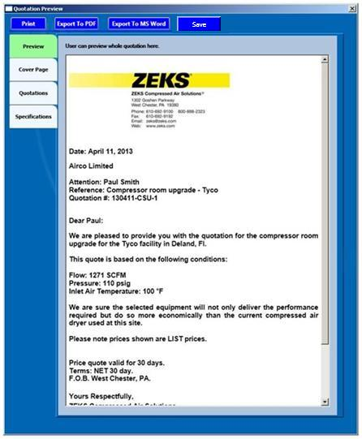

Figure 30: Preview Quotation

Chris (11/04/2013): Across the top of this screen, I would like the user to be able to: Print the quotation, Export the quotation to PDF, Export the quotation to MS Word, Save the Quotation. When exporting the file to PDF or MS Word, I would like the user to first get a dialog box saying “Do you first wish to save this quotation in ZEKSPro before {exporting to PDF} / {exporting to MS Word}? I would not want someone to export the file, thinking they can always just open up the program. The Save Quotation needs to be here as well as the previous Quotation Screen, as the user can add new information to the Cover Page here that would not have been saved up to this point.

TCS (11/07/2013): Done

Chris (11/04/2013): The layout looks very nice. Would like to minimize the tab width so that the user has as wide of a view of the quote as possible.

TCS (11/07/2013): OK

Chris (11/11/2013): Still need the SAVE QUOTATION button on the top. What happens when the user clicks the “X” in the upper right hand corner of this screen?

TCS (11/12/2013): When use clicks X button and if user has edited cover page then user will be shown confirmation message to close it.

## Specifications

**Buttons:**

1. **Print** (Button)

On clicking print button, user will get default print dialog box, user needs to select particular printer, and user can print the quotation after clicking print button on that dialog box only. User will get a message box with message “Do you wish to save this quotation in ZEKSPro before print the quotation.”

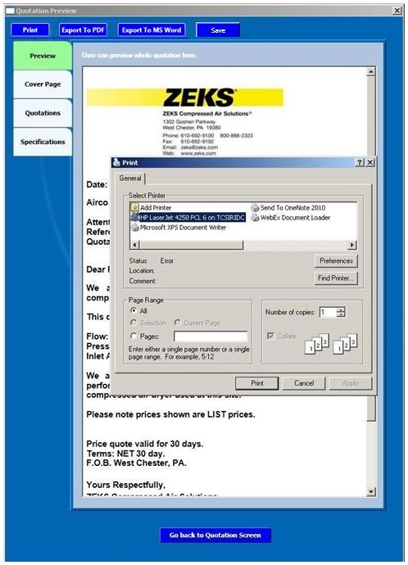

Figure 31: Print Quotation

Chris (11/11/2013): Ronak had a more streamlined approach to insuring the user saves their document (or at least is reminded to save their document) to ZEKSPro that is less intrusive than my original proposal. Please get with him and use his approach.

TCS (11/12/2013): Need to discuss this with Ronak

1. **Export To PDF** (Button)

On clicking this button user will get one file dialog box to select location, after selecting location the quotation will export to desired location in PDF format. Prior to exporting to PDF, user will be prompted to save their file to ZEKSPro. User will get a message box with message “Do you wish to save this quotation in ZEKSPro before print the export.”

1. **Export To MS Word** (Button)

After Clicking this button would launch the users MS Word and the file would appear in that program for editing.

1. **Save Quotation** (Button)

On clicking this button user will get save file dialog box to select location, after selecting location the quotation will get saved in selected location in .zks format.

1. **Go Back to Quotation Screen** (Button)

On clicking this button user will be redirected to the Quotation page.

Note: user will be prompted to save their file to ZEKSPro prior to Export File to PDF and MS Word.

Chris (11/11/2013): This button is not on all of your screen shots. Perhaps it was truncated on the previous screen shot.

TCS (11/12/2013): That’s true Chris, it is truncated in previous screens.

Chris (11/04/2013): Prior to exporting the PDF, user needs to be prompted to save their file to ZEKSPro. Should the user want to make a change on the quote, they would be out of luck if they did not do that.

TCS (11/05/2013): Done

Chris (11/04/2013): This button is not required here. The quotation has already been generated.

TCS (11/05/2013): Done

Chris (11/04/2013): Having the ability to save the quote to ZEKSPro would be good before proceeding in case the user wanted to keep the quote in ZEKSPro before going to ZEKSPro.

TCS (11/05/2013): Done

Chris (11/04/2013): An “Export to MS Word” button would be needed here. Clicking this button would launch the users MS Word and the file would appear in that program for editing. The user would use MS Word save feature to save the MS Word document to their hard drive.

TCS (11/05/2013): Done

## Quotation Cover Page

## Purpose

In this tab User will be able to see the Cover page of the quotation and will be able to modify it, remaining tabs will not be editable.

The standard sentences of quotation will be stored in XML file and these values will be shown on cover page of Quotation.

User can create doc file after clicking Generate Quotation Document button.

User can also edit pre-populated fields in cover page.

## Called from/by

When User clicks on the second horizontal tab of the Quotation Preview tab (Cover Page) then this tab will be shown.

## Layout

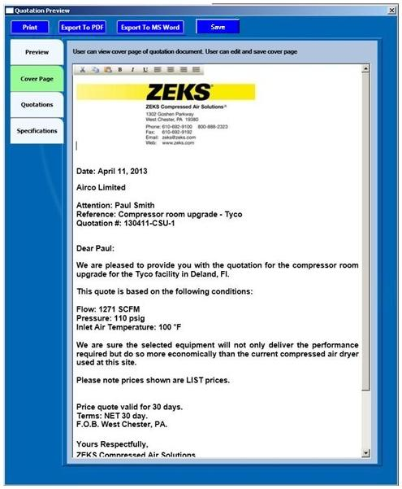

Figure 32: Cover Page

## Specifications

**User Inputs:**

1. **Cover Page** (Rich Text Box): This rich text box will contain cover page of quotation, user can edit it.

Chris (11/04/2013): Since some of the fields will be populated by fields elsewhere in the program (customer name / address, user signature, etc), are these going to be overwritable? I am not requesting that such functionality be required, but if the program is to prepopulate fields in this screen, wouldn’t that make those prepopulated fields uneditable? I would like the mechanics of how this works documented here.

TCS (11/05/2013): It is not possible to keep one part editable and other part non editable.

Chris (11/11/2013): My understanding from Ronak is that an “object” will be created from the initial information and after that, the cover page will be fully editable. This is fine.

TCS (11/12/2013): OK

**Buttons:**

1. **Save** (Button): Since this tab is editable, so user can modify this page accordingly and clicking on save button will save the changes to the quotation.
2. **Tool Strip:** We will provide functionality of Cut, Copy, Paste and Alignment here which will be applicable only for cover page.

## Model Quotation

## Purpose

In this page user will be shown the details of the models, options, quantity and price which were selected by the user earlier.

## Called from/by

When User clicks on the third horizontal tab of the Quotation Preview tab control then this tab will be shown.

## Layout

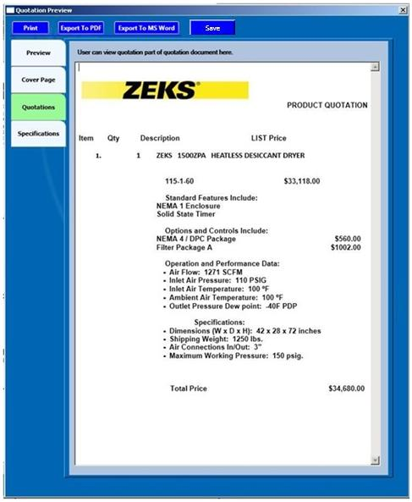

Figure 33: Model Quotation

## Quotation Specification

## Purpose

In this tab user will be shown about the specification of the model and option selected at time of quotation generation.

## Called from/by

When User clicks on the fourth horizontal tab of the Quotation Preview tab control then this tab will be shown.

## Layout

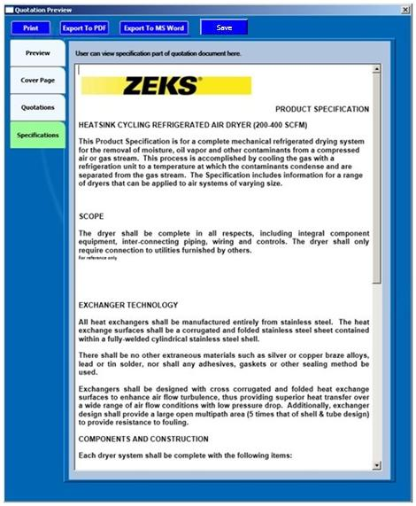

Figure 34: Specification Tab

## Energy Calculations

## Purpose

This menu provides user with the functionality of Energy Saving Calculations. User has to enter some inputs and according to the formulas energy savings will get calculated.

User can select multiple dryers from the Listbox. User needs to click calculate button, to view the output grid. We are only providing calculation of the dryers, whose calculation / formulas are provided by client.

From the Excel-based version of the Dryer Sizer, it will show the Compressed Air Cost. Prefer to show it to the right of the kW Cost / Hr field. It would recalculate once the user entered a new $/kWh cost.

## Called from/by

It is called when the User clicks on Energy Calculations menu provided in the Home page.

## Layout

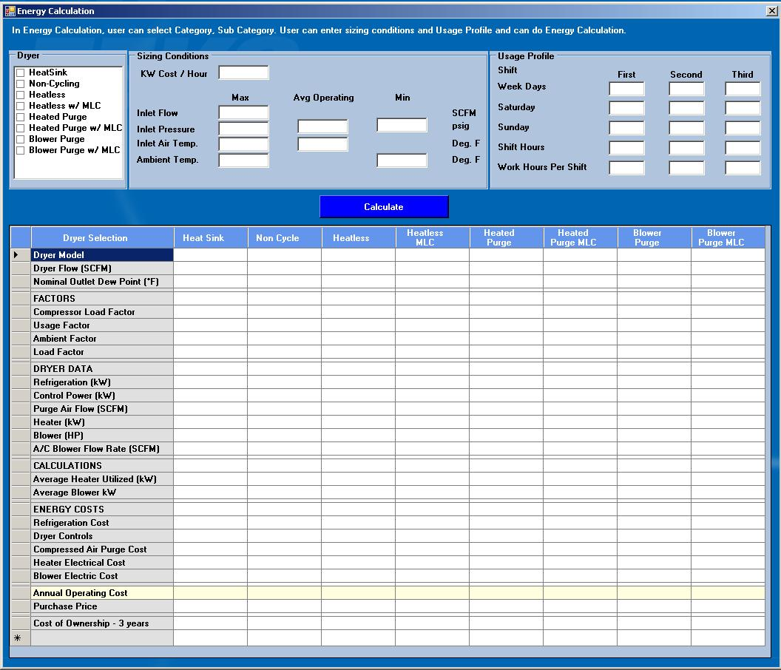

Figure 35: Energy Calculations

Chris (11/04/2013): Some users will use this screen to validate energy costs to Energy Companies. As such, there will need to be some calculated fields shown. From the Excel-based version of the Dryer Sizer, it shows the Compressed Air Cost. That needs to be shown. Prefer to show it to the right of the kW Cost / Hr field. This would not have an input box associated with it. It would recalculate once the user entered a new $/kWh cost.

TCS (11/05/2013): OK

Chris (11/04/2013): For refrigerated dryers, the user should be able to select between air-cooled (which will use the ambient temp in the calcs) and “water cooled”. I think if it restricts the water temp to 85 deg.F, that would be OK. While water temperature would be typically a variable, the dryers need to be reconfigured for temps much higher than 85 deg.F. We can discuss this further.

TCS (11/05/2013): OK

Chris (11/04/2013): The grey fields on the Excel Air Sizer are used to size the equipment. These user input fields should have a slightly different border to segregate these fields from the other user input fields.

TCS (11/05/2013): OK

Chris (11/04/2013): A field that describes the “Lifecycle Years” is necessary for someone to see the total cost of ownership over a desired number of years. Having this field at the bottom of the Usage Profile field will allow the user to input the total number of years for the evaluation. The number of years shown in the bottom line would change depending on the number of years that the user inputted into this field. The calculation would be Annual Operating Cost * Lifecycle Years + Purchase Price.

TCS (11/05/2013): OK

Chris (11/04/2013): Remove “Dryer Selection” from the top of the column. Make dryer model all caps (DRYER MODEL) and keep it left justified. Keep all the ALL CAPS headings where they are. Indent or right justify with a colon the items beneath each. Keep all three of the last rows as-is (no CAPS, left justified).

TCS (11/05/2013): OK

## Specifications

**User Inputs:**

1. **Dryer** (Listbox): User can select any dryers available in Listbox.
2. **Sizing Conditions**

* Refrigerated Dryer(Check Box)

This section ask user to select which type of dryer it is either Air cooled or Water cooled and user has to check accordingly.

* KW Cost / hr (Textbox)

User enters KW Cost / hr.

* Cost / 1000 SCF (TextBox)

User enters Cost / 1000 SCF.

* Max Inlet Flow (TextBox)

User enters Max Inlet Flow

* Min Inlet Flow (TextBox)

User enters Min Inlet Flow

* Max Inlet Pressure(TextBox)

User enters Max Inlet Pressure

* Min Inlet Pressure(TextBox)

User enters Min Inlet Pressure

* Average Operating Inlet Pressure(TextBox)

User enters Average Operating Inlet Pressure

* Max Inlet Temp(TextBox)

User enters Max Inlet Temperature

* Average Operating Inlet Temp(TextBox)

User enters Average Operating Inlet Temperature

* Max Ambient Temp(TextBox)

User enters Max Ambient Temperature

* Min Ambient Temp(TextBox)

User enters Min Ambient Temperature.

* Average Operating Ambient Tem(TextBox)

User enters Average Operating Ambient Temperature.

1. **Usage Profile**

* First Shift Weekdays(TextBox)

User enters value in the textbox.

* Second Shift Weekdays(TextBox)

User enters value in the textbox.

* Third Shift Weekdays(TextBox)

User enters value in the textbox.

* First Shift Saturday (TextBox)

User enters value in the textbox.

* Second Shift Saturday (TextBox)

User enters value in the textbox.

* Third Shift Saturday(TextBox)

User enters value in the textbox.

* First Shift Sunday(TextBox)

User enters value in the textbox.

* Second Shift Sunday(TextBox)

User enters value in the textbox.

* Third Shift Sunday(TextBox)

User enters value in the textbox.

* First Shift Hours(TextBox)

User enters value in the textbox.

* Second Shift Hours(TextBox)

User enters value in the textbox.

* Third Shift Hours(TextBox)

User enters value in the textbox.

* First Shift Work Hours(TextBox)

User enters value in the textbox.

* Second Shift Work Hours(TextBox)

User enters value in the textbox.

* Third Shift Work Hours(TextBox)

User enters value in the textbox.

1. **Lifecycle Years** (TextBox)

Having this field at the bottom of the Usage Profile field will allow the user to input the total number of years for the evaluation.

1. **The Compressed Air Cost (Calculated Field)**

The Compressed Air Cost will be the calculated field. It would recalculate once the user entered a new $/kWh cost.

The formula will be KiloWatt Hour Cost * 0.746 / 4 / 60*1000

1. **Grid of the Energy saving calculation result**

In this section user is shown with the savings calculated for each category, subcategory and their models based on the user inputs.

Energy Savings will show calculations for following points:

* Dryer Model
* Nominal Flow
* Nominal Output Dewpoint
* Refrigeration
* Purge Air Flow
* Control Power
* Heater
* Blower
* Blower Flow Rate
* Usage Factor
* Ambient Factor
* Load Factor
* Partial Heater KW Utilized
* Average Blower
* Dryer Controls
* Refrigeration Cost
* Compressed Air Purge Cost
* Heater Electric Cost
* Blower Electric Cost
* Annual Operating Cost

**Buttons:**

1. **Calculate** (Button): After entering values in above controls when user clicks on Calculate button, then on the basis of formulas energy savings is calculated and will be shown in a grid. The output grid will be shown after clicking of calculate button.

**Formulas to calculate energy savings are**

* *Usage Factor = Total Annual SCF / Actual Annual SCF*

***Where***  *Total Annual SCF = Max Inlet Flow to Dryer * 60 * Total Annual Hours (8736 - constant)*

*Actual Annual SCF = ((First Weekdays * 5*52*hours/shift) + (Second Weekdays * 5*52*hours/shift) + (Third Weekdays * 5*52*hours/shift) + ((First Saturday * 52*hours/shift) + (second Saturday * 52*hours/shift) + (Third Saturday *52*hours/shift)*

*+ ((First Sunday * 52*hours/shift) + (second Sunday * 52*hours/shift) + (Third Sunday *52*hours/shift)) *60*

* *Ambient Factor =1/BTUH * KW Factor*
* *Load Factor = Avg Inlet Air Pressure Factor * Avg Inlet Air Temp Factor*
* *Purge Air Flow (SCFM) = 0.14738 * Dryer Flow*
* *A/C Blower Flow Rate (SCFM) = 0.2 * Dryer Flow (SCFM)*
* *Average Blower = (Blower * 0.746) * 0.975*
* *Refrigeration Cost = Total Annual Hours * Kilowatt Hour Cost * Load Factor * Usage Factor * Ambient Factor * Refrigeration (kW)*
* *Dryer Controls = Total Annual Hours * Kilowatt Hour Cost * Refrigeration (kW)*

*Annual Operating Cost = Refrigeration Cost + Dryer Control*

Chris (11/04/2013): I did not review to validate calcs shown below in any of the sections below. Let me know if I have to do that for this review

TCS (11/07/2013): We have put these formulas from spreadsheet provided by you. Please compare these formulas with spreadsheet.

## Toolbox – Moisture Removal Calculation

## Purpose

In this page User will be provided moisture removal calculation based on some inputs and formulas.

## Called from/by

When user clicks on Toolbox menu provided in the home page then by default first vertical menu is selected (Moisture Removal calculation) and this page is called.

## Layout

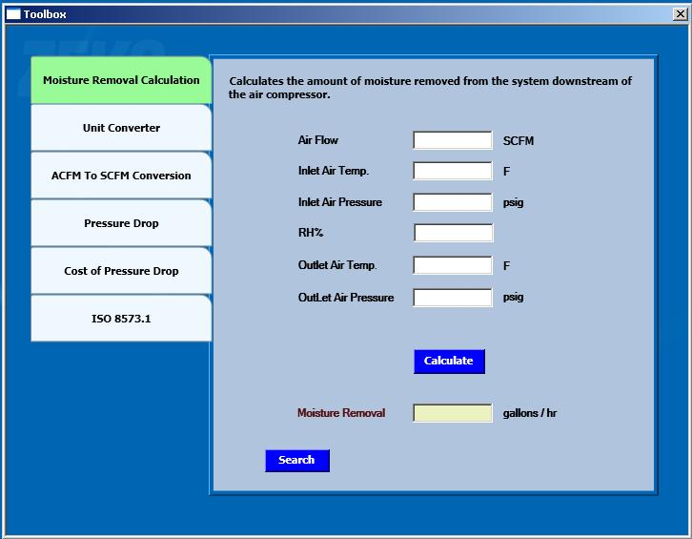

Figure 36: Moisture Removal Calculation

Chris (11/04/2013): Tabs should be narrower to allow the ISO 8573.1 chart to have room to be visible.

TCS (11/05/2013): OK

Chris (11/04/2013): Would like to have these calculations be able to be used with metric units as well.

TCS (11/05/2013): OK

## Specifications

1. **Airflow** (Textbox): User enters the value of Air flow.
2. **Inlet Air Temperature** (Textbox): User enters the value of Inlet Air Temperature.
3. **Inlet Air Pressure**(Textbox): User enters the value of Inlet Air Pressure
4. **RH%** (Textbox) :User enters the value of relative humidity in percentage.
5. **Outlet Air Temperature** (Textbox): User enters the value of Outlet Air Temperature
6. **Outlet Air Pressure** (Textbox) :User enters the value of Outlet Air Pressure.
7. **Calculate** (Button): After entering the values, user clicks on calculate button. On click of calculate Moisture Removal is calculated based on some formulas.

Formula to calculate Moisture Removal:

Moisture Removal = Air Flow * Air Density * 60 * (Inlet Moistures – module Moisture) / Water Density

To calculate ‘Moisture Removal Calculation’, user will require following constant value:

Air Density : 0.075

Water Density : 8.21

Enthalpy : 1060

1. **Moisture Removal** (Textbox): This textbox is non-editable. After clicking calculate button value of Moisture Removal calculated is displayed in this textbox.

## Toolbox – Unit Converter

## Purpose

In this section User will be provided the functionality of unit conversion to match the standard unit’s requirement.

## Called from/by

When user clicks on second vertical tab of Toolbox page then this form is opened.

## Layout

This screen is dynamic and controls is depends on which radio button is selected.

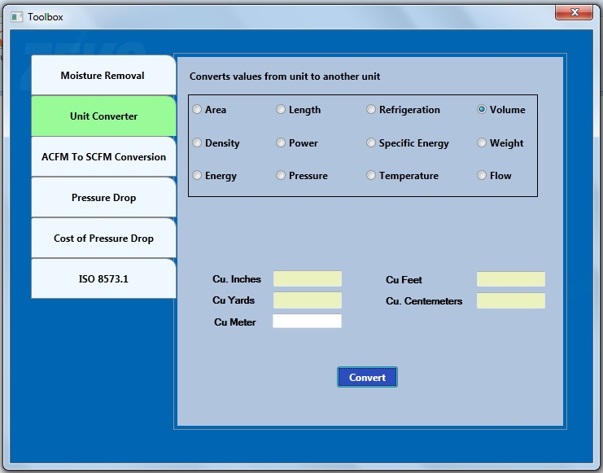

Figure 37: Unit converter

## Specifications

**User Inputs:**

User checks any of the following checkboxes of which conversion is required.

1. **Area** (Radio button)

1 Square Feet= 144 Square Inches

1 Square Feet = 0.092903 Square Meters

1 Square Feet = 92903.04 Square Millimetres

1 Square Inches = 0.00694 Square Feet

1. **Length** (Radio button)

1 Centimetres =0.0328084Feet

1 Centimetres = 0.3937008 Inches

1 Centimetres = 0.01 Meters

1 Centimetres = 10 Millimetres

1 Feet = 30.48 Centimetres

1 Feet = 0.3048 Meters

1 Feet = 304.8 Millimetres

1 Inches = 2.54 Centimetres

1 Inches = 0.0833333 Feet

1 Inches = 0.0254 Meters

1 Inches = 25.4 millimetres

1 Meters = 3.28084 Feet

1 Meters = 39.37008 Inches

1 Meters = 1000 millimetres

1 millimetres = 0.1 Centimetres

1 millimetres = 0.00328 Feet

1 millimetres = 0.03937 Inches

1 millimetres = 0.001 Meters

1. **Refrigeration** (Radio button)
2. **Volume**(Radio button)

1 Square Inches = 0.0006452 Square Meters

1Cubic Feet=1728Cubic Inches

1Square Inches=645.16 Square millimetres

1Cubic Feet= 28.3169Liters

1Square Meters =10.76391Square Feet

1Cubic Inches = 0.00058Cubic Feet

1Square Meters=1550.003Square Inches

1Cubic Meters=35.3147 Cubic Feet

1Square Meters=1000000 Square millimetres

1Cubic Meters = 1000 Litters

1. **Density**(Radio button)
2. **Power**(Radio button)

1 BTU/Hour = 0.2931 Watts

1 Horsepower = 745.7 Watts

1 Watts = 3.4129 BTU/Hour

1 Watts = 0.00134 Horsepower

1. **Specific Energy**(Radio button)
2. **Weight**(Radio button)

1Kilograms = 2.20462Pounds (avoirdupois)

1 Pounds = 0.4536 Kilograms

1. **Energy**(Radio button)

1 BTU = 778.3 Foot-lbs

1Kilograms = 2.20462Pounds (avoirdupois)

1BTU = 0.0002928Kilowatt-Hours

1Pounds = 0.4536Kilograms

1Foot-pounds = 0.001286 BTU

1Foot-pounds = 3.77E-07Kilowatt-Hours

1 Kilowatt-Hours = 3413 BTU

1 Kilowatt-Hours = 2660000 Foot-lbs

1. **Pressure**(Radio button)

1 Atmospheres = 33.9 Ft. of water (at 4 degrees C)

1 Atmospheres = 14.7Pounds/sq. Inch

1 Bars = 14.5 Pounds/sq. Inch

1 Bars = 0.9869 Atmospheres

1 Dynes/sq. Centimetre = 0.000001 Bars

1. **Temperature**(Radio button)
2. **Flow**(Radio button)

1 Cubic Feet per Minute = 0.0004719 Cubic Meters per Second

1 Cubic Feet per Minute = 28.31685Liters per Minute

1 Cubic Meters per Second = 2118.88 Cubic Feet per Minute

1. **Cu Meter**(Textbox)

User enters value of Cu meter in the text box.

1. **Convert**(Button)

As the User clicks on the convert button calculation is done based on formulas provided above.

1. **Cu Inches**(Textbox)

On click of convert button converted value is populated in this textbox.

1. **Cu Feet**(Textbox)

On click of convert button converted value is populated in this textbox.

1. **Cu Yards**(Textbox)

On click of convert button converted value is populated in this textbox.

1. **Cu Centimetres**(Textbox)

On click of convert button converted value is populated in this textbox

**Buttons:**

1. **Convert (Button):** On click of convert button Calculation will performed.

Chris (11/04/2013): Intent of the conversion section is to be able to put an input in any one field and the remaining units convert.

TCS (11/05/2013): Done

## Toolbox – ACFM To SCFM Conversion

## Purpose

In this page user can convert the ACFM flow unit into SCFM based on some formulas.

## Called from/by

It is the third vertical tab of the toolbox page and is called when user clicks it.

## Layout

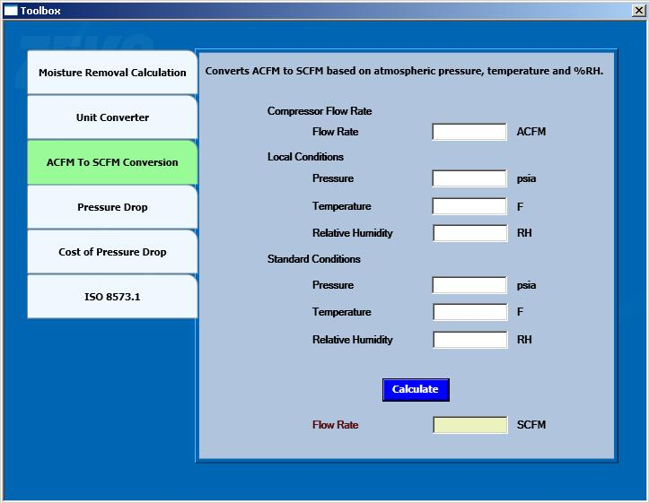

Figure 38: ACFM To SCFM Converter

## Specifications

**User Inputs:**

1. **Flow Rate** (Textbox): User will enter value of flow rate in ACFM.
2. **Pressure** @ Local Conditions (Textbox): User will enter value of pressure at local condition.
3. **Temperature** @ Local Conditions (Textbox): User will enter value of Temperature at local condition
4. **Relative Humidity**@ Local Conditions (Textbox): User will enter value of Relative Humidity at local condition
5. **Pressure** @ Standard Conditions (Textbox): User will enter value of pressure at Standard condition
6. **Temperature** @ Standard Conditions (Textbox): User will enter value of Temperature at Standard condition
7. **Relative Humidity**@ Standard Conditions (Textbox): User will enter value of Relative Humidity at Standard condition
8. **Calculate** (Button): On clicking calculate button, calculation will be done based on input values and formulas.

Formula is:

=Compressor flow rate*temperature factor*((Pressure local condition-(partial pressure local condition*Relative humidity local cond))/ (Pressure local condition-(partial pressure standard condition*Relative humidity standard cond)))*Suction Pressure E factor

To calculate Temperature Factor, the formula is:

= (460*Standard Temp) / (460*Actual Temp)

To calculate Temperature Factor, the formula is:

= (Actual Pressure – Inlet Pressure Drop) / Actual Pressure

1. **Flow Rate**(Textbox)

After calculation converted SCFM value will be displayed in this textbox.

**Buttons:**

1. **Calculate (Button):** On click of calculate button Calculation will performed.

## Toolbox – Pressure Drop

## Purpose

In this page user will be provided functionality of calculating pressure drop based on conditional inputs.

## Called from/by

It is called when User clicks fourth vertical tab of the Toolbox page.

## Layout

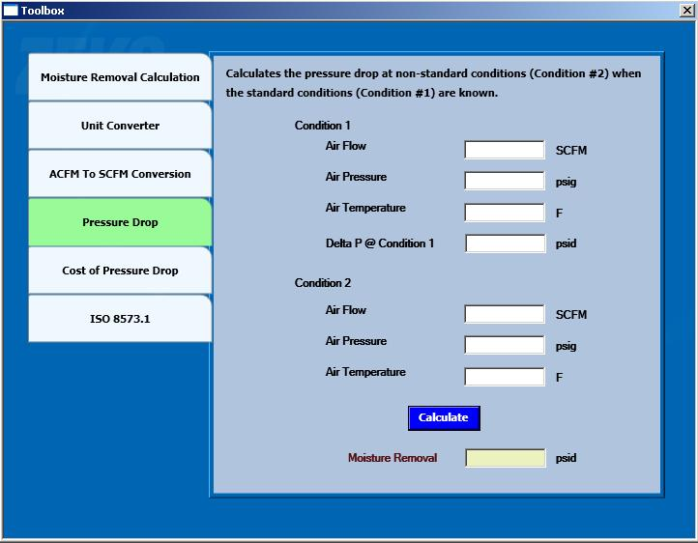

Figure 39: Pressure Drop

## Specifications

**User Inputs:**

1. **Condition 1:**

* Airflow(Textbox)

User enters value of Air flow at condition 1 in this textbox.

* Air Pressure(Textbox)

User enters value of Air Pressure at condition 1 in this textbox.

* Air Temperature(Textbox)

User enters value of Air Temperature at condition 1 in this textbox.

* Delta P @ Condition 1(Textbox)

User enters value of Delta Pat condition 1 in this textbox.

1. **Condition 2:**

* Airflow(Textbox)

User enters value of Air flow at condition 2 in this textbox.

* Air Pressure(Textbox)

User enters value of Air Pressure at condition 2 in this textbox

* Air Temperature(Textbox)

User enters value of Air Temperature at condition 2 in this textbox

* Delta P @ Condition2(Textbox)

User enters value Delta P at condition 2 in this textbox

1. **Pressure Drop** (Textbox): This is non-editable textbox. After calculation of pressure drop its value is displayed in this textbox.

**Buttons:**

1. **Calculate** (Button): After entering values User clicks on Calculate button then based on the formulas Pressure drop is calculated.

Formula to calculate Pressure Drop:

= ((Air flow SCFM condition2/Air flow SCFM condition1) ^ 2)*Delta P @ condition 1*((Air temperature condition2+ 460) / (Air pressure condition2+14.7))*((Air pressure condition1+14.7)/(Air temperature condition1+460))

## Toolbox – Cost Of Pressure Drop

## Purpose

In this page user is shown with the savings due to Cost of the pressure drop.

## Called from/by

It is the fifth vertical tab of the Toolbox page and is called when user clicks that tab.

## Layout

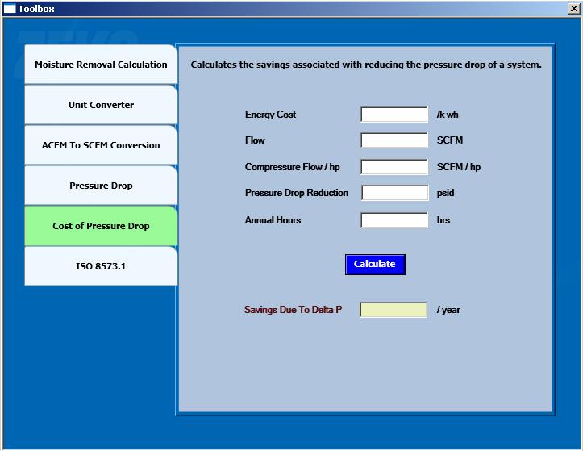

Figure 40: Cost of Pressure Drop

## Specifications

**User Inputs:**

1. **Energy Cost**(Textbox)

User will enter the value of energy cost in this textbox.

1. **Flow**(Textbox)

User will enter the value of Flow in this textbox

1. **Compressor Flow / hp**(Textbox)

User will enter the value of Compressor Flow / hp in this textbox

1. **Pressure Drop Reduction**(Textbox)

User will enter the value of Pressure Drop Reduction in this textbox

1. **Annual Hours**(Textbox)

User will enter the value of Annual Hours in this textbox

1. **Savings due to Delta**(Textbox)

This textbox is non-editable. After calculation value is displayed in this textbox.

**Buttons:**

1. **Calculate (**Button): After entering the values when user will click on the calculate button then based on the formulas savings due to pressure drop is calculated.

Formula is:

=Annual cost per year * Power per Delta * Pressure Drop Reduction

Please refer Existing system Toolbox section for input parameters and calculation formulas regarding above points.

To calculate cost of pressure drop, the user requires following constants:

Energy / hp : 0.746

Power / delta P : 0.50

Motor Power Factor : 110

Motor Efficiency : 0.90

## Toolbox – ISO 8573.1 (Compressed Air Quality Standards)

## Purpose

In this tab user is shown with the static calculation of ISO 8573.1 – Compressed Air Quality Standards.

## Called from/by

It is the last vertical tab of the Toolbox page and is called when user clicks that tab.

## Layout

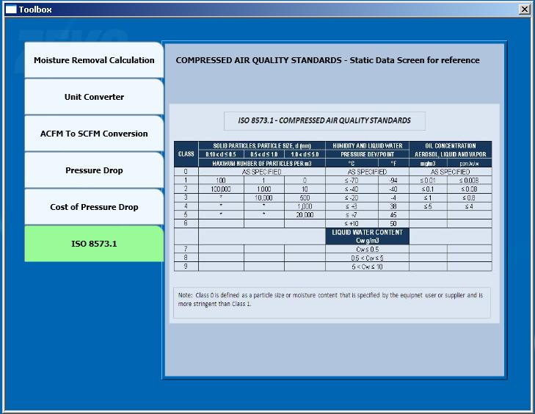

Figure 41: ISO 8573.1 – Compressed Air Quality Standards

## Specifications

1. **Static Page**(Image)

User will be able to view static calculation of ISO 8573.1 – Compressed Air Quality Standards.

## Settings - Logo

## Purpose

In this page user can save / update logo and same will be reflected in the quotation.

## Called from/by

When user clicks on settings menu provided in the home page then the form is opened having four vertical tabs and by default first tab (Logo) is selected and this page is called.

## Layout

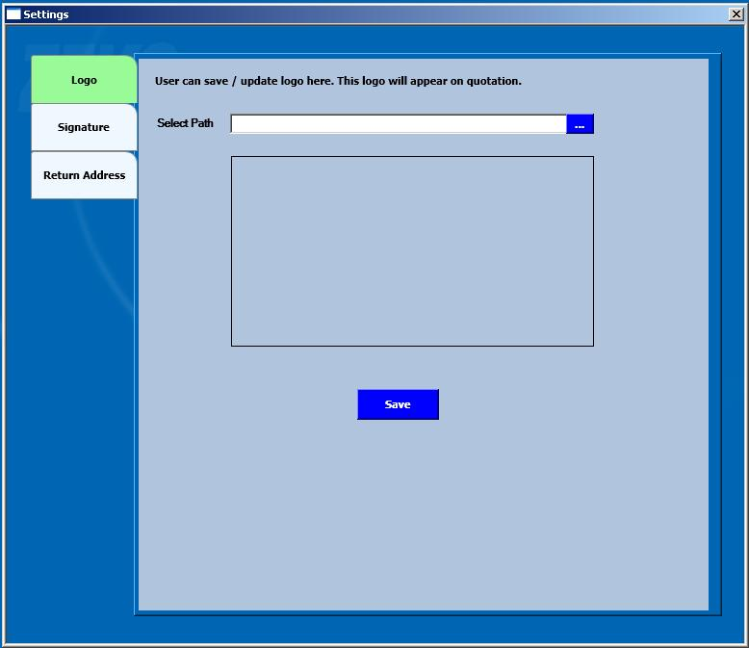

Figure 42: Logo

## Specifications

**User Inputs:**

1. **Browse Dialog Box:** User will be able to browse the desired logo through this dialog box.
2. **TextArea:** In this text area browsed information will be displayed.

**Buttons:**

1. **Save (**Button) : On clicking save button provided information will be saved

## Settings - Signature

## Purpose

User can save/Update signature in this page. The same signature will appear in the quotation.

## Called from/by

It is the second vertical tab of the settings page and is called when user selects it.

## Layout

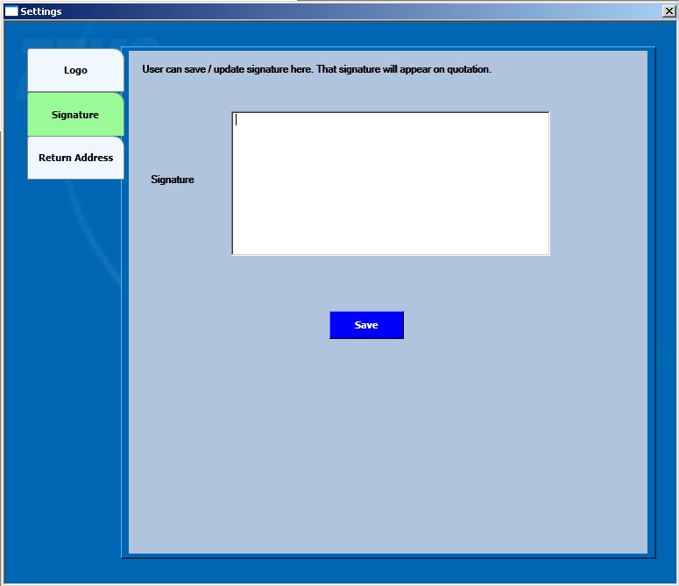

Figure 43: Signature

## Specifications

**User Inputs:**

1. **Signature** (TextArea): In this text area user will be able to update his desired signature.

**Buttons:**

1. **Save** (Button): On clicking save button provided information will be saved.

## Settings – Return Address

## Purpose

In this page user can save/update return address and same will appear in the quotation.

## Called from/by

It is the third vertical tab of the settings page and is called when user selects it.

## Layout

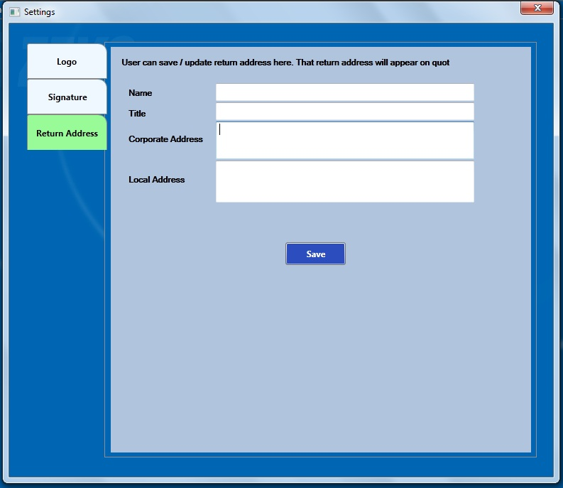

Figure 44: Return Address

## Specifications

**User Inputs:**

1. **Name** (Text Field): In this field user will be able to enter name of addressee.
2. **Title** (Text Field): In this field user will be able to enter title of addressee.
3. **Corporate Address** (Text area): In this text area user will be able to update corporate address of addressee.
4. **Local Address** (Text area): In this text area user will be able to update local address of addressee.

**Buttons:**

1. **Save** (Button): On clicking save button provided information will be saved.

## Help

## Purpose

Application will open a Help file. IR will provide Help file

## Called from/by

If user clicks help menu, the help file will open.

## Layout

## Specifications

# Attachments

Samples .zks file which will generate while saving users selection in Quotation screen.

<?xml version="1.0" encoding="utf-8" ?>

**-** <Item1>

<Quantity>2</Quantity>

<Discount>20</Discount>

**-** <Category>

<RefrigeratedDryer>1</RefrigeratedDryer>

<DessicantDryer>0</DessicantDryer>

<Filteration>0</Filteration>

</Category>

**-** <SubCategory>

<HeatSinkCycling>1</HeatSinkCycling>

<NonCycling>0</NonCycling>

<HighTemperature>0</HighTemperature>

</SubCategory>

**-** <Model>

<HSG100>1</HSG100>

<HSG125>0</HSG125>

<HSG150>0</HSG150>

<HSG200>0</HSG200>

</Model>

**-** <Options>

<O150_1_60>1</O150_1_60>

<O150_1_80>0</O150_1_80>

<O220_1_50>0</O220_1_50>

<NEMA7>1</NEMA7>

</Options>

**-** <SizingConditions>

<InletFlow>100</InletFlow>

<PurgeFlow />

<InletTemp>100</InletTemp>

<InletPressure>100</InletPressure>

<WaterTemp>50</WaterTemp>

</SizingConditions>

</Item1>

Chris (11/04/2013): I will leave this section for Ronak and Kevin to comment on.

TCS (11/05/2013): OK

# Exception Handling

## Application Level

1. The exception handling features help us to deal with any unexpected or exceptional situations that occur when a program is running.
2. Exception handling uses the try, catch, and finally keywords to try actions that may not succeed, to handle failures when you decide that it is reasonable to do so, and to clean up resources afterward.
3. Exceptions can be generated by the common language runtime (CLR), by the .NET Framework or any third-party libraries, or by application code. Exceptions are created by using the throw keyword.
4. The following steps are used to handle the exception:

* Use a try block around the statements that might throw exceptions.
* Once an exception occurs in the try block, the flow of control jumps to the first associated exception handler that is present anywhere in the call stack. The catch keyword is used to define an exception handler.
* If no exception handler for a given exception is present, the program stops executing with an error message.
* If you catch exception, System throws it using the throw keyword at the end of the catch block.
* If a catch block defines an exception variable, we can use it to obtain more information about the type of exception that occurred.
* Exceptions can be explicitly generated by a program by using the throw keyword.
* Exception objects contain detailed information about the error, such as the state of the call stack and a text description of the error.
* Code in a finally block is executed even if an exception is thrown. We will use a finally block to release resources, for example to close any streams or files or database connection that were opened in the try block.

## Data Base Level

Steps for handling exception at Data Base Level:

1. Create a new custom error table.
2. Write the common procedure for handling the current exception which will help us to insert the error details into step1 created table.
3. Use the procedure written in step 2 in the procedures and execute with the exception handling using TRYCATCH statement. Whenever an error occurs, it calls the common stored procedure and inserts the error details.
4. The custom error table lists out the captured error details.