

**PRODUCT SPECIFICATION**

**HEATSINK CYCLING REFRIGERATED AIR DRYER (1000-1600 SCFM)**

This Product Specification is for a complete mechanical refrigerated drying system for the removal of moisture, oil vapor and other contaminants from a compressed air or gas stream. This process is accomplished by cooling the gas with a refrigeration unit to a temperature at which the contaminants condense and are separated from the gas stream. The Specification includes information for a range of dryers that can be applied to air systems of varying size.

**SCOPE**

The dryer shall be complete in all respects, including integral component equipment, inter-connecting piping, wiring and controls. The dryer shall only require connection to utilities furnished by others.

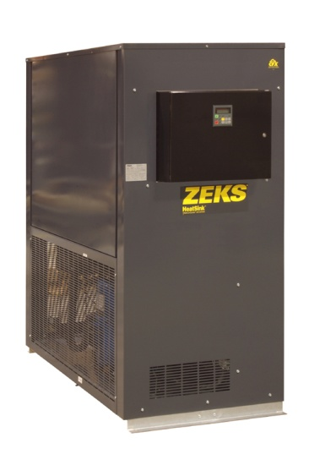

For reference only

**EXCHANGER TECHNOLOGY**

All heat exchangers shall be manufactured entirely from stainless steel. The heat exchange surfaces shall be a corrugated and folded stainless steel sheet contained within a fully-welded cylindrical stainless steel shell.

There shall be no other extraneous materials such as silver or copper braze alloys, lead or tin solder, nor shall any adhesives, gaskets or other sealing method be used.

Exchangers shall be designed with cross corrugated and folded heat exchange surfaces to enhance air flow turbulence, thus providing superior heat transfer over a wide range of air flow conditions with low pressure drop.

Additionally, exchanger design shall provide a large open multipath area (5 times that of shell & tube design) to provide resistance to fouling.

**COMPONENTS AND CONSTRUCTION**

Each dryer system shall be complete with the following items:

* Precooler/Reheater exchanger
* Air chiller
* Centrifugal air/moisture separator
* Thermal mass cooling system
* Thermal mass circulating system
* Refrigeration system equipped with hermetically sealed compressor and water or air-cooled condenser
* Electronic solenoid drain to automatically discharge condensate
* Controls and Instrumentation

**PRECOOLER/REHEATER**

Dryer shall be equipped with a single air-to-air heat exchanger to precool incoming compressed air and reheat outgoing compressed air. Air-to-air heat exchanger shall be constructed completely with stainless steel. The maximum design pressure shall be 220 psig.

**AIR CHILLER**

Compressed air from the precooler/reheater shall be delivered to the air chiller. The air chiller shall consist of stainless steel heat exchangers that exchange heat from the process air stream to the cooled thermal mass fluid.

**CENTRIFUGAL AIR/MOISTURE SEPARATOR**

A vertical air/moisture separator shall be located after the air chiller. Compressed air and water condensed in the air chiller shall be delivered to the separator for the separation and subsequent removal of the water from the compressed air.

REFRIGERATED AIR DRYER (Cont.)

Separation shall be performed at the coldest point in the system by means of centrifugal acceleration, expansion into an area of low velocity with sump area and change of air flow direction. These separation mechanisms shall provide for separation efficiency in excess of 99%.

**THERMAL MASS COOLING SYSTEM**

The thermal mass cooling system shall consist of a thermal mass reservoir, thermal mass fluid and stainless steel evaporator. Refrigerant from the refrigeration system shall be circulated within the evaporator, liberating heat from the thermal mass fluid.

The thermal mass shall thus allow the refrigerant compressor to cycle on and off automatically depending on the heat load to the dryer. The storage container and exchanger system shall be designed to deliver a 38°F PDP.

**THERMAL MASS CIRCULATING SYSTEM**

Thermal mass fluid shall be transferred to the thermal mass fluid to air heat exchanger via the thermal mass fluid pump. Pump shall be maintenance-free, cartridge circulator pump. Pump shall run continuously to maintain flow through the air chiller at all times.

**REFRIGERATION SYSTEM**

The refrigeration system shall be designed to dry a set amount of compressed air. The refrigeration system shall consist of one hermetic reciprocating type compressor, refrigerant feed system and air or water cooled condenser. No hot gas by-pass valve or similar capacity modulating device shall be used in the refrigeration system.

Refrigerant R-404A shall be used to minimize environmental hazard. The amount of refrigerant shall be minimized through use of a measured charge system, to prevent liquid refrigerant floodback to the hermetic compressor.

**MICROPROCESSOR CONTROLS AND INSTRUMENTATION**

The chiller section and associated refrigeration system shall be controlled and monitored by a fully integrated microprocessor. The microprocessor shall control the chiller section to prevent freeze-up. Additionally, the standard microprocessor shall incorporate the following features:

* Chiller Temperature Digital Readout
* High Chiller Temperature Alarm
* Low Chiller Temperature Alarm
* Adjustable Exchanger Temperature
* Percent Savings Digital Readout
* Drain Test Switch
* User Defined Default Display
* Anti-rapid-cycle timer
* Suction Pressure Digital Readout
* Discharge Pressure Digital Readout
* Suction Temperature Digital Readout
* High Discharge Pressure Cutout Alarm
* Low Suction Pressure Cutout Alarm

Microprocessor shall also incorporate field programmable dew point settings to allow the dryer to be more closely matched to seasonal demands. A higher dew point setting shall allow refrigerant compressors to experience a lighter load thereby conserving more energy and further reducing compressor wear and tear.

END PRODUCT SPECIFICATION