**PRODUCT SPECIFICATION**

**HEATSINK CYCLING REFRIGERATED AIR DRYER (10-125 SCFM)**

This Product Specification is for a complete mechanical refrigerated drying system for the removal of moisture, oil vapor and other contaminants from a compressed air or gas stream. This process is accomplished by cooling the gas with a refrigeration unit to a temperature at which the contaminants condense and are separated from the gas stream. The Specification includes information for a range of dryers that can be applied to air systems of varying size.

**SCOPE**

The dryer shall be complete in all respects, including integral component equipment, inter-connecting piping, wiring and controls. The dryer shall only require connection to utilities furnished by others.

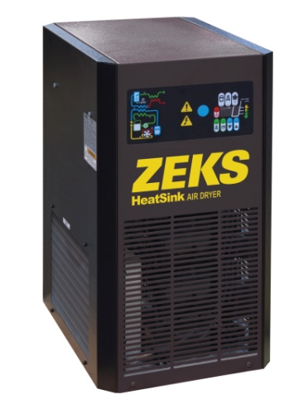

For reference only

**EXCHANGER TECHNOLOGY**

The dryers shall be provided with a multi-function compact heat exchanger that is comprised of a precooler / reheater, three layer chiller section, condensate discharge section, and internal flow path in a single device.

The heat exchanger sections are comprised of a stacked array of extruded aluminum plates that contain a plurality of uniform internal passages for optimal heat transfer. The plates are fully brazed to ensure that the fluid flow paths are properly segregated.

The precooler / reheater and heat exchanger sections are brazed to aluminum end-plates which unify the assembly and create the internal flow path form the entire exchanger.

**COMPONENTS AND CONSTRUCTION**

Each dryer system shall be complete with the following items:

* Integral heater exchanger that incorporates a precooler / reheater exchanger, three layer heat exchanger section, condensate removal section, and internal flow path section.
* Thermal mass cooling and circulation system
* Refrigeration system equipped with hermetically sealed compressor and air cooled condensing system
* Electric solenoid drain with clean out port
* Full featured electronic controller with LED display and digital temperature sensors.

**PRECOOLER / REHEATER SECTION**

The air-to-air heat exchanger shall simultaneously precool the incoming hot & saturated compressed air stream and reheat the outgoing compressed air utilizing the cool air leaving the three layer heater exchanger section. The pre-cooler / re-heater reduces the refrigeration compressor capacity required for drying the compressed airstream.

**THREE LAYER CHILLER SECTION**

The three layer heat exchanger is comprised of three isolated fluid circuits; i.e. compressed air, refrigerant, and thermal mass fluid.

The cooled compressed air leaving the pre-cooler / re-heater section enters the three layer chiller section via an internal flow path within the exchanger.

REFRIGERATED AIR DRYER (Cont.)

**THREE LAYER CHILLER SECTION (Continued)**

Further cooling & drying is achieved as the air stream contacts the cold surface area generated by circulating cold refrigerant gas when the compressor is operational. The refrigerant gas will also simultaneously cool the thermal mass fluid through a heat transfer process.

The dried airstream is then directed to the inlet of the pre-cooler / reheater section after this process. The condensate produced by mechanical cooling will separate through gravity and collect at the bottom of the sump.

The thermal mass fluid circulates constantly when the dryer is activated for operation. When the refrigeration system is automatically turned off during reduced compressor load conditions, the compressed air continues to be cooled by exchanging cold energy that is stored in the thermal mass fluid. When the temperature of the thermal mass fluid rises above the design set-point condition, the controller will activate the compressor and condenser fan to resume the cooling process.

**CONDENSATE REMOVAL**

Condensate that is removed from the air stream by mechanical cooling is designed to collect at the bottom of the internal sump. The condensate is discharged from the sump through a solenoid drain that is operated by the main unit controller.

**THERMAL MASS COOLING SYSTEM**

The thermal mass cooling system shall consist of a thermal mass reservoir, thermal mass fluid, circulator pump, and interconnecting tubing to the three layer heat exchanger section.

Thermal mass fluid shall be transferred to the air chiller via the thermal mass fluid pump. Pump shall be maintenance-free, cartridge circulator pump. Pump shall run continuously to maintain flow through the air chiller at all times when the controller is activated for operation.

The thermal mass shall thus allow the refrigerant compressor to cycle on and off automatically depending on the heat load to the dryer. The

reservoir and inter-connecting piping system shall be fully insulated.

**REFRIGERATION SYSTEM**

The refrigeration system shall be designed to dry a set amount of compressed air. The refrigeration system shall consist of one hermetic reciprocating type compressor, refrigerant feed system and air cooled condensing system. No hot gas by-pass valve or similar capacity modulating device shall be used in the refrigeration system.

Refrigerant R-134A shall be used to minimize environmental hazard. The amount of refrigerant shall be minimized through use of a measured charge system.

**CONTROLS AND INSTRUMENTATION**



The dryer shall be provided with an electronic controller that automatically operates the refrigeration system and the timed operation of the condensate drain valve. The controller shall utilize a temperature sensor to continuously monitor the temperature of the thermal mass fluid and activate the refrigeration system as required to maintain the temperature set-point.

The controller shall also continuously monitor the compressor discharge temperature via a surface mounted temperature sensor that is mounted to the refrigerant discharge line. The controller will automatically disable the compressor if the measured temperature value exceeds the high limit temperature set-point.

The controller shall be provided with a display that provides operational status and functional alarms and incorporate function keys that permit the user to activate the dryer for operation, adjust drain timing settings, activate the solenoid drain valve, and check energy savings values.

END PRODUCT SPECIFICATION