**MIST ELIMINATOR (150-8000 SCFM)**

**PRODUCT SPECIFICATION**

This Product Specification is for a heavy duty coalescing type, self-cleaning filter/separator designed to remove oil and water aerosols from a compressed air system with a minimum of pressure drop.

**HEAVY DUTY MIST ELIMINATOR**

**SCOPE**

This specification describes a standard Heavy Duty Mist Eliminator Filter for the removal of oil aerosols, moisture, and other contaminants from a compressed air or gas stream.

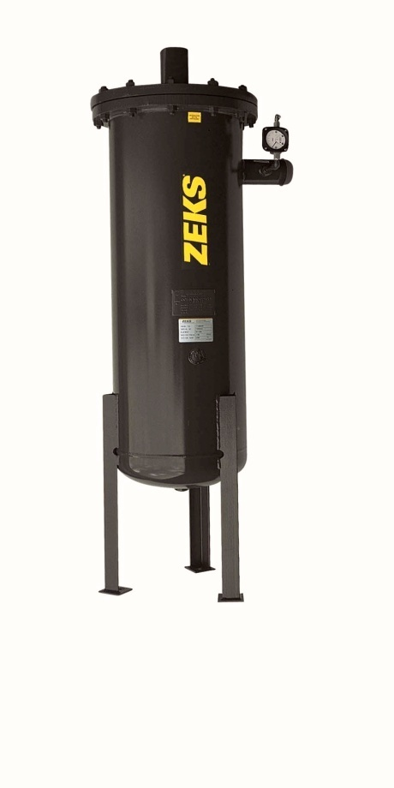

For Reference Only

**COMPONENTS AND CONSTRUCTION**

The filter shall be designed to use three types of filtration mechanisms:

* Inertial Impaction
* Direct Interception
* Brownian Movement

These three methods of filtration shall enable this filter to remove sub-micron oil mist and particles with an efficiency of 99.98% down to a particle size of 0.1 micron. Efficiency for all other particles shall be better than 99.5%.

The design pressure drop of the filter upon installation shall be .5 PSID and will remain less than 1 PSID for seven to ten years.

Recommended change-out is 2-3 PSID

Mist Eliminator element shall be warranted for a minimum of three years from date of startup.

The filter housing shall be carbon steel, ASME stamped and coded, rated for 150 psig maximum working pressure.

Housing shall be equipped with fully flanged opening top for access and replacement of Mist

Eliminator element.

The filter element shall consist of special electrical grade glass fibers packed between two carbon steel support screens. Mist particles shall collect on the glass fibers and coalesce into a liquid film which shall be pulled by gravity to the bottom of the filter housing. Average diameter of glass fibers shall be between 7 and 11 microns.

Maximum loading capability to deliver specified efficiency shall not be lower than 2000 mg/m. Total oil carryover shall not exceed .5 PPM under maximum loading condition.

**STANDARD FEATURES**

**Pressure Differential Gauge**

Pressure Differential Gauge shall be factory mounted. Gauge shall be color-coded type to provide positive indication for filter replacement.

Gauge shall have 0-5 PSID scale divided into 1 PSID increments.

**Pressure Relief Valve**

Pressure relief valve is provided as standard. Relief valve setting is 165 PSIG.

END PRODUCT SPECIFICATION