**PRODUCT SPECIFICATION**

**ZFF Filter (1800 – 13200 SCFM)**

This Product Specification is for a standard filter for the removal of oil aerosols, moisture, and other contaminants from a compressed air or gas stream.

**SCOPE**

This specification describes a standard ZFF Filter for the removal of oil aerosols, moisture, and other contaminants from a compressed air or gas stream. ZFF Filters incorporate all the factors necessary for efficient filtration of compressed air and gas, with features that allow them to be easily sized, installed and maintained.

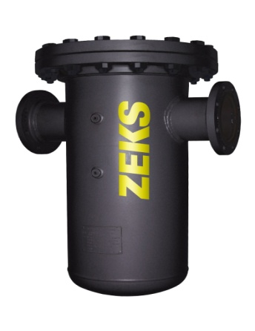

**COMPONENTS AND CONSTRUCTION**

Coalescing and particulate filters shall be designed for the separation and removal of oil carryover, dust and dirt from air before it enters air system conditioning equipment, piping, or pneumatic tools. Carbon filters shall be designed to remove vapors and odors from the compressed air stream.

ZFF elements are designed for one-year usage when operated within design parameters. Carbon elements are designed for 6 month/4000 hour service when operated within design parameters.

The filter element shall be multi-wrapped borosilicate glass microfiber construction with inner and outer perforated stainless steel support sleeves. It shall include a prefiltration layer to extend element service life. Outer layer of element shall include needle felt to prevent decay or breakage during service life.

Recommended temperature rating is 100°F, with a 250°F maximum temperature rating. (Higher operating temperatures will result in greater oil carryover.)

The filter housing shall be all-welded steel, certified to ASME, Section VIII, Division 1. Filter housing should be rated for 150-psig maximum working pressure.

Vessel shall be top-loading, for ease in element changeout.

Bottom drain connection port ½”

**PRESSURE DIFFERENTIAL GAUGE**

Pressure Differential Gauge shall be factory mounted. Gauge shall be dual sided, color-coded type to provide positive indication for filter replacement.

ZFF FILTER (Cont.)

**Element Grades**

Grade P - Particulate/Bulk Liquid Filtration

For removal of small particles and dirt, and for liquid coalescing. Also used where high concentrations of air born dirt are present in the ambient air.

* 5 microns
* 5 ppm oil carryover
* 0.5 psi Delta P-clean and dry
* 1 psi Delta P saturated.

## Grade G – General Purpose Filtration

For general use to protect pneumatic tools and actuators from dirt, oil and dust. Used to coalesce air compressor lubricant carryover out of the air stream..

* 1 micron
* 0.1 ppm oil carryover
* 1.0 psi Delta P clean and dry
* 2 psi Delta P saturated.

## Grade H – High Efficiency Filtration

Used for fine coalescing and when removal of very small particles is required.

* .01 micron
* .01 ppm oil carryover
* 1.5 Delta P clean and dry
* 3 psi Delta P saturated.

## Grade A – Activated Carbon Finishing

For removal of vapors and odors. A Grade “H” (high efficiency) filter must be installed upstream of Grade A filter. Residual vapors bind to the surface of the activated carbon molecules. Grade A elements must be replaced at 6 months of 4,000 hours, whichever if first.

* .01 micron
* .003 ppm oil carryover
* 1 psi Delta P clean and dry

END PRODUCT SPECIFICATION