**HIGH TEMPERATURE REFRIGERATED AIR DRYER (15-100 SCFM)**

**PRODUCT SPECIFICATION**

This Product Specification is for a complete mechanical refrigerated drying system for the removal of moisture, oil vapor and other contaminants from a compressed air or gas stream. This process is accomplished by cooling the gas with a refrigeration unit to a temperature at which the contaminants condense and are separated from the gas stream. The Specification includes information for a range of dryers that can be applied to air systems of varying size.

**SCOPE**

The dryer shall be complete in all respects, including integral component equipment, inter-connecting piping, wiring and controls. The dryer shall only require connection to utilities furnished by others.

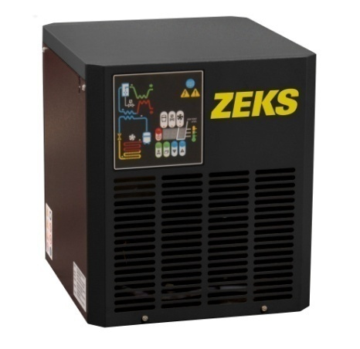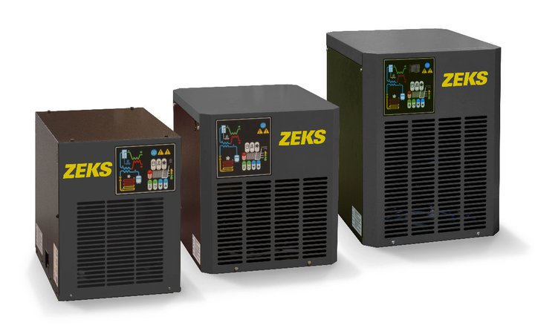

For Reference Only

**COMPONENTS AND CONSTRUCTION**

Each dryer system shall be complete with the following items:

* Integrated air cooled aftercooler
* Refrigerant chiller section
* Refrigeration system equipped with hermetically sealed compressor and air cooled condenser
* Mesh pad air/moisture separator
* Internal coalescing filter
* Timed solenoid drain to discharge condensate
* Control system to initiate and monitor system operation

**AFTERCOOLER**

Hot, wet air is cooled by an integral air-cooled aftercooler prior to the precooler/reheater exchanger.

**CHILLER SECTION**

Compressed air shall be delivered to the chiller section where air is pre-cooled and then delivered to the evaporator. The chiller section shall consist of a specially-designed flat plate, corrosion resistant heat exchanger that includes a precooler/reheater, refrigerant evaporator and moisture separator.

Air-to-air heat exchange shall occur in a counter-flow orientation to maximize heat transfer. Chiller section shall be fully insulated and shall be designed to deliver a 45°F PDP.

**REFRIGERATION SYSTEM**

The refrigeration system shall consist of one hermetic reciprocating type compressor, refrigerant feed system, variable speed fan, air-cooled condenser and refrigerant evaporator. Refrigerant R-134a shall be used to minimize environmental hazard. The amount of refrigerant shall be minimized, through the use of a measured charge system, to prevent liquid refrigerant floodback to the hermetic compressor. No hot-gas bypass valve shall be used.

HIGH PRESSURE REFRIGERATED AIR DRYER (CON’T)

**AIR/MOISTURE SEPARATOR**

Compressed air and water condensed in the chiller section shall be delivered to the separator for the separation and subsequent removal of the water from the compressed air. Separation shall be performed at the coldest point in the system by means of a stainless steel demister pad. Condensate shall be discharged from the separator via an electronic timed drain valve.

**ENCLOSURE**

NEMA 12 enclosure is standard. Type 12 enclosures are designed to protect enclosed equipment from fibers, lint, dust and dirt.

**CONTROLS AND INSTRUMENTATION**

The refrigeration system shall be operated and monitored by a microprocessor controller. The controller shall include easy-to-use graphic interface and permit adjustment of timed drain parameters, as well as provide visual indication of refrigeration system status, drain operation status, alarm status and variable-speed fan operation.

END PRODUCT SPECIFICATION