**MULTIPLEX NON-CYCLING REFRIGERATED AIR DRYER (3,600-24,000 SCFM)**

**PRODUCT SPECIFICATION**

**SCOPE**

The dryer system shall be complete in all respects, including integral component equipment, inter-connecting piping, wiring, controls and sequencer. The modular dryer shall only require single-point connections to utilities by others.

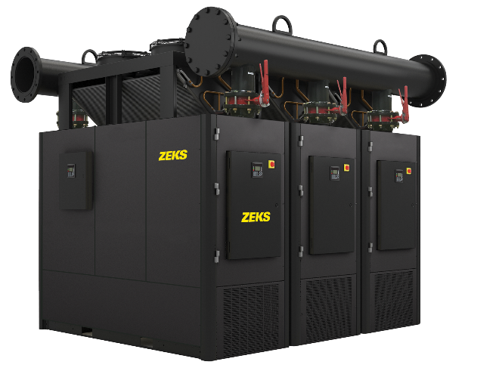

For reference only

**EXCHANGER TECHNOLOGY**

The precooler / reheater and evaporator heat exchangers in each module shall be manufactured within a single, all-aluminum module. The module shall include an integral moisture separator. The heat exchanger sections shall be comprised of a stacked array of extruded aluminum plates that contain a plurality of uniform internal passages for optimal heat transfer.

**COMPONENTS AND CONSTRUCTION**

Each module of the dryer system shall be complete with the following items:

* Precooler/Reheater Exchanger
* Refrigerant Evaporator Section
* Moisture Separator
* Dual Element Inlet Filter
* Electronic Hot Gas Valve
* Pneumatically Actuated No-Loss Drain
* Module Controls and Instrumentation

**PRECOOLER/REHEATER**

Dryer module shall be equipped with an air-to-air heat exchanger to precool incoming compressed air and reheat outgoing compressed air. Precooling the air reduces the air temperature entering the evaporator section, thereby reducing energy requirements. Warm, reheated air exiting the dryer reduces potential for pipe sweat at dryer outlet. Air-to-air heat exchanger shall be integral to the exchanger module.

**EVAPORATOR**

Compressed air from the precooler/reheater shall be delivered to the evaporator, where the air is cooled, thereby condensing out moisture. The evaporator shall be integral to the exchanger module.

**AIR/MOISTURE SEPARATOR**

A moisture separator shall be located after the evaporator. Separator shall be integral to the exchanger module. Compressed air and water condensed in the evaporator shall be delivered to the separator for the separation and subsequent removal of the water from the compressed air.

Separation shall be performed at the coldest point in the system, with the bulk moisture separation occurring at the bottom of the separator section. Moisture re-entrainment shall be prevented by centrifugal acceleration that results from the air stream’s 180 degree turn within the module. These separation mechanisms shall provide for separation efficiency in excess of 99%.

**FILTRATION**

A dual element, internal filter assembly complete with two factory installed general purpose filter elements shall be provided within each dryer module as standard to protect the heat exchanger from piping system debris upstream of the dryer and to improve the delivered air quality. The inlet filter assembly shall be provided with a timed solenoid drain to expel accumulated condensate.

**REFRIGERATION SYSTEM**

Each module’s refrigeration system shall be designed to dry a set amount of compressed air. The refrigeration system shall consist of one hermetically sealed, high-efficiency scroll compressor, air or water cooled condenser, and other refrigeration components needed for proper operation. Refrigerant R410A shall be used to minimize environmental hazard.

Electronic hot gas valve and dedicated hot gas valve controller monitored by the dryer microprocessor controller is included.

**DRAIN ASSEMBLY**

Dryer shall be equipped with two drains:

* Heat Exchanger Module Drain – A pneumatically operated no loss drain with liquid level switch shall be provided as standard and shall be monitored by the module controller continuously when the module is powered.
* Internal Filter Drain – A dedicated solenoid drain with adjustable on / off timer and Y strainer with a shut-off valve shall enable full removal of condensed moisture from the inlet filter assembly.

**CONTROLS AND INSTRUMENTATION**

Each module’s refrigeration system shall be controlled and monitored by a fully integrated microprocessor. The microprocessor shall incorporate the following features:

* Chiller Temperature Digital Readout
* Ambient Air Temperature Readout
* Electronic Hot Gas Bypass Valve Operating Status
* Suction Pressure Digital Readout
* Discharge Pressure Digital Readout
* Suction Temperature Readout
* High Filter Pressure Drop Alarm
* Adjustable Baud Rate

Microprocessor shall also incorporate field programmable chiller temperature settings to allow the dryer to more closely match seasonal demands. A higher chiller temperature setting shall allow refrigerant compressors to experience a lighter load thereby conserving more energy and further reducing compressor run time.

**SYSTEM CONTROLLER**

The main power box shall contain the primary fuse protection necessary for each module. It shall be factory wired to each of the modules including the communications wiring needed for communicating between the system controller and each module.

The System Controller:

* Continuously monitor the compressed air inlet & outlet temperature & pressure values while the unit is operational.
* Monitor the operation of each module via RS485.
* Permit the unit to be remotely monitored via RS485 communications.
* Incorporate a user-friendly LCD display to allow user to visually monitor the operation of the dryer and an integral keypad to permit a user to make parameter adjustments through the user interface.
* Incorporate an SD Card Slot, which allows for program upgrades without the need for replacing the controller.
* Permit the unit to be operated in three different operating modes:

1. Automatic
2. Manual
3. Remote

The control circuit in the main power box shall contain a primary phase monitor that will energize the control circuit for each module when the wiring is properly phased and no fault conditions are detected. The phase monitor shall detect incorrect power phasing of the dryer and protect against voltage imbalance conditions.

END PRODUCT SPECIFICATION