**NON-CYCLING REFRIGERATED AIR DRYER (1800-3000 SCFM)**

**PRODUCT SPECIFICATION**

**SCOPE**

The dryer shall be complete in all respects, including integral component equipment, inter-connecting piping, wiring and controls. The dryer shall only require connection to utilities furnished by others.

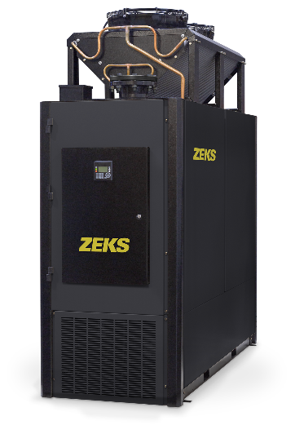

For reference only

**EXCHANGER TECHNOLOGY**

The precooler / reheater and evaporator heat exchangers shall be manufactured within a single, all-aluminum module. The module shall include an integral moisture separator. The heat exchanger sections shall be comprised of a stacked array of extruded aluminum plates that contain a plurality of uniform internal passages for optimal heat transfer.

**COMPONENTS AND CONSTRUCTION**

Each dryer system shall be complete with the following items:

* Precooler/Reheater Exchanger
* Refrigerant Evaporator Section
* Moisture separator
* Dual Element Inlet Filter
* Refrigeration system
* Electronic Hot Gas Valve
* Dual Timed Electric Drains
* Controls and Instrumentation

**PRECOOLER/REHEATER**

Dryer shall be equipped with an air-to-air heat exchanger to precool incoming compressed

air and reheat outgoing compressed air. Precooling the air reduces the air temperature entering the evaporator section, thereby reducing energy requirements. Warm, reheated air exiting the dryer reduces potential for pipe sweat at dryer outlet. Air-to-air heat exchanger shall be integral to the exchanger module.

**EVAPORATOR**

Compressed air from the precooler/reheater shall be delivered to the evaporator, where the air is cooled, thereby condensing out moisture. The evaporator shall be integral to the exchanger module.

**AIR/MOISTURE SEPARATOR**

A moisture separator shall be located after the air chiller. Separator shall be integral to the exchanger module. Compressed air and water condensed in the air chiller shall be delivered to the separator for the separation and subsequent removal of the water from the compressed air.

Separation shall be performed at the coldest point in the system, with the bulk moisture separation occurring at the bottom of the separator section. Moisture re-entrainment shall be prevented by centrifugal acceleration that results from the air stream’s 180 degree turn within the module. These separation mechanisms shall provide for separation efficiency in excess of 99%.

**REFRIGERATION SYSTEM**

The refrigeration system shall be designed to dry a set amount of compressed air. The refrigeration system shall consist of one hermetically sealed, high-efficiency scroll compressor, air or water cooled condenser, and other refrigeration components needed for proper operation. Refrigerant R410A shall be used to minimize environmental hazard.

Electronic hot gas valve and dedicated hot gas valve controller monitored by the dryer microprocessor controller is included.

**FILTRATION**

A dual element, internal inlet filter assembly complete with two factory installed general purpose filter elements shall be provided within the dryer as standard to protect the heat exchanger from piping system debris upstream of the dryer and to improve the delivered air quality. The inlet filter assembly shall be provided with a timed solenoid drain to expel accumulated condensate.

**DRAIN ASSEMBLY**

Dryer shall be equipped with two drains:

* Heat Exchanger Module Drains – A pair of timed electric solenoid drains shall be provided. The timing sequence of the drains can be set by the controller.
* Internal Filter Drain – A dedicated solenoid drain with adjustable on / off timer and Y strainer with a shut-off valve shall enable full removal of condensed moisture from the inlet filter assembly.

**CONTROLS AND INSTRUMENTATION**

The refrigeration system shall be controlled and monitored by a fully integrated microprocessor. The standard microprocessor shall incorporate the following features:

* Chiller Temperature Digital Readout
* Ambient Air Temperature Readout
* Electronic Hot Gas Bypass Valve Operating Status
* Drain Test Function
* Suction Pressure Digital Readout
* Discharge Pressure Digital Readout
* Suction Temperature Digital Readout
* High Filter Pressure Drop Alarm
* Phase Monitor Fault Alarm
* RS485 Communication
* Adjustable Baud Rate

END PRODUCT SPECIFICATION