**PRODUCT SPECIFICATION**

**PREMIER NON-CYCLING REFRIGERATED AIR DRYER (125-1000 SCFM)**

This Product Specification is for a complete mechanical refrigerated drying system for the removal of moisture, oil vapor and other contaminants from a compressed air or gas stream. This process is accomplished by cooling the gas with a refrigeration unit to a temperature at which the contaminants condense and are separated from the gas stream. The Specification includes information for a range of dryers that can be applied to air systems of varying size.

**SCOPE**

The dryer shall be complete in all respects, including integral component equipment, inter-connecting piping, wiring and controls. The dryer shall only require connection to utilities furnished by others.

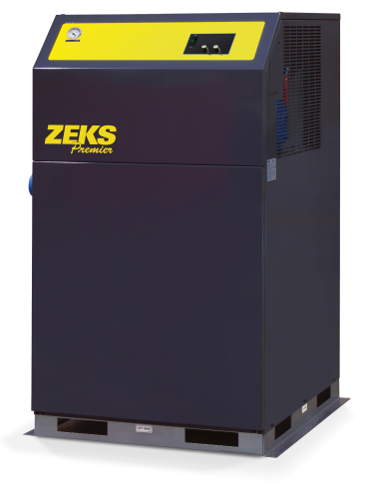

For reference only

**EXCHANGER TECHNOLOGY**

All compressed air heat exchangers shall be manufactured entirely from stainless steel. The heat exchange surfaces shall be a corrugated and folded SS sheet contained within a fully-welded, cylindrical SS shell.

There shall be no other extraneous materials such as silver or copper braze alloys, lead or tin solder, nor shall any adhesives, gaskets or other sealing method be used.

Exchangers shall be designed with cross corrugated and folded heat exchange surfaces to enhance air flow turbulence, thus providing superior heat transfer over a wide range of air flow conditions with low pressure drop.

Additionally, exchanger design shall provide a large open multipath area (5 times that of shell & tube design) to provide resistance to fouling.

**COMPONENTS AND CONSTRUCTION**

Each dryer system shall be complete with the following items:

* Precooler/Reheater exchanger
* Air chiller
* Centrifugal air/moisture separator
* Refrigeration system equipped with hermetically sealed compressor and air cooled condenser
* Electronic solenoid drain to automatically discharge condensate
* Controls and instrumentation

**PRECOOLER/REHEATER**

Dryer shall be equipped with a single air-to-air heat exchanger to precool incoming compressed air and reheat outgoing compressed air. Air-to-air heat exchanger shall be constructed completely with stainless steel. The maximum design pressure shall be 300 psig.

**AIR CHILLER**

Compressed air from the precooler/reheater shall be delivered to the air chiller. The air chiller shall consist of heat exchangers that exchange heat from the process air stream to the cooled refrigerant.

REFRIGERATED AIR DRYER (Cont.)

**CENTRIFUGAL AIR/MOISTURE SEPARATOR**

A vertical air/moisture separator shall be located after the air chiller. Compressed air and water condensed in the air chiller shall be delivered to the separator for the separation and subsequent removal of the water from the compressed air

Separation shall be performed at the coldest point in the system by means of centrifugal acceleration, expansion into an area of low velocity with sump area and change of air flow direction. These separation mechanisms shall provide for separation efficiency in excess of 99%.

**REFRIGERATION SYSTEM**

The refrigeration system shall be designed to dry a set amount of compressed air. The refrigeration system shall consist of one hermetic reciprocating type compressor, refrigerant feed system and air or water cooled condenser. A hot gas by-pass valve shall be used in the refrigeration system.

Refrigerant R-404A shall be used to minimize environmental hazard. The amount of refrigerant shall be minimized through use of a measured charge system, to prevent liquid refrigerant floodback to the hermetic compressor.

**CONTROLS AND INSTRUMENTATION**

Dryer shall incorporate automatic controls for proper operation which shall be preset at the factory. Dryers shall utilize a fan cycling switch to control the condensing temperature by cycling the fan based on refrigerant discharge pressure. A hot gas by-pass valve shall be used to maintain suction pressure and temperature.

Dryer shall include a refrigerant suction pressure gauge for refrigeration system.

END PRODUCT SPECIFICATION