**PRODUCT SPECIFICATION**

**HEATSINK CYCLING REFRIGERATED AIR DRYER (150 SCFM)**

This Product Specification is for a complete mechanical refrigerated drying system for the removal of moisture, oil vapor and other contaminants from a compressed air or gas stream. This process is accomplished by cooling the gas with a refrigeration unit to a temperature at which the contaminants condense and are separated from the gas stream. The Specification includes information for a range of dryers that can be applied to air systems of varying size.

**SCOPE**

The dryer shall be complete in all respects, including integral component equipment, inter-connecting piping, wiring and controls. The dryer shall only require connection to utilities furnished by others.

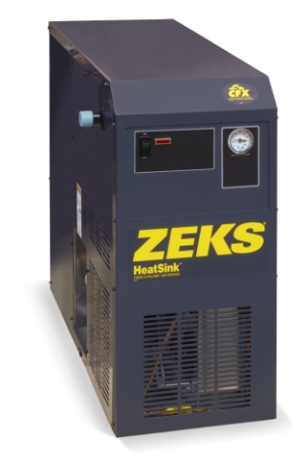

For reference only

**EXCHANGER TECHNOLOGY**

All chiller and precooler/reheater heat exchangers shall be manufactured entirely from stainless steel. The heat exchange surfaces shall be a corrugated and folded stainless steel sheet contained within a fully-welded cylindrical stainless steel shell.

There shall be no other extraneous materials such as silver or copper braze alloys, lead or tin solder, nor shall any adhesives, gaskets or other sealing method be used.

Exchangers shall be designed with cross corrugated and folded heat exchange surfaces to enhance air flow turbulence, thus providing superior heat transfer over a wide range of air flow conditions with low pressure drop. Additionally, exchanger design shall provide a large open multipath area (5 times that of shell & tube design) to provide resistance to fouling.

**COMPONENTS AND CONSTRUCTION**

Each dryer system shall be complete with the following items:

* Precooler/Reheater exchanger
* Air chiller
* Centrifugal air/moisture separator
* Thermal mass cooling system
* Thermal mass circulating system
* Refrigeration system equipped with hermetically sealed compressor and air cooled condenser
* Electronic solenoid drain to automatically discharge condensate
* Controls and Instrumentation

**PRECOOLER / REHEATER**

Dryer shall be equipped with a single air-to-air heat exchanger to precool incoming compressed air and reheat outgoing compressed air. Air-to-air heat exchanger shall be constructed completely of stainless steel. The maximum design pressure shall be 300 psig.

REFRIGERATED AIR DRYER (Cont.)

**AIR CHILLER**

Compressed air from the precooler/reheater shall be delivered to the air chiller. The air chiller shall consist of a single stainless steel exchanger that exchanges heat from the process air stream to the cooled thermal mass fluid.

**CENTRIFUGAL AIR / MOISTURE SEPARATOR**

A vertical air/moisture separator shall be located after the air chiller. Compressed air and water condensed in the air chiller shall be delivered to the separator for the separation and subsequent removal of the water from the compressed air.

Separation shall be performed at the coldest point in the system by means of centrifugal acceleration, expansion into an area of low velocity with sump area and change of air flow direction. These separation mechanisms shall provide for separation efficiency in excess of 99%.

**THERMAL MASS COOLING SYSTEM**

The thermal mass cooling system shall consist of a thermal mass reservoir, thermal mass fluid and copper coil evaporator. Refrigerant from the refrigeration system shall be circulated within the evaporator, liberating heat from the thermal mass fluid.

The thermal mass shall thus allow the refrigerant compressor to cycle on and off automatically depending on the heat load to the dryer. Reservoir shall be fully insulated with 1" minimum foam insulation. The storage container and exchanger system shall be designed to deliver a 38°F PDP.

**THERMAL MASS CIRCULATING SYSTEM**

Thermal mass fluid shall be transferred to the thermal mass fluid to air heat exchanger via the thermal mass fluid pump. Pump shall be maintenance-free, cartridge circulator pump. Pump shall run continuously to maintain flow through the air chiller at all times.

**REFRIGERATION SYSTEM**

The refrigeration system shall be designed to dry a set amount of compressed air. The refrigeration system shall consist of one hermetic reciprocating type compressor, refrigerant feed system and air or water cooled condenser. No hot gas by-pass valve or similar capacity modulating device shall be used in the refrigeration system.

Refrigerant R-404A shall be used to minimize environmental hazard. The amount of refrigerant shall be minimized through use of a measured charge system, to prevent liquid refrigerant floodback to the hermetic compressor.

**CONTROLS AND INSTRUMENTATION**

The chiller section and associated refrigeration system shall be automatically controlled. The thermal mass fluid temperature is maintained by a thermostat that monitors the temperature and cycles the refrigeration system in response to varying air flow and temperature. The thermostat shall control the chiller section to prevent freeze-up.

In addition to the factory set thermostat, a suction pressure gauge is provided as standard equipment. This gauge monitors the pressure of the refrigerant gas before it enters the compressor

A "High Temp" alarm light is provided to indicate an elevated thermal mass temperature. The light is controlled by a thermostat that monitors the thermal mass and closes to energize the light at approximately 55°F.

END PRODUCT SPECIFICATION